 | ACTIVIDAD  De acuerdo a las imágenes y descripciones, indique por medio de líneas las oraciones que mejor describan los estados de ánimo, ejemplo:  He is not sad, he is hungry (él no está triste, él está hambriento “tiene hambre”)
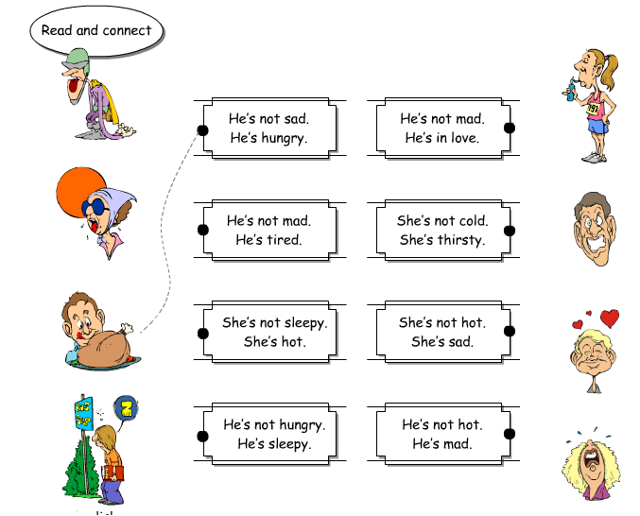
ACTIVIDAD
De acuerdo a la lectura “A robbery”, responda:
Reading comprehension
What was the man in apartment 2 doing? | He was . . .
When was the robbery?

Where were the college students

Who was in the hospital?

Why were the burglars in the building?

ACTIVIDAD
Identifique el adjetivo para cada verbo y complete las siguientes respuestas empleando sujeto + to be + adjetivo. (ver ejemplo N° 6)

1. | Why are you crying? | I am crying because
2. | Why is the baby eating? | The baby is crying because
3. | Why is your father shouting? | My father is crying because
4. | Why are they laughing? | They are laughing because
5. | Why are we sleeping? | We are sleeping because
6. | Why is the girl drinking lemonade? | The girl is drinking lemonade because she is thirsty
7. | Why are they going to the doctor? | They are going to the doctor because
8. | Why is your sister taking a shower? | My sister is taking a shower because

