CLEI | TIEMPO | NOMBRE DE LA GUÍA | PERIODO N° | ÁREA
Cuatro | 10 semanas | Describing experiences and opinions | Dos | Inglés

Periodo 02
Estándar | Leer y comprender narraciones y descripciones sobre temas que me son familiares.
Competencia | Lectura |  | Escritura
Comunicativa | - Identificar iniciación, nudo y desenlace en una narración  - Comprender relaciones de adición, contraste, orden temporal y espacial y causa efecto entre enunciados sencillos. | - Escribir narraciones sobre experiencias personales y hechos a mi alrededor

EXPRESSING OBLIGATION

El verbo “have got / has got” significa “tener”; sin embargo, con este mismo también se expresa obligación, reemplazando “got” por “to”, cuyo significado es “tener que”, así:

I  You  We  They | have to | get up early tomorrow
He  She  It | has to | get up early tomorrow
Model: Are you going home now?
¿Estás yendo a casa ahora?

Yes, I have to cook dinner.
Sí, yo tengo que cocinar la cena

Para las negaciones y preguntas, se usa el presente simple, cuyos auxiliares son DO y DOES:

A: Do you have to study this afternoon? ¿Usted tiene que estudiar esta tarde?
B: no, I don’t have to go to the college. No, no tengo que ir al colegio.

A: Does the teacher go to the classroom? ¿el profesor tiene que ir al salón?
B: No, he doesn’t have to teach in colleges. No, él no tiene que enseñar en colegios.

Para las negaciones se utiliza have to para todos los pronombres (sin cambiar a has to)

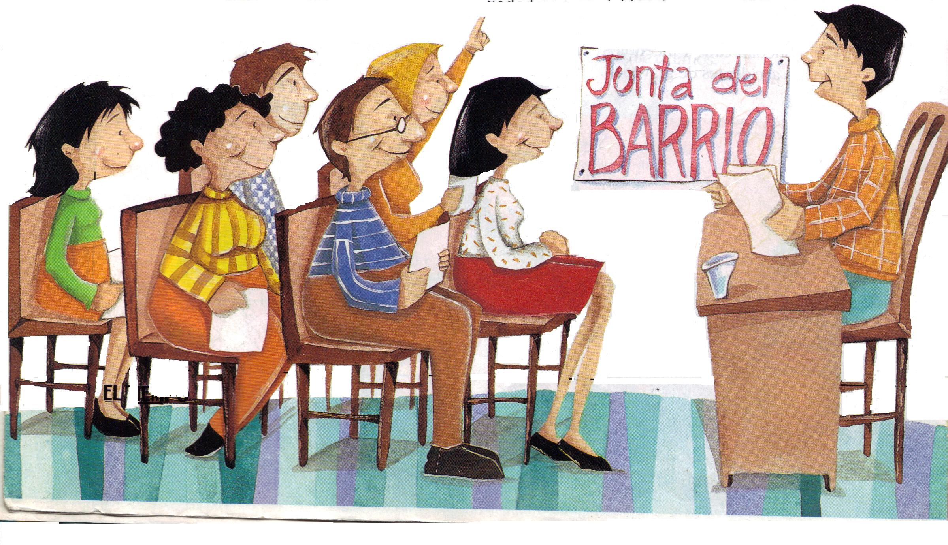  Are you going to the drugstore? |  | Is she going to the gym?
Yes, I have to buy some medicine |  | Yes, she has to work out.
Is the chef going to the restaurant? |  | Are they in the classroom?
Yes, he has to cook |  | Yes, they have to study

 | ACTIVIDAD  De manera lógica responda cada pregunta con una oración expresando obligación (tener que: have to / has to)
- Are you going to the library?
Yes, I have to read a book.
- Is Lucas going to bed now?
- Are they using the telephone?
- Is he going to the optician?
- Are you working overtime tonight?
- Are they taking their car to the mechanic?
- Are you taking a taxi home tonight?
- Is your mother going to the drugstore?
- Are your sisters going to the supermarket?
- Are you buying some paint?
- Is Karla going to the post-office?

CAN

El verbo o auxiliar CAN significa “poder”, y tiene cuatro connotaciones.
- Expresa habilidad o capacidad: I can walk: yo puedo caminar
- Expresa posibilidad: I can study: yo puedo estudiar
- Expresa inhabilidad: I can’t fly: yo no puedo volar
- Expresa permiso: Can I leave? ¿puedo irme?

Se consideran auxiliares aquellos verbos que se pueden utilizar en oraciones negativas e interrogativas, algunos de ellos son: must, could, should, may, might. Éstos los veremos más adelante.
Ahora a través de una lectura identificaremos la función de los verbos CAN y HAVE/HAS TO:
- Henry is annoyed. He’s applying for a driver’s license, and he’s upset about all the things he has to do.

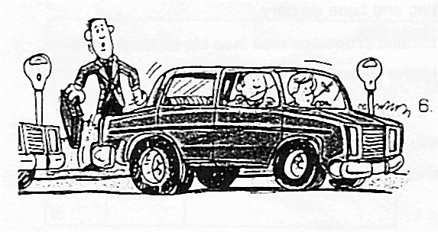
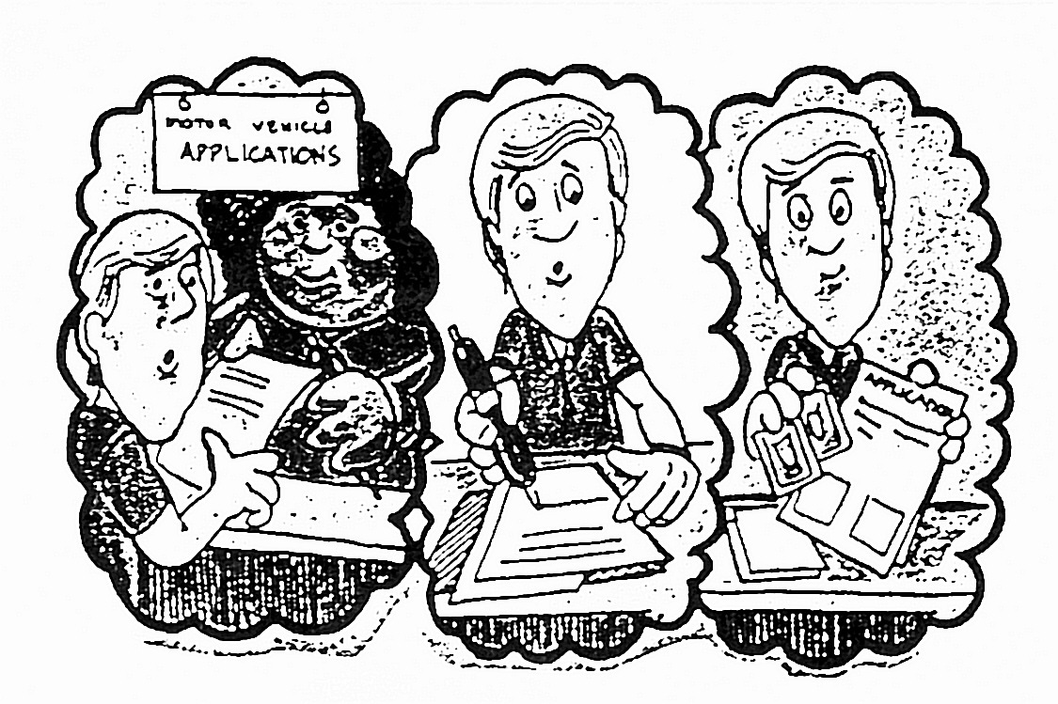
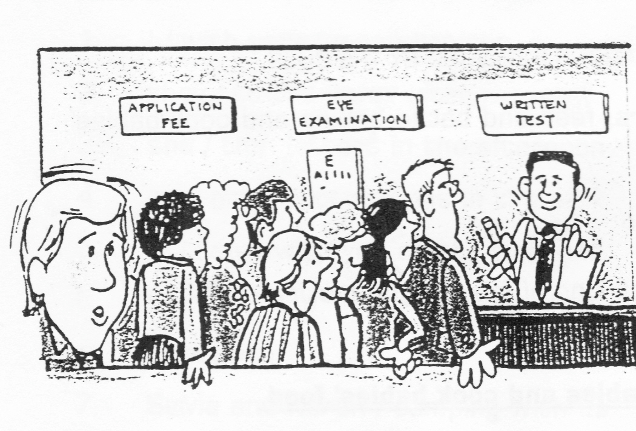
- First, he has to go to the Motor Vehicle Department and pick up an application form. He can’t ask for the form by telephone, and he can’t ask for it by mail. He has to go downtown and pick up the form in person.

- He has to fill out the form in duplicate, he can’t use a pencil, he has to use a pen, he can’t use blue ink, he has to use black ink, and he can’t write in script, he has to print.

- He also has to attach two photographs to the application, they can’t be old photographs, they have to be new. They can’t be large, they have to be small, and they can’t be black and white, they have to be color.

- Then he has to submit his application. He has to wait in a long line to pay his application fee. He has to wait in another long line to have an eye examination, and believe it or not, he has to wait in ANOTHER line to take the written test!

- Finally, he has to take a road test. He has to make a right turn, a left turn, and a U – turn, and he even has to park his car on a crowded street.

- No wonder Henry is annoyed! He’s applying for a driver’s license, and he can’t believe all the things he has to do.

ACTIVIDAD
Identifique el orden cronológico en que se desarrolla la situación, empleando verbos. Luego identifique los requisitos para las solicitudes propuestas.
 | Go to the Motor Vehicle Department
 | Request (solicitud ) | Requirements (requisito)
 | Photographs | New and color
 | Pick up the application
 | Fill out the form
 | Ink color
 | Tool for writing

TIME EXPRESSIONS

Estas expresiones se utilizan para indicar con qué frecuencia se realiza una acción.

ENGLISH | SPANISH | ENGLISH | SPANISH
Every day | Cada día - todos los días | Once a day | Una vez al día
Every night | Cada noche- todas las noches | Once a month | Una vez al mes
Every morning | Cada mañana - todas las . . . | Once a year | Una vez al año
Every afternoon | Cada tarde - todas las tardes | Twice a week | Dos veces a la semana
Every week | Cada semana - todas las … | Twice a day | Dos veces al día
Every weekend | Cada fin de semana - todos… | Twice a month | Dos veces al mes
Every month | Cada mes - todos . . . | 3 times a day | Tres veces al día
Every year | Cada año - todos… | 4 times a week | cuatro veces a la semana
Every Sunday | Cada domingo | 6 times a year | Seis veces al año
Every other day | Cada otro día / día por medio | From time to time | De vez en cuando
Every other Sunday | Cada 15 días los domingos | Once in a while | Todo el tiempo
Estas expresiones de tiempo se colocan al final de la oración como parte de su complemento.

I visit my family twice a week | yo visito a mi familia 2 veces a la semana
The teacher sends e-mails every day | el profesor envía correos todos los días
We study at Ciber every week | nosotros estudiamos en el Ciber todas las semanas
I go swimming once a month | yo voy de natación una vez al mes
My mother watches TV every night | mi madre ve televisión todas las noches
My brothers shave every other day | mis hermanos se afeitan día por medio
It rains twice a week | llueve dos veces a la semana

ACTIVIDAD
De acuerdo a situaciones que viva en su entorno, describa con qué frecuencia se desarrollan algunas de éstas a partir de las expresiones que se dan a continuación. Procure emplear diferentes sujetos.
Every day | I study at Cibercolegio every day | Yo estudio en el Cibercolegio todos los días
Once a month
Twice a year
Every night
Every weekend
From time to time
Every day
Every year
Every Sunday
Three times a day

THE SIMPLE PAST TENSE

Los verbos en pasado simple permiten hablar de acciones que ya han sucedido (el envió sus actividades, ella estudió para el chat), se diferencia del pasado progresivo (él estuvo enviando sus actividades, ella estuvo estudiando para el chat) porque no lleva gerundio.
Para formar el pasado se utilizan verbos regulares e irregulares:
- Verbos regulares: se forman añadiendo la particular ED al infinitivo: study – studied
- Verbos irregulares: la escritura de estos verbos en pasado y participio suele ser distinta, es decir, cambia la escritura: take – took.

NOTA: No hay una regla que determine cuáles son verbos regulares y cuáles irregulares, sólo con la práctica se logra diferenciarlos.

Después de conocerse el tiempo presente simple, se hace más fácil comprender este nuevo tiempo, ya que el auxiliar para todos los pronombres es DID, y el orden para las preguntas y negaciones es el mismo.

Verbos regulares terminados en Y precedidos por consonante, cambia la Y por I y agrega ED:
I studied my English lesson yesterday
The girl cried because her mother left

Verbos regulares terminados en Y precedidos por una vocal, simplemente agregue ED:
The team played the game last night
The boy prayed for his mother because she was having an operation

Todos los demás verbos regulares añaden D ó ED para formar el pasado
We danced during the party at Cibercolegio in December
My father worked hard last night

Verbos irregulares cambian su forma base al pasado simple
I saw a movie last night
My parents took vacation last year

AFIRMACIÓN |  |  |  | NEGACIÓN |  |  |  |  |  |  |  |  | INTERROGACIÓN
I  You  He  She  It  We  They | listened | to music |  | I  You  He  She  It  We  They |  | didn’t |  | listen |  |  | to music |  | Did |  | I  You  He  She  It  We  They | listen |  | to music?
PRESENT |  |  |  |  | PAST |  |  |  |  | PRESENT |  |  |  |  |  |  | PAST
Answer |  | Responder |  |  | Answered |  |  |  |  | Lose |  |  |  | Perder |  |  | Lost
Arrive |  | Llegar |  |  | Arrived |  |  |  |  | Make |  |  |  | Hacer |  |  | Made
Ask |  | Preguntar |  |  | Asked |  |  |  |  | Mean |  |  |  | Significar |  |  | Meant
Begin |  | Comenzar |  |  | Began |  |  |  |  | Meet |  |  |  | Encontrar |  |  | Met
Believe |  | Creer |  |  | Believed |  |  |  |  | Open |  |  |  | Abrir |  |  | Opened
Break |  | Romper |  |  | Broke |  |  |  |  | Pay |  |  |  | Pagar |  |  | Paid
Bring |  | Traer |  |  | Brought |  |  |  |  | Play |  |  |  | Jugar |  |  | Played
Buy |  | Comprar |  |  | Bought |  |  |  |  | Read |  |  |  | Leer |  |  | Read
Call |  | Llamar |  |  | Called |  |  |  |  | Ride |  |  |  | Montar |  |  | Rode
Catch |  | Atrapar |  |  | Caught |  |  |  |  | Run |  |  |  | Correr |  |  | Ran
Choose |  | Escoger |  |  | Chose |  |  |  |  | Say |  |  |  | Decir |  |  | Said
Clean |  | Limpiar |  |  | Cleaned |  |  |  |  | See |  |  |  | Ver |  |  | Saw
Close |  | Cerrar |  |  | Closed |  |  |  |  | Sell |  |  |  | Vender |  |  | Sold
Come |  | Venir |  |  | Came |  |  |  |  | Send |  |  |  | Enviar |  |  | Sent
Cook |  | Cocinar |  |  | Cooked |  |  |  |  | Shut |  |  |  | Gritar |  |  | Shut
Cost |  | Costar |  |  | Cost |  |  |  |  | Sing |  |  |  | Cantar |  |  | Sang
Do |  | Hacer |  |  | Did |  |  |  |  | Sit |  |  |  | Sentarse |  |  | Sat
Drink |  | Beber |  |  | Drank |  |  |  |  | Sleep |  |  |  | Dormir |  |  | Slept
Drive |  | Conducir |  |  | Drove |  |  |  |  | Speak |  |  |  | Hablar |  |  | Spoke
Eat |  | Comer |  |  | Ate |  |  |  |  | Spend |  |  |  | Gastar |  |  | Spent
Fall |  | Caer |  |  | Fell |  |  |  |  | Stand |  |  |  | Pararse |  |  | Stood
Feel |  | Sentir |  |  | Felt |  |  |  |  | Start |  |  |  | Comenzar |  |  | Started
Find |  | Encontrar |  |  | Found |  |  |  |  | Steal |  |  |  | Robar |  |  | Stole
Fix |  | Reparar |  |  | Fixed |  |  |  |  | Swim |  |  |  | Nadar |  |  | Swam
Fly |  | Volar |  |  | Flew |  |  |  |  | Take |  |  |  | Tomar |  |  | Took
Forget |  | Olvidar |  |  | Forgot |  |  |  |  | Talk |  |  |  | Hablar |  |  | Talked
Get |  | Conseguir |  |  | Got |  |  |  |  | Teach |  |  |  | Enseñar |  |  | Taught
Give |  | Dar |  |  | Gave |  |  |  |  | Tell |  |  |  | Contar |  |  | Told
Go |  | Ir |  |  | Went |  |  |  |  | Think |  |  |  | Pensar |  |  | Thought
Have |  | Tener |  |  | Had |  |  |  |  | Travel |  |  |  | Viajar |  |  | Traveled
Hear |  | Oír |  |  | Heard |  |  |  |  | Understand |  |  |  | Entender |  |  | Understood
Help |  | Ayudar |  |  | Helped |  |  |  |  | Wait for |  |  |  | Esperar |  |  | Waited for
Hold |  | Abrazar |  |  | Held |  |  |  |  | Wake up |  |  |  | Despertar |  |  | Woke up
Keep |  | Guardar |  |  | Kept |  |  |  |  | Walk |  |  |  | Caminar |  |  | Walked
Know |  | Saber |  |  | Knew |  |  |  |  | Watch |  |  |  | Ver |  |  | Watched
Leave |  | Dejar |  |  | Left |  |  |  |  | Wear |  |  |  | Llevar puesto |  |  | Wore
Listen |  | Escuchar |  |  | Listened |  |  |  |  | Win |  |  |  | Ganar |  |  | Won
Live |  | Vivir |  |  | Lived |  |  |  |  | Write |  |  |  | Escribir |  |  | Wrote

Completemos las siguientes oraciones con el verbo en paréntesis, en tiempo pasado:
Oh! I didn’t give my boss the report!!
- He went to a museum. (go)
(-) he didn’t go to a museum
(?) Did he go to a museum?

- We drove to the university this morning. (drive)
(-) We didn’t drive to the university this morning.
(?) Did we drive to the university this morning?

- John knew the answers to the question. (know)
- Mr. Jordan came to class late yesterday. (come)
- Clara wore a new dress to the party. (wear)
- Mr. Smith bought a new overcoat last week. (buy)
- I wrote several letters last night. (write)
- They took a taxi home after class. (take)
- Monica taught History last year. (teach)
- She chose a pretty dress for the party. (choose)
- I ate three sandwiches at lunch today. (eat)
- Julio sent the letter by airmail. (send)
- Nora felt very bad yesterday. (feel)
- The teacher drank too much coffee last night. (drink)
- The man sold the house at a low price. (sell)

Los anteriores verbos son irregulares, pues cambian su escritura en pasado. Para el caso de las negaciones y preguntas siempre escribimos el verbo en tiempo presente.
Ahora describamos algunas acciones que realizamos en tiempo pasado:
THE WILSONS’ PARTY

Mr. and Mrs. Wilson invited all their friends and relatives to a party last night. They stayed home all day yesterday and prepared for the party.
In the morning the Wilsons worked outside. Their daughter, Margaret, cleaned the yard. Their son, Bob, painted the fence. Mrs. Wilson planted flowers in the garden, and Mr. Wilson fixed their broken front steps.
In the afternoon the Wilsons worked inside the house. Margaret washed the floors and vacuumed the living room carpet. Bob dusted the furniture and cleaned the basement. Mr. and Mrs. Wilson stayed in the kitchen all afternoon. He cooked spaghetti for dinner and she baked apple pies for desert.
The Wilsons finished all their work at six o’clock. Their house looked beautiful inside and out.
The Wilsons’ guests arrived at about 7:30, after they arrived, they all sat in the living room. They ate cheese and crackers, drank wine, and talked. Some people talked about their children. Other people talked about the weather and EVERYBODY talked about how beautiful the Wilsons’ house looked inside and out!
The Wilsons served dinner in the dining room at 9:00. Everybody enjoyed the meal very much. They liked Mr. Wilson’s spaghetti and they “loved” Mrs. Wilson’s apple pie.
After dinner everybody sat in the living room again. First, Bob played the piano and his sister, Margaret, sang. Then, Mr. and Mrs. Wilson showed slides of their trip to Hawaii. After that, they turned on the stereo and everybody danced.
As you can see, the Wilsons’ guests enjoyed the party very much. In fact, nobody wanted to go.

Para realizar y dar respuestas a preguntas formuladas a partir de un texto en inglés es necesario identificar el orden de las mismas, veamos algunas preguntas, las cuales pueden ser de dos clases:

- Aquellas cuyas respuestas son relativas: Yes o No.
  - Éstas se reconocen porque comienzan sólo con el auxiliar, ejemplo:
    - Did Margaret sing? Yes, she sang.
    - Did Bob and Margaret cook spaghetti? No, they didn’t cook spaghetti.

Cada pregunta debe seguir el orden anterior, utilizando el verbo en presente, ya que cuando está el auxiliar DID no debe ir en pasado; caso contrario son las respuestas afirmativas, ya que en éstas se debe escribir el verbo en pasado.

Para realizar preguntas con Wh questions empleamos el mismo orden del presente simple:
Wh + did + sujeto + verbo (presente) + complemento

What did you do last weekend? Last weekend I worked and studied.

ACTIVIDAD
Después de leer “the Wilsons’ party” seleccione 5 verbos regulares e irregulares en presente y pasado, luego invente 4 preguntes y respóndalas de acuerdo al texto
Regular |  | Irregular
Present | Past | Present | Past
 |  | 1.
 |  | 2.
 |  | 3.
 |  | 4.
 |  | 5.
Questions |  | Answers
- What
- Where
- When
- Did
USING ADVERB TO SHOW CAUSE AND EFFECT

Ahora emplearemos preposiciones y adverbios para indicar causa y efecto:

 | SPANISH | EXAMPLE
Because | Porque, ya que | Because he was sleepy, he went to bed  (ya que él tenía sueño, se acostó)  He went to bed because he was sleepy  (él se acostó porque tenía sueño)

USING PREPOSITIONS TO SHOW CAUSE AND EFFECT

 | SPANISH | EXAMPLE
Because | Ya que | Because the weather was cold, we stayed home  (ya que el tiempo estaba frío, nos quedamos en casa)
Because of | A causa de | Because of the cold weather, we stayed home  (a causa del tiempo frío, nos quedamos en casa)
Due to | Debido a | Due to the cold weather, we stayed home  (debido al tiempo frío, nos quedamos en casa)
NOTA: | Because + subject and verb  Because of and due to + a noun object

SHOWING DIRECT OPPOSITION

 | SPANISH | EXAMPLE
While | Mientras | Mary is rich, while John is poor  (Mary es rica, mientras que John es pobre)
But | Pero | John is poor, but Mary is rich  (John es pobre, pero Mary es rica)
However | Sin embargo | John is poor, however Mary is rich  (John es pobre, sin embargo Mary es rica)
ACTIVIDAD
Analice las situaciones ocurridas en la lectura “the Wilsons’ party” y complete las siguientes oraciones de manera lógica empleando causa, contraste, efecto, oposición, etc.
_____________because _______________ | _______________porque __________________
Because of the party __________________ | A causa de la fiesta ________________________
While Mrs. Wilson planted flowers_______ | Mientras la señora Wilson plantaba flores_______
Bob painted the fence_______ Margaret sang | Bob pintó la fachada ________Margaret cantó
They worked outside because ___________ | Ellos trabajaron afuera porque _______________
Because there was a party ______________ | Ya que había una fiesta _____________________

WHEN WAS THE LAST TIME YOU . . . ?

Por medio de la pregunta: when was the last time (that) you. . . daremos información de acciones que hemos realizado en el pasado, significa: ¿cuándo fue la última vez que tú...? como en el caso del español, en inglés se utiliza un complemento en pasado (verbo):
When was the last time you played soccer?
(¿Cuándo fue la última vez que tú jugaste fútbol?)

Al pensar en una posible respuesta nos damos cuenta de la opción de decir una fecha o una cantidad de tiempo desde ese momento hasta ahora:

The last time I played soccer was in May / on vacation / last week / last night / yesterday /
(La última vez que jugué fútbol fue en mayo / en vacaciones / la semana pasada / anoche / ayer /

O también existe la opción de decir:
hace un mes | hace un año | hace dos días | hace 1 semana
One month ago | one year ago | two days ago | one week ago

Para estas respuestas utilizamos AGO (hace) después de la cantidad.
- When was the last time you went to Coveñas?  (Cuándo fue la última vez que fuiste a Coveñas?  - The last time I went to Coveñas was in December.  (La última vez que fui a Coveñas fue en diciembre) | 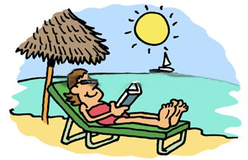

- When was the last time you had an accident?  (Cuándo fue la última vez que tuviste un accidente?)  - The last time I had an accident was three years ago.  (La última vez que tuve un accidente fue hace tres años) | 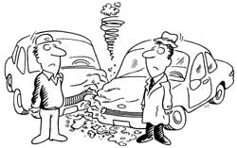

ACTIVIDAD
Indique la última vez que usted o una tercera persona realizó determinada acción (verbo en pasado), completando los espacios.
1. | The last time that | I |  | was | 1 year ago
2. | The last time that |  |  | Was
3. | The last time that | My best friend |  | Was
4. | The last time that |  |  | Was
5. | The last time that |  |  | Was | Last year
6. | The last time that |  |  | Was
7. | The last time that |  | Traveled by bus | Was
8. | The last time that |  |  | Was

In October | En octubre | 2 hours ago | Hace dos horas
Yesterday | Ayer | Last year | El año pasado
This morning | Esta mañana | Last month | El mes pasado
Last week | La semana pasada | Last weekend | El fin de semana pasado

BIBLIOGRAFÍA

Willis, D. (1991). Student’s grammar. Bungay, Suffolk: HarperCollins Publishers
CESDE, Centro de Estudios Especializados. (1998). English Booklet. Medellín
Pruebas de Estado (ICFES). 2006 A.

CIBERGRAFÍA

http://www.google.com.co/imghp?hl=es&tab=wi
http://www.edhelper.com/
http://www.enchantedlearning.com/Home.html

