CLEI | TIEMPO | NOMBRE DE LA GUÍA | PERIODO N° | ÁREA
Seis | 11 semanas | What have I done in my life? | Uno | Inglés

Periodo 01
Estándar | Escribir textos que explican mis preferencias, decisiones y actuaciones
Competencia | Lectura |  | Escritura
Comunicativa | - Asumir una posición crítica frente al punto de vista del autor  - Utilizar variedad de estrategias de comprensión de lectura adecuadas al propósito y tipo de texto | - Valorar la escritura como un medio de expresión de mis ideas y pensamientos, quién soy y qué sé del mundo.

FREQUENCY ADVERBS
Always | Siempre | Do you smoke?  No, we never smoke
Usually | Usualmente
Often | Con frecuencia
Sometimes | Algunas veces
Seldom | Pocas veces
Rarely | Raramente
Never | Nunca
SUBJECT + FREQUENCY ADVERB + VERB + COMPLEMENT

Los anteriores adverbios de frecuencia se colocan después del pronombre:
 | He always sleeps until noon  Él siempre duerme hasta el medio día

HOW OFTEN
Para preguntar por frecuencia se utiliza “how often”, significa: con qué frecuencia, cada cuánto, qué tan frecuente?
Después de esta “W” question, en la pregunta, se coloca el auxiliar de acuerdo al tiempo (do, does, did, will) + sujeto + verbo + complemento.

How often will you send activities? | ¿Con qué frecuencia enviará usted actividades?
How often do you work? | ¿Con qué frecuencia usted trabaja?
How often did you visit the dentist? | ¿Con qué frecuencia visitaba el odontólogo?
NEVER ON SUNDAY |  | 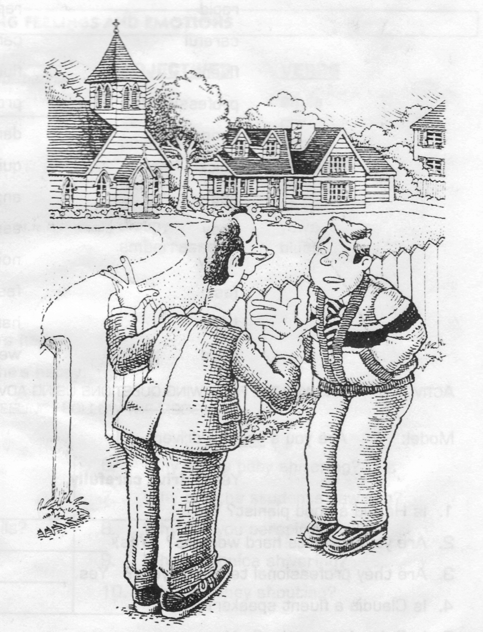
Reverend: | Oh!, hello, Mr. Benson.  I never see you in church nowadays.
Benson: | Oh, well, Reverend Wilson. That’s true, but my wife always goes to church.  She goes every Sunday.
Reverend: | I know, but you never come.
Benson: | Well, I rarely come . . . but I’m always there on Christmas and Easter.
Reverend: | But what about Sundays, Mr. Benson?
Benson: | Uh, I’m usually busy on Sundays. For example, I often wash my car on Sunday mornings.
Reverend: | I see. Why don’t you wash your car on Saturday next week?
Benson: | Oh. I can’t do that, Reverend.
Reverend: | Why not?
Benson: | It’s my son’s wedding day next Saturday.  I’m going to church!

 | ACTIVIDAD  Del anterior diálogo deduzca en tercera persona 5 situaciones, demostrando comprensión del tema a través del uso de sus propias palabras y utilizando los adverbios en el lugar correcto.
Reverend never sees Mr. Benson in church. |  | El reverendo nunca ve al señor Benson en misa
- En el anterior ejemplo se aprecia el mismo orden de la oración inicial, sólo se cambia de sujetos, adjetivos posesivos y conjugación verbal.
- Cuando hay verbo to be en la oración el adverbio de frecuencia se coloca después de éste:
His wife is always in mass (su esposa siempre está en misa)
CITY AND COUNTRY
Chris:  Jeff:  Chris:  Jeff:  Chris:  Jeff:  Chris:  Jeff:  Chris:  Jeff:  Chris:  Jeff:  Chris:  Jeff:  Chris:  Jeff:  Chris:  Jeff:  Chris:  Jeff:  Chris:  Jeff: | Jeff! I’ve got a new job! I’m going to live in New York.  You are? I lived in New York five years ago.  Did you like it?  Not very much.  Why not?  Well, there were too many people, and there was too much noise.  I love crowds and noise!  Well, I don’t. And I don’t like pollution.  What do you mean?  There isn’t enough fresh air in New York.  But you can go to concerts and the ballet and Broadway…  Who has enough money for all that?  And the rents are very high.  Why is that?  Because there aren’t enough apartments.  I still prefer big cities.  But why?  I was born in a small town. It was too quiet and too dull.  You were lucky.  I don’t think so. There wasn’t much to do. That’s why young people go to New York.  But New York is too expensive for young people  But they still go. They want excitement.  Well, I don’t want excitement. I just want a quiet life. That’s all. | 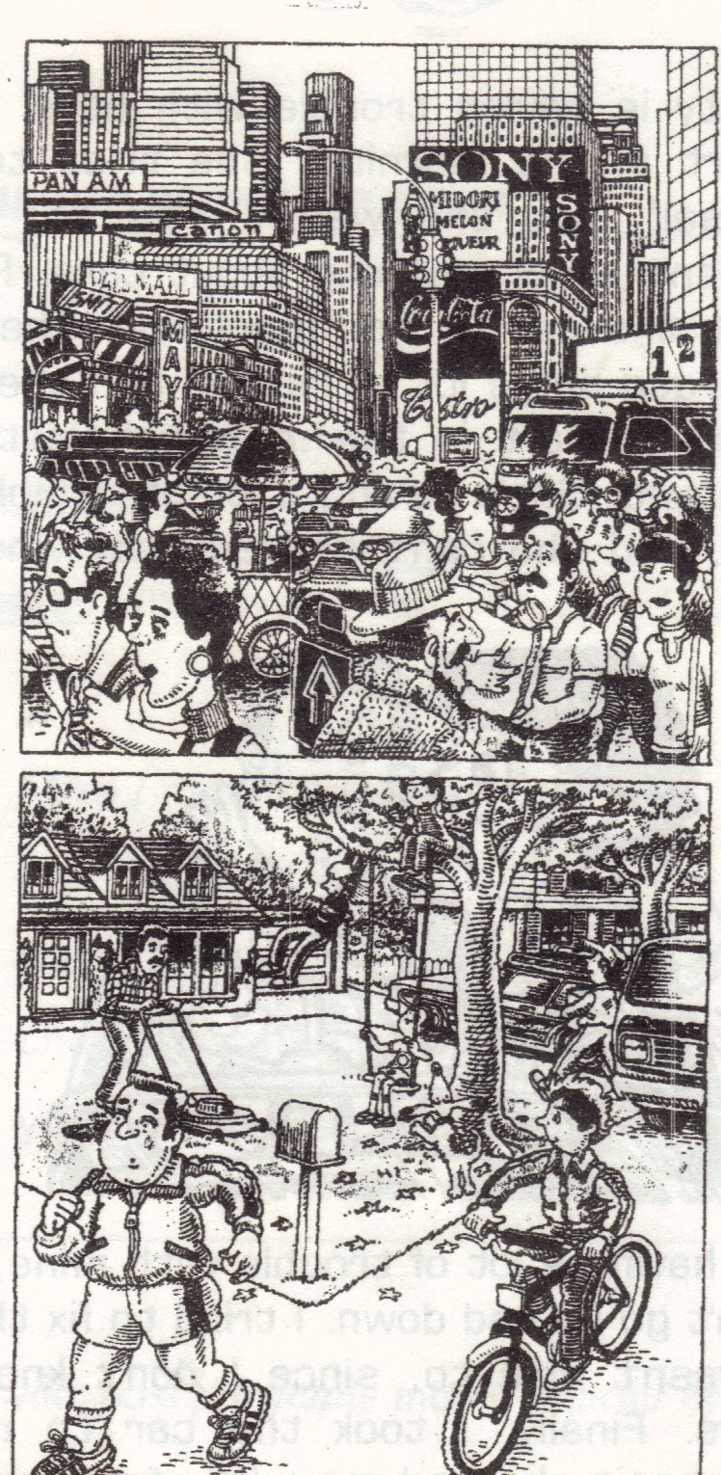
De acuerdo al anterior diálogo se puede deducir que:

Jeff doesn’t like New York: a Jeff no le gusta Nueva York
Apartments in New York are expensive: Los apartamentos en New York son costosos:
ACTIVIDAD
De acuerdo con las características de cada personaje y los lugares empleados en el diálogo, marque una X en el espacio adecuado, así:

1. Oraciones que comiencen con el pronombre HE pertenecen a Jeff o Chris.
2. Oraciones o frases que contengan adjetivos o adverbios pertenecen a New York o a small town.
Characteristics | Jeff | Chris | New York | A small town
He Lived in New York | X
Cheap rents
He doesn’t like cities
Young people prefer
He doesn’t like quiet life
Too much pollution
Fresh air
Expensive life
Not much to do
He has a new job
He can go to concerts
Too quiet

THE PRESENT PERFECT TENSE

El tiempo presente perfecto se emplea para hablar de una acción que empezó en el pasado y todavía no ha terminado o tiene un efecto en el presente: usted ya ha llegado y se encuentra aún en ese lugar.
Se construye con el verbo “haber” (have/has) + el participio del verbo (arrived):
I  You  We  They | have
He  She  It | has

I have slept: yo he dormido

Para realizar oraciones en este tiempo es necesario identificar la conjugación del verbo “haber”, que es igual al verbo “tener”:

De esta manera conjugamos el verbo “haber”: yo he, tú has, él ha, nosotros hemos, vosotros habéis, ellos han. Después se escribe el verbo en participio, es decir, las terminaciones ado-ido del español: hablado, cantado, dormido, leído, estudiado… aunque algunas son irregulares: so, to y cho: dicho, satisfecho, muerto, impreso…

En inglés los verbos se clasifican en regulares e irregulares:

Regulares: son los que al escribirse en pasado y participio se les agrega ed:
verbo | presente | pasado | participio
vivir | live | lived | lived

Irregulares: son los que cambian su escritura en pasado y participio:
verbo | presente | pasado | participio
escribir | write | wrote | written

El verbo, entonces, sólo tienen tres formas de escritura en inglés: presente, pretérito y participio. El futuro se forma agregando WILL + el verbo en presente.
En unidades anteriores hemos trabajado presente y pretérito, ahora veremos el participio para formar el presente perfecto.
Se llaman tiempos perfectos los que llevan verbo “tener” + verbo en pasado participio:
Se puede observar en los siguientes ejemplos que de acuerdo al sujeto se escribe HAVE o HAS, luego el verbo en su tercera forma:

it has rained too much |  | Ha llovido mucho
I have sent my homeworks |  | Yo he enviado mis trabajos

THE PRESENT PERFECT TENSE

Identifique la conjugación del verbo “haber” y el uso de verbos regulares e irregulares:

I’m an employee of the Goodwell Computer Company. This is a typical Friday afternoon at our office. All the employees are working overtime. We haven’t gone home because we haven’t finished our work yet. Friday is always a very busy day.
The secretary still hasn’t typed two important letters. The bookkeeper hasn’t written all the paycheck. The office clerks haven’t delivered all the mail, and the boss still hasn’t talked to three important people who are waiting to see him.
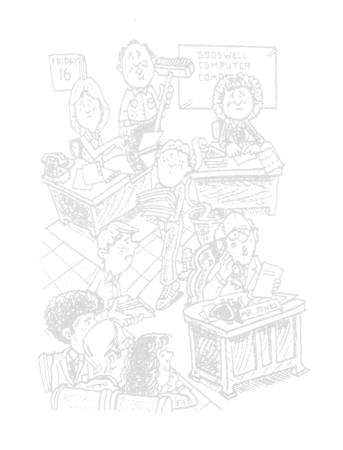
As for me, I’m the custodian, and I haven’t finished my work yet either. I still haven’t cleaned all the offices because my co-workers haven’t gone home yet! I’m not really surprised. Friday is always a very busy day at our office.
PRESENT |  | SPANISH | PAST | PARTICIPLE |  | PRESENT | SPANISH | PAST | PARTICIPLE
Answer |  | Responder | Answered | Answered |  | Lose | Perder | Lost | Lost
Arrive |  | Llegar | Arrived | Arrived |  | Make | Hacer | Made | Made
Ask |  | Preguntar | Asked | Asked |  | Mean | Significar | Meant | Meant
Begin |  | Comenzar | Began | Begun |  | Meet | Encontrar | Met | Met
Believe |  | Creer | Believed | Believed |  | Open | Abrir | Opened | Opened
Break |  | Romper | Broke | Broken |  | Pay | Pagar | Paid | Paid
Bring |  | Traer | Brought | Brought |  | Play | Jugar | Played | Played
Buy |  | Comprar | Bought | Bought |  | Read | Leer | Read | Read
Call |  | Llamar | Called | Called |  | Ride | Montar | Rode | Ridden
Catch |  | Atrapar | Caught | Caught |  | Run | Correr | Ran | Run
Choose |  | Escoger | Chose | Chosen |  | Say | Decir | Said | Said
Clean |  | Limpiar | Cleaned | Cleaned |  | See | Ver | Saw | Seen
Close |  | Cerrar | Closed | Closed |  | Sell | Vender | Sold | Sold
Come |  | Venir | Came | Come |  | Send | Enviar | Sent | Sent
Cook |  | Cocinar | Cooked | Cooked |  | Shut | Gritar | Shut | Shut
Cost |  | Costar | Cost | Cost |  | Sing | Cantar | Sang | Sung
Do |  | Hacer | Did | Done |  | Sit | Sentarse | Sat | Sat
Drink |  | Beber | Drank | Drunk |  | Sleep | Dormir | Slept | Slept
Drive |  | Conducir | Drove | Driven |  | Speak | Hablar | Spoke | Spoken
Eat |  | Comer | Ate | Eaten |  | Spend | Gastar | Spent | Spent
Fall |  | Caer | Fell | Fallen |  | Stand | Pararse | Stood | Stood
Feel |  | Sentir | Felt | Felt |  | Start | Comenzar | Started | Started
Find |  | Encontrar | Found | Found |  | Steal | Robar | Stole | Stolen
Fix |  | Reparar | Fixed | Fixed |  | Swim | Nadar | Swam | Swum
Fly |  | Volar | Flew | Flown |  | Take | Tomar | Took | Taken
Forget |  | Olvidar | Forgot | Forgotten |  | Talk | Hablar | Talked | Talked
Get |  | Conseguir | Got | Gotten |  | Teach | Enseñar | Taught | Taught
Give |  | Dar | Gave | Given |  | Tell | Contar | Told | Told
Go |  | Ir | Went | Gone |  | Think | Pensar | Thought | Thought
Have |  | Tener | Had | Had |  | Travel | Viajar | Traveled | Traveled
Help |  | Ayudar | Helped | Helped |  | Wait for | Esperar | Waited for | Waited
Hold |  | Abrazar | Held | Held |  | Wake up | Despertar | Woke up | Waken up
Know |  | Saber | Knew | Known |  | Watch | Ver | Watched | Watched
Leave |  | Dejar | Left | Left |  | Wear | Ponerse | Wore | Worn
Listen |  | Escuchar | Listened | Listened |  | Win | Ganar | Won | Won
Live |  | Vivir | Lived | Lived |  | Write | Escribir | Wrote | Written
Los anteriores son verbos irregulares, ya que su escritura cambia en los diferentes tiempos.
Al igual que con el verbo “tener”, el verbo haber” se puede escribir de forma contracta así:
I  You  We  They | ’ve | seen a movie recently | I’ve gone to that park before.
I  You  We  They | ’ve | seen a movie recently | I haven’t gone to that park before.
I  You  We  They | ’ve | seen a movie recently | Have I gone to that park before?
He  She  It | ’s | seen a movie recently | Janet has worked for a long time.
He  She  It | ’s | seen a movie recently | Janet hasn’t worked for a long time.
He  She  It | ’s | seen a movie recently | Has Janet worked for a long time?

HAVE / HAS son verbos auxiliares, por esto se puede negar o preguntar con éstos mismos.
ACTIVIDAD
Complete los espacios con los verbos HAVE o HAS según el caso y un segundo verbo en pasado participio que mejor se acomode a la oración.
1. | Nancy |  |  | her boyfriend 3 times this week.
2. | Your sister |  |  | a job?
3. | I |  |  | at that restaurant before.
4. | it |  |  | a lot this month.
5. | We |  |  | English for several months.
6. | Gabriel García Márquez |  |  | many good novels.
7. | you |  |  | the lottery
8. | My sister |  |  | a horse in the farm.
9. | My classmates |  |  | many mistakes on the exam.
10. | My friends and I |  |  | champagne at the parties.
11. | Many of my friends |  |  | their arms or legs once or twice.
12. | Colombian national team |  |  | several soccer games.
13. | My father |  |  | too many these days.
14. | My dog |  |  | me three times this month.
15. | I |  |  | many friends in my life.
16. | That girls says that she |  |  | me before.
17. | Cibercolegio |  |  | a good place to study.
A VERY DEDICATED DOCTOR
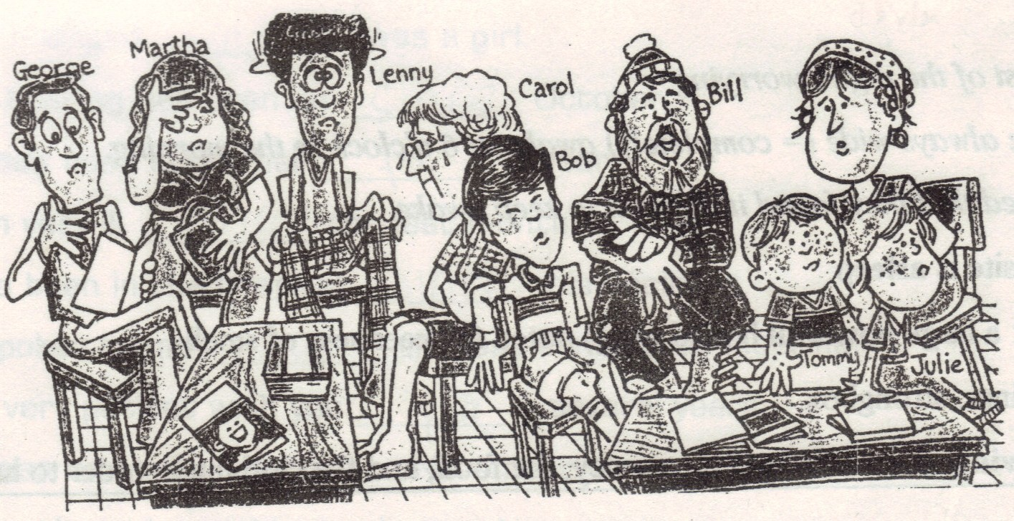
1. Dr. Fernando’s waiting room is very full today. A lot of people are waiting to see him, and they’re hoping that the doctor can help them. George’s neck has been stiff for more than a week. Martha has had a headache since yesterday, and Lenny has felt dizzy since early this morning. Carol has had a high fever for two days. Bob’s knee has been swollen for three weeks, Bill’s arm has been black and blue since last week, and Tommy and Julie have had little red spots all over their bodies for the past twenty-four hours.

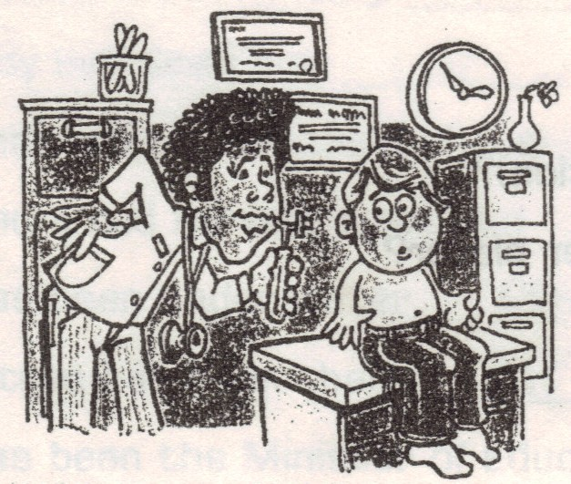 | 2. Dr. Fernando has been in the office since early this morning. He has already seen a lot of patients, and he will certainly see many more before the day is over. Dr. Fernando’s patients don’t know it, but he also isn’t feeling very well. He has had a pain in his back since last Thursday, but he hasn’t taken any time to stay at home and rest. He has had a lot of patients this week, and he’s a very dedicated doctor.

ACTIVIDAD
Identifique las diferentes situaciones de la historia y dé respuesta a éstas de acuerdo al tiempo (presente perfecto/progresivo) y forma de la pregunta (gerundio/simple)
Why isn’t the doctor feeling well?
When are the patients waiting for the doctor?
What has happened with Lenny?
What does the underlined word “him” refer to?
What does the underlined word “them” refer to
Why hasn´t the doctor stayed resting at home?
Why do you think he is a dedicated doctor?
How often does the doctor work?
Where are there many patients?
How is Dr. Fernando feeling?

SINCE AND FOR
I have worked since I was a boy.
SINCE:  desde | Indicates “from then until now”  Indica “desde ahora hasta entonces”
FOR:  por | Indicates “during the continuance of”  Indica “durante la continuación de”
FOR |  | SINCE
Five years  Four hours  Seven hours  A long time |  | Eight o’clock  Last week  Yesterday evening  1983



ACTIVIDAD
De las 20 opciones que se dan a continuación, seleccione 10 de ellas y complételas con SINCE o FOR, anexe además su traducción al español. Observe el uso del presente perfecto a través de los auxiliares HAVE/HAS y el uso del participio:

- He has been in prison for a year.
Él ha estado en prisión por un año
- I’ve known that _____ a long time.
- She has driven the same car _____ 1975.
- Things have changed _____ I was a baby.
- That trunk has been on the hall _____ a year.
- He has been very ill _____ the last month.
- Mr. Pitt has been in the hospital _____ his accident.
- He hasn’t spoken to me ____ the last committee meeting.
- I have been very patient with you _____ several years.
- They have been on strike _____ November.
- The strike has lasted _____ six months.
- I’ve been watching TV _____ four o’clock.
- I’ve been working _____ a long time.
- We’ve had no gas _____ the strike began.
- Nobody has seen him _____ four days.
- He has been under water _____ half an hour.
- That tree has been there ____ 2.000 years.
- He has been the Minister of Education _____ 1999.
- We’ve had terrible weather _____ the last month.
- Nobody has come to see us _____ we bought these bloodhounds.
 | WHERE HAS HE GONE?
Nancy: | Janet, what´s the matter?
Janet: | It’s my husband. He’s gone.
Nancy: | Gone? Where has he gone?
Janet: | He’s gone to Acapulco.
Nancy: | Oh, Janet. You poor thing! I’m so sorry. Has he gone with . . . with another woman?
Janet: | What? Of course not. He hasn’t gone with another woman. He’s gone there on business.
Nancy: | When is he coming back?
Janet: | Tomorrow.
Nancy: | I don’t understand. Why are you crying?
Janet: | I miss him.
Nancy: | Look, Janet, there’s a movie at the theater downtown . . . “Star Wars-Five”.
Janet: | Yes?
Nancy: | Well, stop crying and let’s go and see it.

En el anterior diálogo se observan oraciones en diferentes tiempos:
- Presente perfecto pregunta: where has he gone?
- Presente progresivo pregunta: when is he coming?
- Presente simple negación: I don’t understand
- Presente perfecto negación: he hasn´t gone with another woman
- Presente simple pregunta: what’s the matter?

Con la práctica reconocemos que las preguntas tienen el mismo orden, sólo es necesario identificar el auxiliar de cada tiempo, el cual se utiliza también en negaciones, de esta manera damos respuestas acordes a lo que nos solicitan basados en textos, diálogos, etc.
NOTA: El verbo to be siempre funciona como auxiliar (is, are, am, was, were)
MY LIFE
 | I have been a good student.  I have studied in different schools, and Ciberschool has been a very nice experience.  I have lived in a big city with my parents; they have lived happily married for 35 years.  I have one brother and one sister. My brother has been a teacher and my sister has worked as a secretary.  I haven’t married because I haven’t had the opportunity to have a good job, but I’m studying to be an excellent professional.  My life has been pleasant because I have had a great family and wonderful friends. They have taught me how to enjoy every day.
TITLE
I have . . .

ACTIVIDAD
A través del presente perfecto, apoyado en otros tiempos como pasado y presente simple, describa lo que ha sido su vida, familia, estudio, y demás similares al ejemplo, de una manera amplia, empleando creatividad y conceptos gramaticales estudiados en la unidad.
Anexe un título a su historia.

BIBLIOGRAFÍA

Willis, D. (1991). Student’s grammar. Bungay, Suffolk: HarperCollins Publishers
CESDE, Centro de Estudios Especializados. (1998). English Booklet. Medellín
Pruebas de Estado (ICFES). 2006 A.

CIBERGRAFÍA

http://www.google.com.co/imghp?hl=es&tab=wi
http://www.edhelper.com/
http://www.enchantedlearning.com/Home.html

There was: hubo (para singular) para el plural se utiliza there were
There isn’t: no hay
Too: demasiado
That´s why: por eso es que
That’s all: eso es todo

