ACTIVIDADES EVALUATIVAS
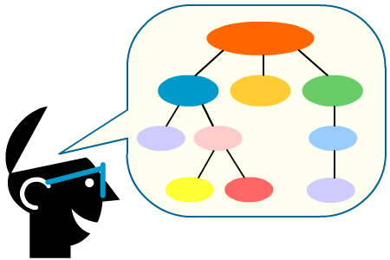

CONCEPTUALIZACION

1. Con la ayuda de tus familiares investiga para que se utiliza el computador en las siguientes partes:

En mi casa el computador se utiliza para: __________________
______________________________________________________
______________________________________________________
______________________________________________________
______________________________________________________
______________________________________________________
______________________________________________________
En el hospital los computadores se utilizan para: ____________
______________________________________________________
______________________________________________________
______________________________________________________
______________________________________________________
______________________________________________________
En la biblioteca se utilizan los computadores para: ___________
______________________________________________________
______________________________________________________
______________________________________________________
______________________________________________________
______________________________________________________
______________________________________________________
En el banco los computadores los usan para: ________________
______________________________________________________
______________________________________________________
______________________________________________________
______________________________________________________

- Encuentra en la siguiente sopa de letras diez partes del hardware de un computador, explica con tus propias palabras cuál es la utilidad que presenta cada una de esas partes señaladas.

E | U | K | S | E | G | L | V | N | U | H | K | T | N | X | A | F | R | A | U
R | N | A | M | S | M | P | P | P | W | Q | J | U | R | A | R | R | P | N | A
R | M | F | T | U | G | H | N | X | Y | A | C | F | D | E | O | R | O | D | J
O | U | K | I | O | Y | R | D | G | A | R | I | U | S | Q | S | Z | T | K | D
T | P | S | U | M | S | C | J | N | E | R | A | Q | T | Y | E | D | S | L | D
O | R | P | T | P | L | O | F | G | H | O | X | E | K | K | R | E | I | J | D
P | O | S | Q | Z | S | U | U | K | B | W | C | O | S | J | P | F | T | R | E
F | C | U | E | P | Q | L | H | J | W | L | Z | Y | O | W | M | M | K | Q | B
D | E | P | H | T | A | Q | W | I | A | R | Z | O | J | N | I | R | Z | Q | E
N | S | M | P | D | N | K | W | D | G | T | O | S | G | C | U | U | I | X | N
Q | A | V | O | O | K | A | O | Y | N | S | Z | V | R | V | Z | C | E | B | T
S | D | R | Z | X | O | M | L | K | W | N | I | O | Q | Y | C | K | L | V | W
C | O | O | A | X | O | R | I | R | D | I | F | J | W | C | A | M | T | W | W
V | R | N | G | Q | V | T | H | S | A | O | Q | R | V | P | P | D | R | K | P
E | P | Y | F | C | Z | O | J | Q | N | P | I | Y | D | S | I | J | W | W | B
W | J | P | L | D | S | J | W | O | E | W | H | F | R | X | U | C | F | D | U
E | Z | B | Q | A | Q | S | B | Y | N | F | L | I | Y | Q | L | X | W | B | O
R | O | T | I | N | O | M | P | X | Y | I | K | G | P | M | T | F | E | N | Q
R | E | N | A | C | S | E | W | P | L | Q | W | Y | T | S | O | B | V | M | P
I | H | O | G | U | V | K | O | L | G | F | J | W | S | Z | T | Y | G | G | N

