Student’s name: |  | Date:



Watch and listen to this information, and complete (1). Then complete (2) with your own personal data.

Andres´ personal information

1

Name:

Last name:

Nickname:

Age:

Date of birth:

Place of birth:

Hobby:

Likes:

Your personal information

2

Name:

Last name:

Nickname:

Age:

Date of birth:

Place of birth:

Hobby:

Likes:





Interview a family member (father, mother, sister, brother), using the 8 questions on the following video: http://ucn.adobeconnect.com/p8esb25ktg4/ and then write the answers:

Family member: (dad, sister…..)
Questions | Answers
1. What’s your name?  2.  3.  4.  5.  6.  7.  8. | My name is . . .

Write a short dialogue using expressions from the lesson:
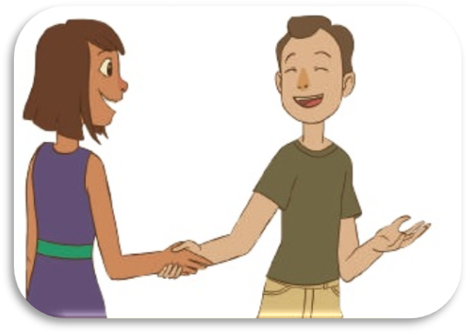
A
B
A
B
A
B
A
B
A
B


Here are some family members (as well as some countries and nationalities)


From the list above choose the family members according with their gender, and add the ones you know (try to add as many as possible)

Male | Female | Plural
Father

Read about Valery’s family and complete her family tree.

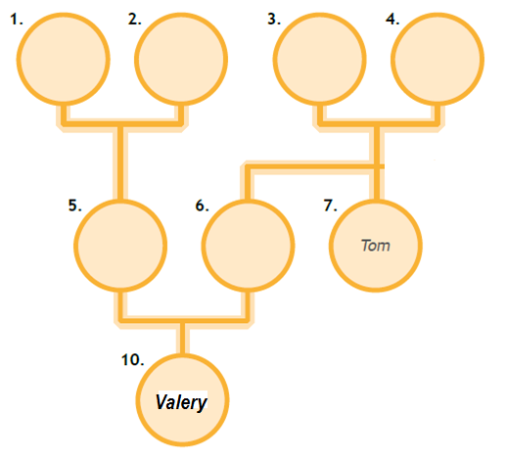

Hello, I´m Valeria and this is my family tree. My parents are Andrés and Ximena. They are great parents, I´m an only child. Alvaro and Maria Isabel are my mom´s parents so they are my grandma and my grandpa, and Hector and Consuelo also are my grandparents because they are my dad´s parents. My dad has a brother; his name is Tom. He is my uncle.

By Valeria Velásquez – Cibercolegio student - 2016

