Student’s name: |  | Date:

From the list, drag and drop the food you like and the food you do not like.

I like | I don’t like
What time do you have these meals? Complete with the time and the meals you eat.

A | I eat breakfast at in the morning. | I eat
B | I eat lunch at in the afternoon. | I eat
C | I eat dinner at in the evening. | I eat
D | In my free time at | I eat


Listen to this dialogue, identify what Kelly and Matt like and do not like. (TRACK 65)

Ask some of your family members what they like or do not like eating. Follow the example:

Who. . .

doesn’t like bread? |  | has fish for lunch?
prefers juice to coffee? |  | thinks vegetables are good for you?
always has a big breakfast? |  | doesn’t like chicken?
buys an apple for a snack? |  | loves chocolate?
eats salad for lunch? | My dad | eats four meals a day?

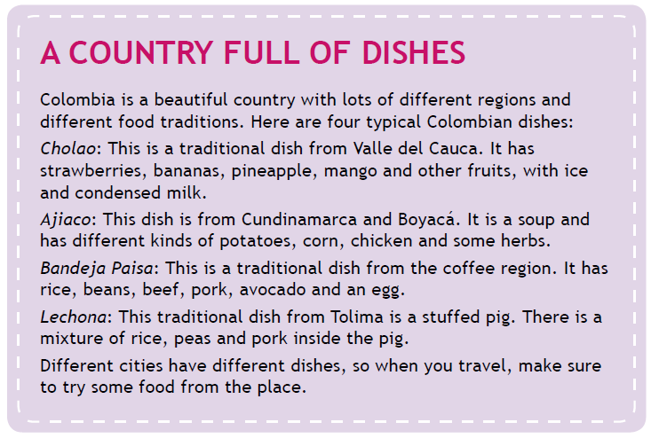
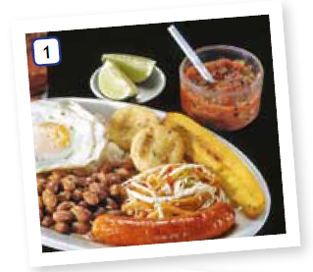

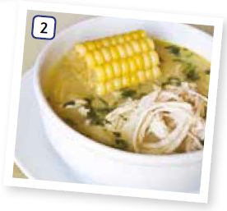

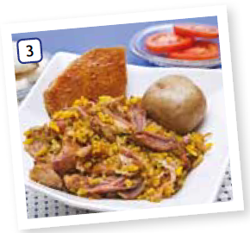



Read the previous text and complete the description of three dishes:

Name: Cholao  Place:  Ingredients: | Name:  Place:  Ingredients: rice … | Name:  Place: Boyacá  Ingredients:

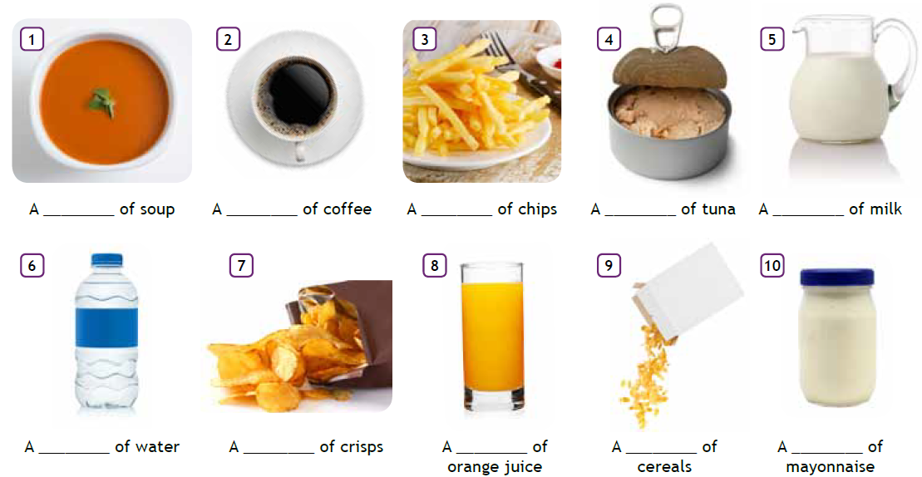
Find the meaning of the words in the box and complete the descriptions:
glass

bottle bowl packet cup glass plate box tin jar jug

Identify the following fruits

De la lecture, identifique los cuidados de aseo, rutinas

Reconozca con qué frecuencia

Comida, frutas, entrevisa a los papás a quienes le sgusta, a quiéne son.
Foto a refigerador y describir mercado
Cuidado personal
96: encuesta, formar oracones: I never eat…
97: a glass of, a pavket of
11 rutina

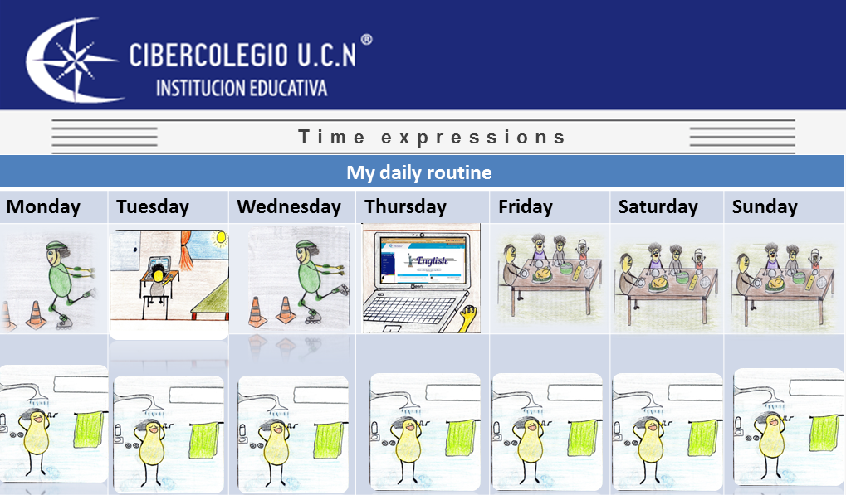

Watch the video and identify how to use some time expressions and adverbs of frequency.

Images by Alejandra and Mateo Castañeda – Ciberschool students - 2015

Explanation by Diego Piedrahíta – English Teacher – 2016


This video is about a daily routine by one of our partners.

You will learn how to describe what you do every day, and also the importance of healthy habits such meals and free time activities.

By Valentine Sánchez – Cibercolegio student - 2015
https://www.youtube.com/watch?v=m4dFJ_jcI7g

After watching the previous video about Valentina’s daily routine, answer:

How often does she take a shower?
Answer:
What does she eat for breakfast?
Answer:
Why does she work out?
Answer:
What’s her favorite soccer team?
Answer:
What does she do in her free time?
Answer:
What does she eat for dinner?
Answer:
What free time activities do you do every day?
Answer:

