Student’s name: |  | Date:

In 2012 Sandra Victoria, a Cibercolegio student, predicted what would happen by 2050. Do you agree/disagree with her? Use some of the following options to state your points of view (Follow the example):
I disagree with Sandra. I am sure that flying cars will be very expensive, and so buses, taxis and current automobiles will exist by 2050.
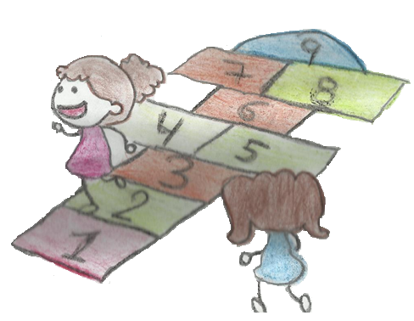

- I (really) think that . . .
I agree with Sandra. In my opinion families will be smaller than now, because life will be very expensive.
- I believe (that) . . .
- I’m sure that . . .
- In my opinion / my opinion is . . .
- I agree with . . .
- I disagree with . . .
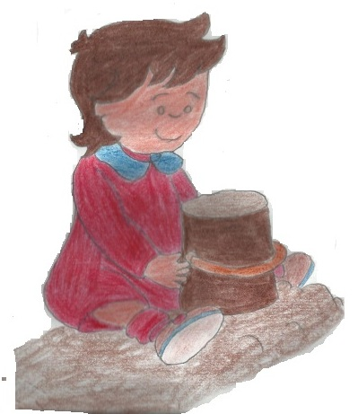
- I guess / imagine . . .
- I have no doubt that . . .
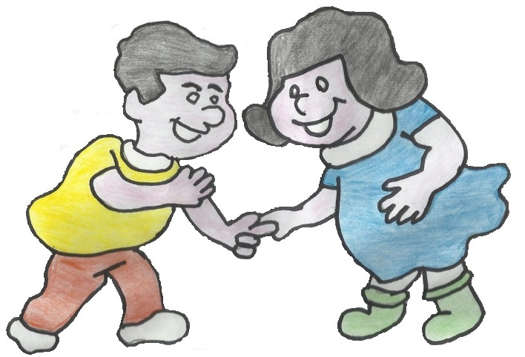
- I strongly believe that . . .

By 2050 the study will be by internet and learners will study from their houses. But houses will be smaller and families will have only one child.

There will be flying cars and the buses, taxis, motorbikes and trucks will disappear, because the new means of transportation will be aerial.

The families will have better living conditions thanks to internet and many other electronic devices, but there will be too much pollution because people don’t care the planet.

These are my opinions:
____________________________________________________________________________________________________________________________________________________________________________________________________________________________________________________________________________________________________________________________________________

Interview one of your parents (or family member) about how the community, neighborhood, city or country has changed in terms of natural resources and care for the planet. Then write comparative sentences.

Follow the example:

Leading questions:
- Did people protect the planet more than now?
- Does Colombia have more natural resources than before?
- Do we really save water?

Comparative and superlative sentences:
- People were more respectful and responsible with the environment than now.
- Colombia was one of the richest countries in water supply.
http://media.wix.com/ugd/da6c03_d5e85d2341344780a8e604804d9f54ce.pdf (examples)
These are my leading questions conclusions (comparative and superlative):

- Leading questions 1:
- Leading questions 2:
- Conclusion 1:
- Conclusion 2:
- Conclusion 3:
- Conclusion 4:
- Conclusion 5:
- Conclusion 6:
- Conclusion 7:

Which of the following predictions do you think will come true? Explain your reasons
- People will be much healthier.
- Forests will disappear.
- There will be more floods.
- People will live longer.
- There will be less pollution.
- The world will be cleaner.
- More animals will become extinct.
- Houses and apartments will be smaller.
- People won’t eat meat.
- People won’t be able to breathe outside.
- I think forest will disappear because people don’t protect……

Record your voice: http://vocaroo.com/
Link (recording):

Write a survey to identify how people in your school, house and neighborhood protect the planet and save water: (1: never 2: rarely 3: sometimes 4: usually 5. Always)
Complete their answers.

Example:
 | Do you turn off the faucet while you brush your teeth?
 | 1 | 2 | 3 | 4 x | 5
2.
 | 1 | 2 | 3 | 4 | 5
 | 1 | 2 | 3 | 4 | 5
 | 1 | 2 | 3 | 4 | 5
 | 1 | 2 | 3 | 4 | 5
 | 1 | 2 | 3 | 4 | 5

