Student’s name: |  | Date:



Listen to some people describing places in Colombia- which words do they use? (TRACK 86)
Write the words you listen to.

A | Sierra Nevada de Santa Marta
B | The Magdalena River
C | The Orinoco
D | Chocó Rainforest
E | Colombian coastlines
F | Volcanoes in Colombia

Listen again and complete the sentences with the correct words:

colder | colorful | dangerous | highest | longest | warmer | wettest | wide

- The Sierra Nevada de Santa Marta is the world’s __________ coastal mountain range. | d. Chocó, in the north west of Colombia, is one of the world’s _________ rainforests.
- It is a __________ river, which runs from south to north ending in the city of Barranquilla. | e. the Pacific Ocean is __________ and wilder, but the Caribbean sea is __________ calmer and more __________.
- The Orinoco is one of the __________ rivers in South America. | f. Galeras is one of the most __________ volcanoes in the world.

To reflect!

Approximately how much water do you use when you . . .

1. | Flush the toilet? | 4. | Do the laundry in a washing machine?
 | - 5 – 10 liters  - 10 – 20 liters  - 20 – 30 liters |  | - 30 – 40 liters  - 50 – 100 liters  - 100 – 150 liters
2. | Take a 10-minute shower? |  | - 30 – 40 liters  - 50 – 100 liters  - 100 – 150 liters
 | - 40 liters  - 70 liters  - 100 liters | 5. | Where do you think we use most water at home? Put the following in order
3. | Do the washing-up for 5 minutes? |  | - Doing the laundry  - Cleaning the kitchen  - Preparing food  - In the bathroom
- 10 liters
- 20 liters
- 30 liters


How often does Tania, and her family, use water? Write the activities in the correct column (TRACK 89):
 |  | Interviewer: | Tania, tell us about how you and your family use water. What do you do every day that uses water?
 |  | Tania: | Well, I drink a lot of water – about eight glasses of water every day. My parents prepare the meals every day, and my sister and I do the washing-up.
 |  | Interviewer: | Do you have a shower every day?
 |  | Tania: | I have a shower twice a day! In the mornings and in the evenings, because I go running in the evenings. But I don’t wash my hair every day. I do that four times a week. There’s a bath in our bathroom, but I never have a bath.
 |  | Interviewer: | What about the weekends?
Tania: | My mom does the laundry at the weekends. So I guess that uses a lot of water. Also, my dad washes his car every weekend. But we live in an apartment and we don’t have a garden, so we never use water to water the plants.
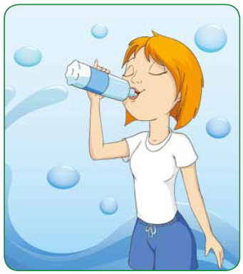

Every day | Twice a day | 4 times a week | Never | At weekends
Drink 8 glasses of water

Tell your teacher how often you use water. Use the box to help you.

I drink water about 5 times…..

Useful expressions

Once a day / week / month

Twice a day / week / month

Three times a day / week /…

Every weekend

Every morning

Read the next predictions and write them on the correct heading in the chart.
- People will be much healthier.
- Forests will disappear.
- There will be more floods.
- People will live longer.
- There will be less pollution.
- The world will be cleaner.
- More animals will become extinct.
- Houses and apartments will be smaller.
- People won’t eat meat.
- People won’t be able to breathe outside.
Positive predictions | Negative predictions

