Student’s name: |  | Date:



Read the story “This was my life” and identify some points of view:

- What did Diego use to do in the afternoons?

- What did he do in the mornings?

- Did Diego and his brother jump on numbers traced on the floor?

- Where did his sister use to play?

- Did Diego’s family and friends have internet service by 1980’s?

- Did you like the story? Why?

- Was your childhood similar to Diego’s?

- What do you think about this experience told by Diego?

- What games were practiced by Diego and his sister?

After reading the story mentioned, maybe you made a comparison between Diego’s childhood and yours. Which words do you remember from your childhood? Did you use internet when you were a child? – follow the examples:

From my childhood I remember these words:
Game, internet, social networks….

From Diego’s story, deduce 5 consequences of his childhood, after comparing it with current children – follow the example:

- Diego was happier than now because he enjoyed little things.
- Current children are passive because they do not exercise.

Devices improve our life quality.

Could you study at Cibercolegio if internet didn’t exist? The answer is “NO”. Internet has improved not only the access to knowledge, but also the communication among people living in different places.
Concerning knowledge, ICTs (Information and Communication Technologies) have allowed students to learn more easily by using different resources such as: video, text, audio, image, game…..
How will you use ICT for improving your life conditions? – go to “Learning Guide” and see the “time line” example, then answer, using your own words:

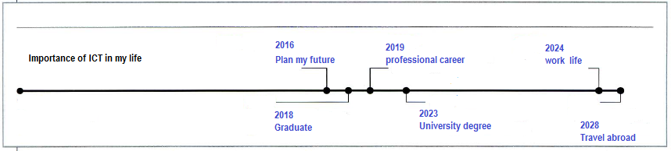
What will happen in . . .
2016
2018
2019
2023
2024
2028

