|  |  |  |  |  |  |
| --- | --- | --- | --- | --- | --- |
|  |  | |  | | |
| **ENGLISH**  BEGINNERS  Session 4  ---------------------------------------------------------  «Family members» | | |
|  | | |
| INTRODUCTION | | | |  |  |
|  | |  | * You need to learn how to talk about your family members. | | |

­­

**FAMILY MEMBERS**

**Learn some family members:**

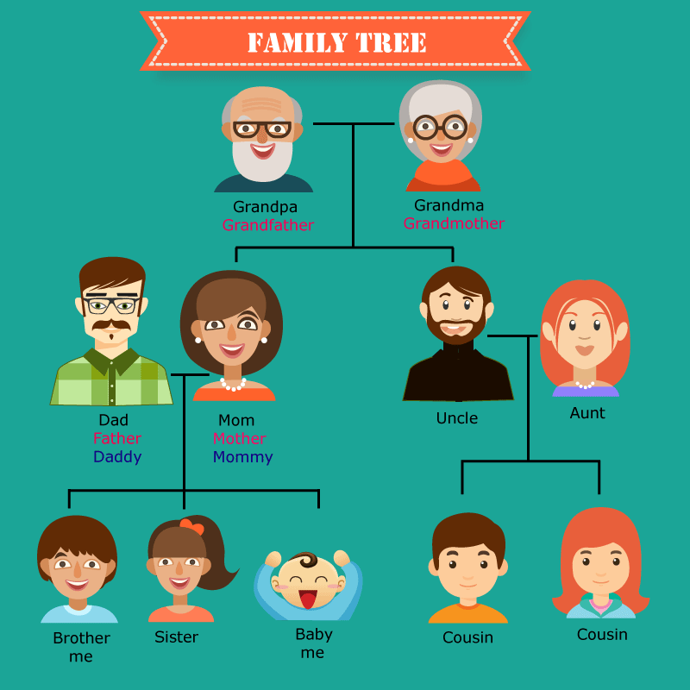

|  |  |
| --- | --- |
|  | **Exercise:** [**Click here**](http://www.english-time.eu/hry/family-tree.php?zpet=dite) |

**HOMEWORK**

* **Hacer una presentación con fotos de tu familia y el nombre correspondiente.**

|  |  |
| --- | --- |
| Photo | Photo |
|  |  |
| Photo | Photo |
|  |  |
| Photo | photo |
|  |  |

|  |  |  |
| --- | --- | --- |
| BIBLIOGRAPHY |  |  |

|  |  |
| --- | --- |
|  | * <http://www.english-time.eu/hry/family-tree.php?zpet=dite> * <http://www.dreamstime.com/photos-images/family-tree.html> |