|  |  |  |  |  |  |
| --- | --- | --- | --- | --- | --- |
|  |  | |  | | |
| **ENGLISH**  Beginners  ---------------------------------------------------------  Session 5. Parts of the body | | |
|  | | |
| INTRODUCTION | | | |  |  |
|  | |  | **Try to learn the parts of the body with the next song:**   |  |  | | --- | --- | |  | [**Click here**](https://www.youtube.com/watch?v=gxphoOOwTbo) | | | |

**TOPIC: PARTS OF THE BODY**

**Learn some parts of the body**

Use these labels to name the parts of the body.

**Head**

**Eye**

**Nose**

**Mouth**

**Shoulder**

**Neck**

**Arm**

**Hand**

**Elbow**

**Leg**

**Foot**

**Ancle**

**Knee**

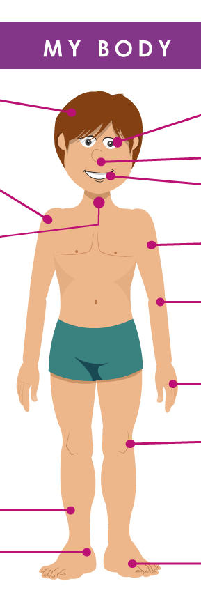

|  |  |
| --- | --- |
|  | **Resources**  [**Click here**](https://www.youtube.com/watch?v=QkHQ0CYwjaI)  [**Click here**](https://learnenglishkids.britishcouncil.org/sites/kids/files/attachment/flashcards-body.pdf)  **class**: **http://ucn.adobeconnect.com/p8d0gmbw70z/** |

**HOMEWORK**

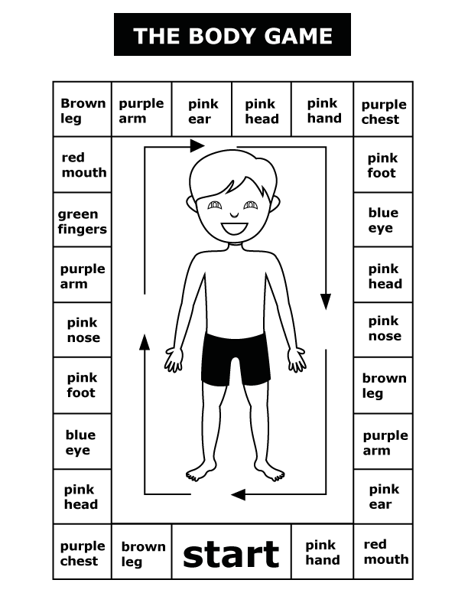

|  |  |  |
| --- | --- | --- |
| BIBLIOGRAPHY |  |  |

|  |  |
| --- | --- |
|  | * <https://learnenglishkids.britishcouncil.org/sites/kids/files/attachment/flashcards-body.pdf> |