|  |  |  |  |  |  |
| --- | --- | --- | --- | --- | --- |
|  |  | |  | | |
| **ENGLISH**  BEGINNERS  Session 6  ---------------------------------------------------------“What time is it?” | | |
|  | | |
| INTRODUCTION | | | |  |  |
|  | |  | * In this lesson, we are going to learn how you can say the time in English. Remember there are two common ways of telling the time and you can use the better for you. | | |

­­

**What time is it?**

**What's the time in English:**

There are two common ways of telling the time?

**»** **Formal but easier way:**

Say de hours first and then the minutes.

**Example:** 7:45 - seven forty-five

For minutes 01 through 09, you can pronounce the '0' as oh.

**Example:** 11:06 – eleven (oh) six

**» More popular way:**

Say the minutes first and then the hour.

**Example:** 7:15 – fifteen minutes past seven

Another possibility of saying '15 minutes past' is: a quarter past

Another possibility of saying '15 to' is: a quarter to

Another possibility of saying '30 past' is: half past

**Example**: 5:30 – half past five

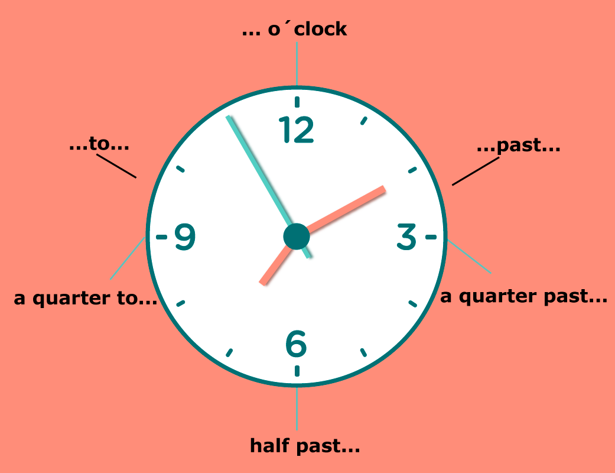

|  |  |
| --- | --- |
|  | **Examples :** [**Click here**](https://www.youtube.com/watch?v=ub62GCUMZZo) |

|  |  |
| --- | --- |
|  | **Activity :** [**Click here**](https://learnenglishkids.britishcouncil.org/en/games/whats-the-time) |

**HOMEWORK**

* **What time is it?**

|  |  |
| --- | --- |
| 10:30 |  |
| 2:15 |  |
| 4:45 |  |
| 7:35 |  |
| 5:28 |  |

|  |  |
| --- | --- |
|  | **Recording class:** [**Click here**](http://ucn.adobeconnect.com/p7re3he1pag/) |

|  |  |  |
| --- | --- | --- |
| BIBLIOGRAPHY |  |  |

|  |  |
| --- | --- |
|  | * <https://www.ego4u.com/en/cram-up/vocabulary/time> * <https://learnenglishkids.britishcouncil.org/en/games/whats-the-time> * [http://ucn.adobeconnect.com/p7re3he1pag/](http://ucn.adobeconnect.com/p7re3he1pag/?OWASP_CSRFTOKEN=07a473c583adf4d6a6c0954f3e459d1617e5fc120f9f9544023a23cf1b216e91) |