
ENGLISH
BEGINNERS
Session 7
---------------------------------------------------------“My daily routine”
INTRODUCTION |  |  |  |  | 
 |  |  | - In this lesson, we are going to learn how you can talk about your daily routine.

My daily routine
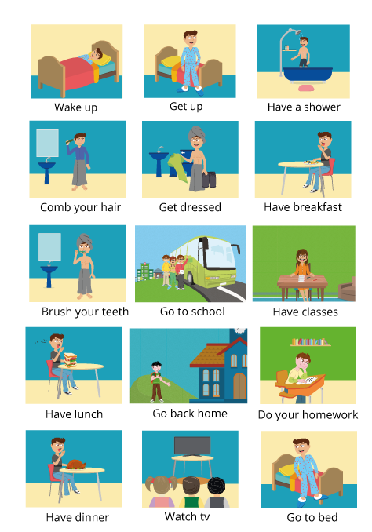

 | Flashcards: Click here

Examples:

» I wake up at 6.30 a.m.
» I have a shower at 7 a.m.
» She goes to school at 8.00 o’clock
» They have classes from 9 a.m. to 2 p.m.

Activity: Click here

Activity: Click here

Activity: Click here

HOMEWORK
Make a PowerPoint presentation with seven (7) sentences and pictures (better photographs) about your daily routine.

Recording class: Click here

BIBLIOGRAPHY
 | »https://learnenglishkids.britishcouncil.org/sites/kids/files/attachment/flashcards-daily-routines.pdf  »https://learnenglishkids.britishcouncil.org/en/word-games/daily-routines  »http://enjoyenglish.free.fr/english/primaire/concentration/athome2/athome_.html  »http://www.eslgamesplus.com/time-and-daily-routines-esl-interactive-board-game/

