
ENGLISH
BEGINNERS
Session 8
---------------------------------------------------------“The weather”
INTRODUCTION |  |  |  |  | 
 |  |  | - In this lesson, we are going to learn how you can talk about the weather. You can answer the question:  “What is the weather like?”

The weather
  Sunny | 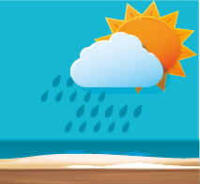  Rainy
  Cloudy |   Snowy

  Windy | 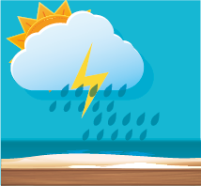  Stormy
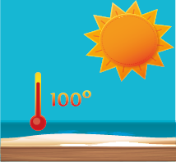  Hot | 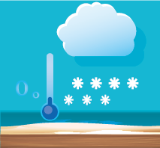  Cold

 | Video: English for kids Lessons Weather what’s the weather like.

Activity:

HOMEWORK
Weather Draw! - Draw the weather


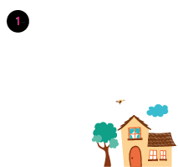 | 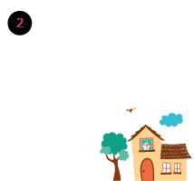
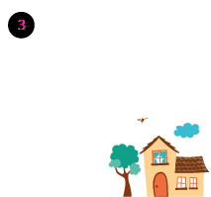 | 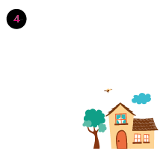
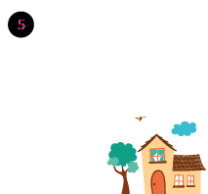 | 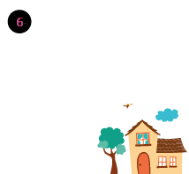

Recording class:

BIBLIOGRAPHY
 | »https://www.youtube.com/watch?v=CVuKr5y9AbY  »http://www.englishexercises.org/makeagame/viewgame.asp?id=6206  »https://learnenglishkids.britishcouncil.org/en/word-games/weather-1

