|  |  |  |  |  |  |
| --- | --- | --- | --- | --- | --- |
|  |  | |  | | |
| **ENGLISH**  BEGINNERS  Session 1  ---------------------------------------------------------  «Prepositions of place» | | |
|  | | |
| INTRODUCTION | | | |  |  |
|  | |  | Prepositions of Place are used to show the position or location of one thing with another.  It answers the question "Where?” | | |

­­

**LAS PREPOSICIONES DE LUGAR**

Se ubican detrás del verbo principal, que suele ser el verbo «**to be**» (ser, estar), en cualquiera de los tiempos pasados, presentes o futuros y en sus formas tanto simples como compuestas.

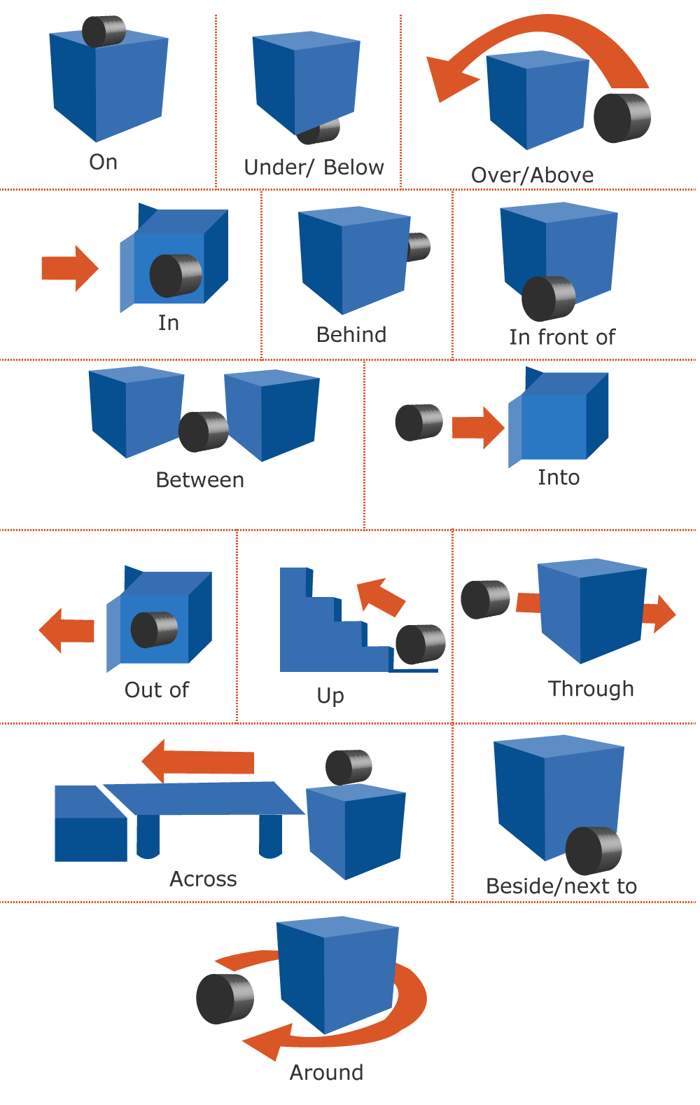

### Example:

**LAS PREPOSICIONES DE LUGAR**

**My living room:**

In my living room there is a clock on the wall and there is a ball under the table. There are 2 pillows on the sofa and there is a lamp between some flowers and a book. My cat sits next to the sofa.

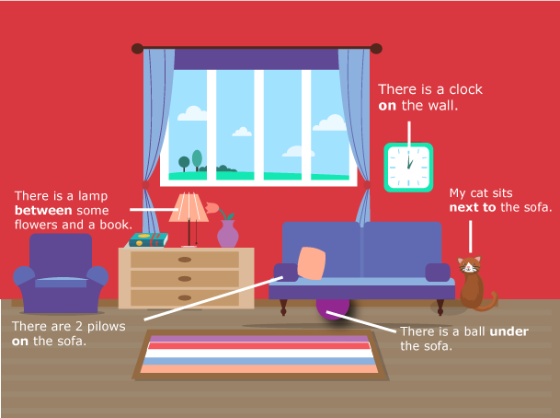

|  |  |  |
| --- | --- | --- |
| BIBLIOGRAPHY |  |  |

|  |  |
| --- | --- |
|  | * [**http://www.grammar.cl/rules/prepositions-of-place.htm**](http://www.grammar.cl/rules/prepositions-of-place.htm)**gfgdggdd** * [**http://www.curso-ingles.com/aprender/cursos/nivel-basico/prepositions/prepositions-of-place**](http://www.curso-ingles.com/aprender/cursos/nivel-basico/prepositions/prepositions-of-place) |