
ENGLISH
BEGINNERS
Session 9
---------------------------------------------------------“Clothes”
INTRODUCTION |  |  |  |  | 
 |  |  | - In this lesson, we are going to learn how you can talk about the clothes. You can answer the question: “what are you wearing?”

Clothes
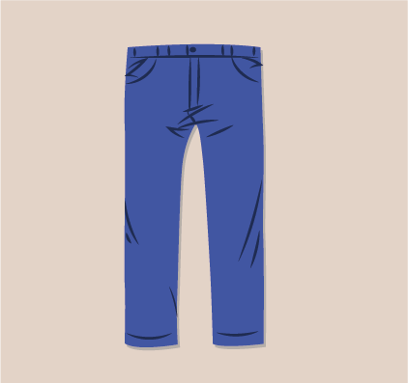  Jeans | 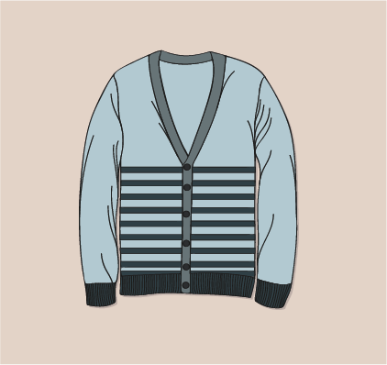  Sweater
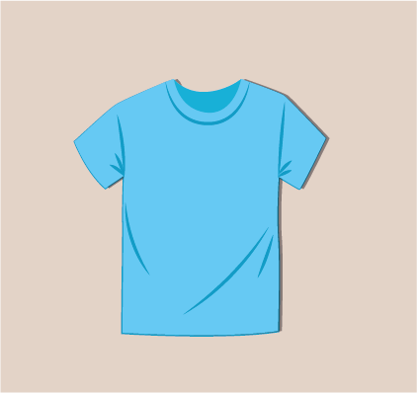  T-shirt | 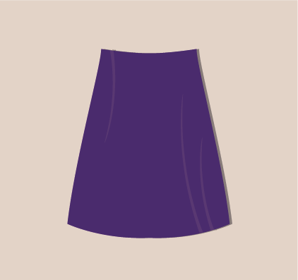  Skirt

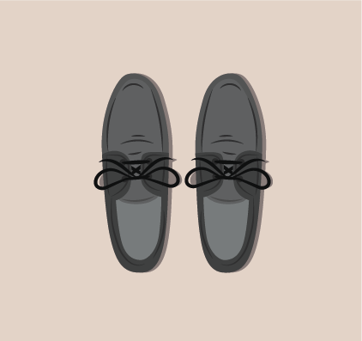  Shoes | 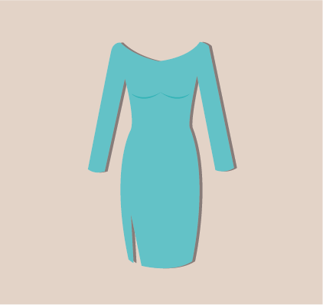  Dress
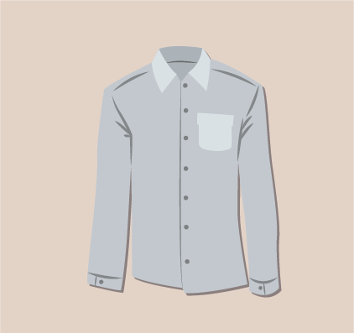  Shirt | 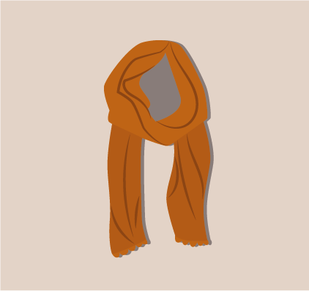  Scarf

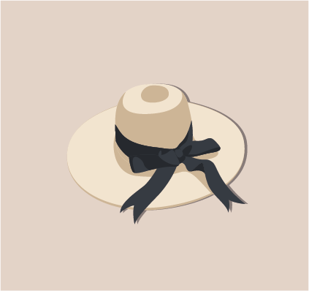  Hat | 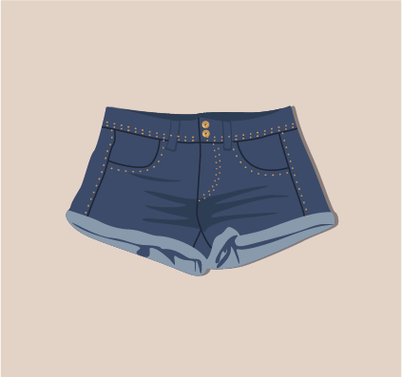  Shorts
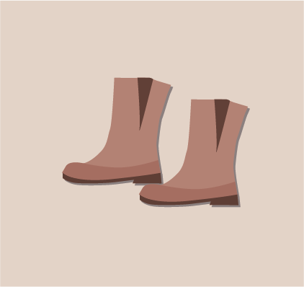
Boots

 | Flashcards

Video: Clothing songs for kids-My clothes with sentences-ELF kids videos.

Activity

HOMEWORK

H.W:

NOTA: recuerden que esta tarea la deben de montar en Unit 4-Homework.

Recording class

BIBLIOGRAPHY
 | - https://learnenglishkids.britishcouncil.org/sites/kids/files/attachment/flashcards-clothes-set-1.pdf  - https://learnenglishkids.britishcouncil.org/en/word- games/clothes-1  - https://learnenglishkids.britishcouncil.org/es/games/match-the-kit  - learnenglishkids.britishcouncil.org/es/games/teddy-dresser  - https://learnenglishkids.britishcouncil.org/sites/kids/files/attachment/worksheets-clothes.pdf

