 | ACTIVIDAD  A continuación se darán unas descripciones de las imágenes, de acuerdo a su grado de comparación altere su tamaño, bien sea más grande, más pequeña, más lejos, etc, además coloque diferentes precios a los computadores y edades a los policías.
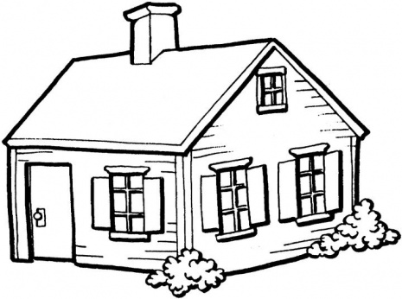 |  |   $ | $
A | B | A | B
 |  |   Age: | Age:
A | B | A | B
- The house A is bigger than house B
- The house B isn’t as big as house A
- The computer A isn’t as expensive as computer B
- The computer B is more expensive than computer A
- The computer A is cheaper than computer B
- The school bus A isn’t farther than school bus B
- The school bus B is farther than school bus A
- The police A is fatter than police B
- The police B is taller than police A
- The police A isn’t as old as police B
ACTIVIDAD
Realice una oración en presente simple con los siguientes verbos, varíe los pronombres utilizados, tratando de darle uso a cada uno de ellos (I, you, he, she, it, we, they).
smoke
go to the doctor
take a shower
watch TV
go to discotheques
rain in my city
go to the stadium
eat fast food
talk on the phone
take a taxi

