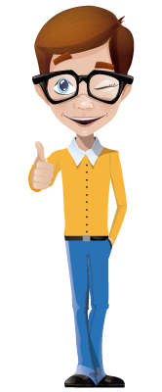
Hello, my friends

The pronouns are very important for communicating with others, because I can describe who I am talking to or about, and also for indicating the person or object who receives the action.

Let’s see how to use them.

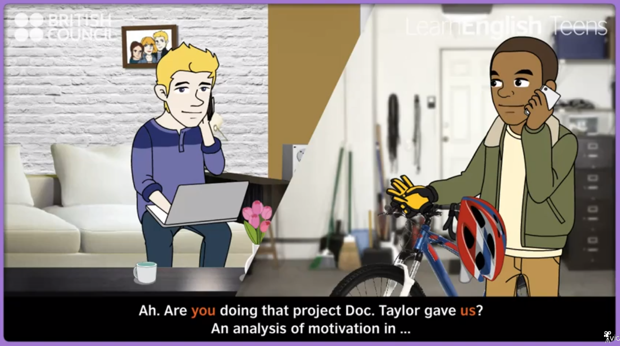

Watch this video, and identify how to use some personal pronouns and possessives:

http://learnenglishteens.britishcouncil.org/grammar-vocabulary/grammar-videos/personal-pronouns-and-possessives

ACTIVITY. From the last video, identify the function of pronouns and possessives.
Write some sentences and categorize the pronouns and possessives.
Subject pronouns | Object pronouns | Possessive adjectives | Possessive pronouns
I | Me | My | Mine
YOU | You | Your | Yours
He | Him | His | His
She | Her | Her | Hers
It | It | Its | ____
We | Us | Our | Ours
They | Them | Their | Theirs

1 | Are you doing that project Dr Taylor gave us? | Subject – object
2
3
4
5
6
7
8
9

ACTIVITY. What happen on the video?
Write some sentences that describe what happens there. Follow the example.
 | Told by the video | Told by you
1 | I’ve got a new bike! My uncle bought it for me. It’s my birthday present. | He’s got a new bike! His uncle bought it for him. It’s his birthday present.
2
3
4
5
6
7
8
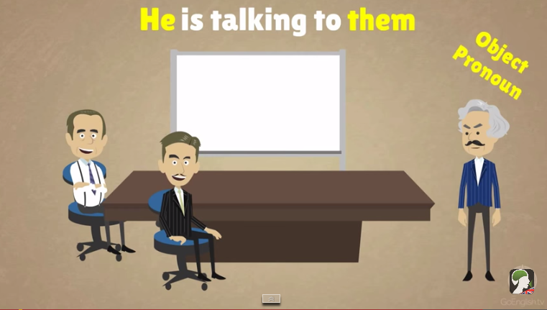

https://www.youtube.com/watch?v=XUIL5mFH5y4

On the last video we can notice how the pronouns are used. The subject ones are placed before the verb, and the object ones are laced after the verb.

The manager is talking to the employees.

He is talking to them

ACTIVITY. Write ten similar sentences in which you use subject and object pronouns.

- My parents help my little sister with the tasks – they help her with the tasks.

