
Hello, my friends

What happen if I don’t study?, if I cheat on an exam? If I don’t eat healthy?

Let’s see what happen if some situations occur.

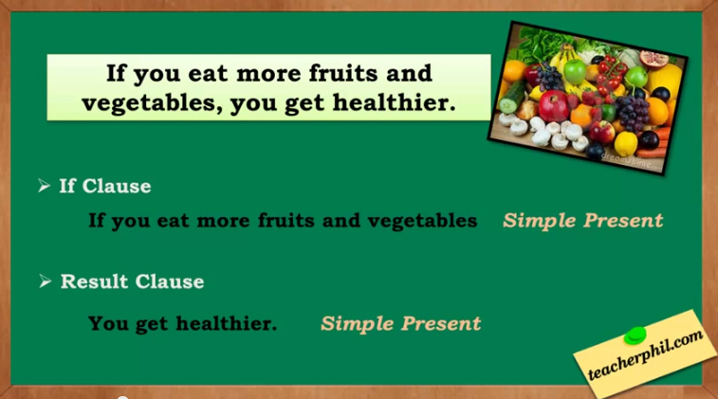

Watch this video, and identify how to use the zero conditional:

https://www.youtube.com/watch?v=TPPJL3ip-vY


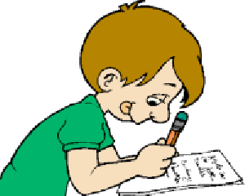
- If I jump, I fall.
- If I get into the pool, I get wet.
- If I drink liquor, I get drunk.
- If I don’t eat, I get hungry

:

If I read, I learn

ACTIVITY. From the last video, identify 8 conditional sentences.

1 | If I eat vegetables, | I get healthier
2
3
4
5
6
7
8
9

ACTIVITY. Complete according to a logical result (in present).
 | Present | Present
1 | If I don’t eat healthy, | I get sick
2 | If I don’t work,
3 | If I study hard,
4 | If I don’t do my tasks
5 | If I train hard,
6 | If I close my eyes,
7 | If I cut onion,
8 | If I cheat on exams,

But I can also use imperative sentences in zero conditional:
- If you talk to the teacher, tell him that I need a help.
- If it is raining, don’t use your computer.
- If the class is over, say good bye.
- If a classmate sends you a message, reply it.

ACTIVITY. Complete the first clause, according to the second one:

 | If there is an exam available on platform, | take it.
1 | If ___________________________________, | open the window.
2 | If ___________________________________, | don’t leave.
3 | If ___________________________________, | call the police.
4 | If ___________________________________, | tell your mom.
5 | If ___________________________________, | don’t cry.
6 | If ___________________________________, | run!
7 | If ___________________________________, | do it.
8 | If ___________________________________, | tell me the truth
9 | If ___________________________________, | fix it.

