FUTURE CONTINUOUS TENSE

El tiempo futuro continuo o progresivo se emplea con el mismo auxiliar WILL, aunque anexando BE + verbo + gerundio:

I will be ending my career in 2014. (Yo estaré terminando mi carrera en el 2014).

Es indispensable que en este futuro se utilice BE, al igual que el verbo siguiente de manera progresiva (gerundio); para negar o preguntar se emplea el orden ya estudiado, ya que BE + verbo + gerundio hacen parte del complemento, por lo tanto su ubicación siempre será al final de la oración, así:

My father will be painting the house (mi padre estará pintando la casa)
My father won’t be painting the house.
Will my father be painting the house?

Se puede apreciar que en las oraciones en futuro, en sus diferentes formas, el cambio de posición de las palabras sólo corresponde al sujeto y al auxiliar.

My neighbors will be visiting her family on vacation | 
My neighbors won’t be visiting her family on vacation
Will my neighbors be visiting her family on vacation?

I will be studying at Cibercolegio | 
I won’t be studying at Cibercolegio
Will I be studying at Cibercolegio?

Growing up
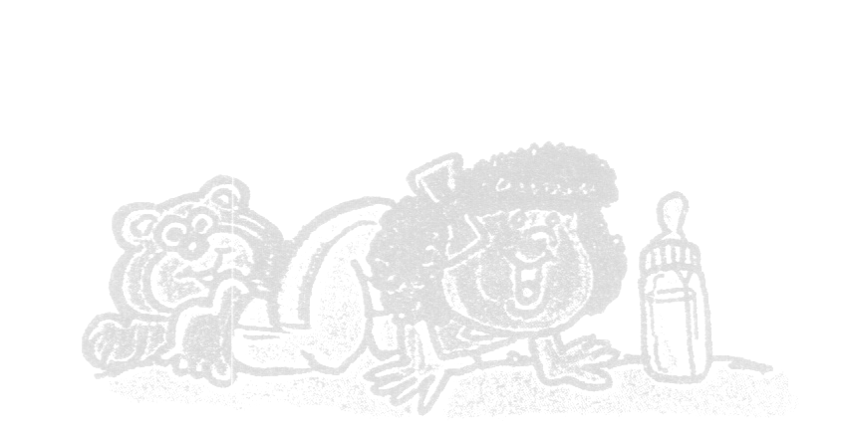 | - Jessica is growing up. Very son she’ll be walking and she’ll be playing with the other children in the neighborhood. Jessica can’t believe how quickly time flies! She won’t be a baby very much longer. Soon she’ll be a little girl.
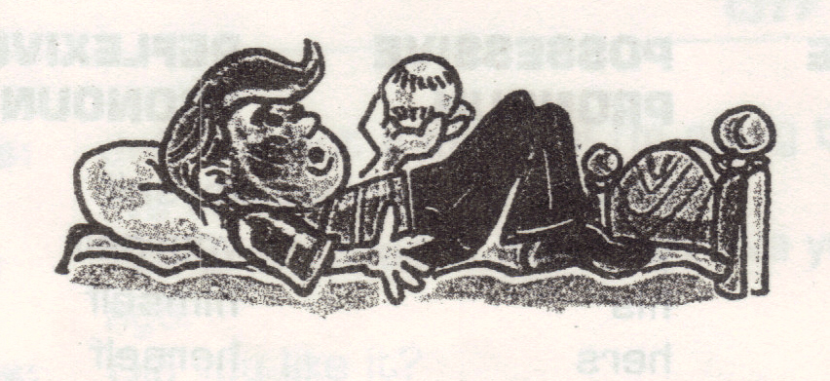 | - Tommy is growing up. Very son he’ll be shaving, he’ll be driving and he’ll be going out on dates. Tommy can’t believe how quickly time flies! He won’t be a little boy very much longer. Soon he’ll be a teenager.
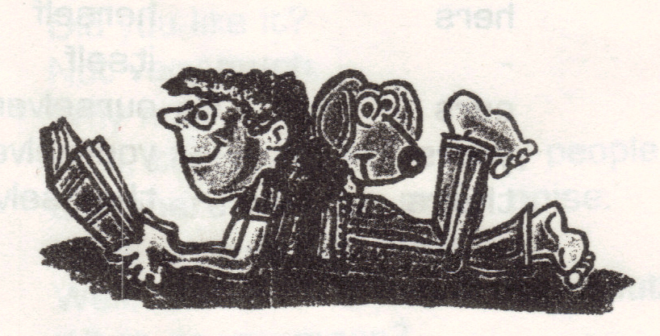 | - Katy is growing up. Very soon she’ll be going to college, she’ll be living away from home and she’ll be starting a career. Katy can’t believe how quickly time flies! She won’t be a teenager very much longer. Soon she’ll be a young adult.
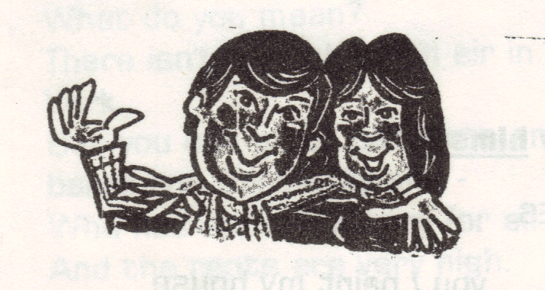 | - Pater and Sally are getting older. Very soon they’ll be getting married. They’ll be having children and they’ll be buying a house. Peter and Sally can’t believe how quickly time flies! They won’t be young adults very much longer. Soon they’ll be middle-aged.
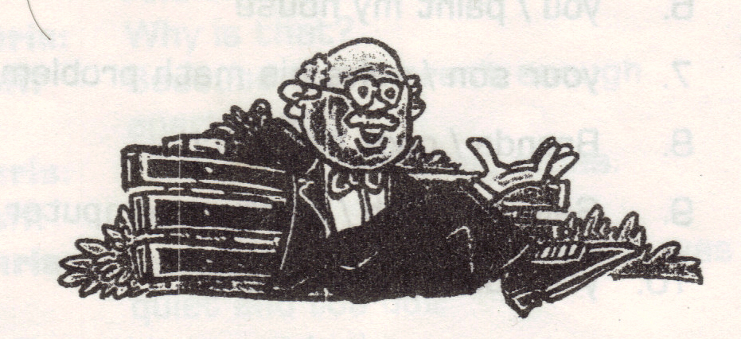 | - Walter is getting older. Very son he’ll be reaching the age of sixty-five, he’ll be retiring and he’ll be taking it easy for the first time in his life. Walter can’t believe how quickly time flies! He won’t be middle-aged very much longer. Soon he’ll be a senior citizen.

