REAL PRESENT CONDITIONAL


El condicional presente indica la consecuencia de una acción del presente en el futuro, en éste se mezclan ambos tiempos verbales, así:

Si yo tengo una terrible enfermedad, yo visitaré al médico
If I have a terrible sickness, I will visit the doctor.

Se puede observar en el anterior ejemplo que cada oración tiene sujeto, verbo y complemento.
If + Sujeto + Verbo (Presente) + Complemento, Sujeto + Will + Verbo + Complemento

O

Sujeto + will + verbo + complemento + if + sujeto + verbo (presente) + complemento

I will visit the doctor if I have a terrible sickness

Existen dos formas de emplear este condicional, o bien comenzando con IF + la oración en presente o bien con la oración en futuro con WILL.
Para realizar correctamente estas oraciones en forma condicional, basta con pensar en español lo que deseamos expresar, ya que en inglés es similar la escritura y el orden de estas oraciones, de esta manera nos daremos cuenta en qué tiempo o forma debe ir cada verbo.
Verb in present verb in future
If Bill has a serious problem, he will ask his father for help.

If clause dependant clause
Las oraciones en presente, al igual que en futuro, pueden escribirse en afirmación o negación:
If my father doesn’t work, we won’t have money to go shopping.
Por medio de las siguientes situaciones deduciremos oraciones condicionales:
Too bad!
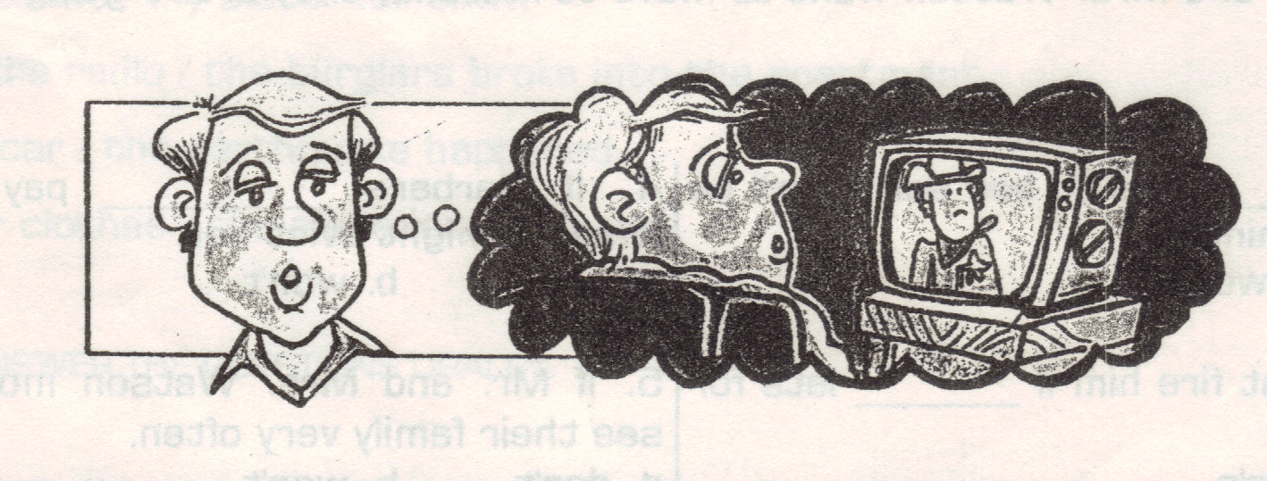

Ronald wants to stay up late tonight to watch a movie tonight, but he knows he shouldn’t. If he stays up late to watch a movie, he won’t go to bed until after midnight. If he doesn’t go to bed until after midnight, he‘ll probably be very tired in the morning. If he’s very tired in the morning, he might oversleep. If he oversleeps, he’ll be late for work. If he’s late for work, his boss might get angry and fire him. So, even though Ronald wants to stay up late to watch a movie tonight, he won’t. Too bad!

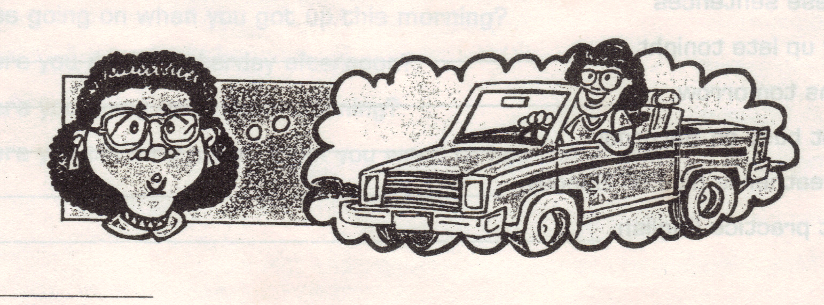

Barbara wants to buy a new car, but she knows she shouldn’t. If she buys a new car, she’ll have to take a lot of money out of her bank account. If she has to take a lot of money out of her bank account, she won’t have much left. If she doesn’t have much left, she won’t have enough to pay the rent. If she doesn’t have enough to pay the rent, her landlord might evict her from her apartment. So, even though Barbara wants to buy a new car, she won’t. Too bad!

