THE LOVE OF YOUR LIFE
- Unjumble the letter in these sentences to find words connected with dating.
- I met my girlfriend on a (NILDB) date.
- I met my boyfriend at a (TYRAP).
- My aunt met her husband through a dating (NYEGAC).
- Some people meet their perfect partner through a (SRALPONE) ad.
- I met my girlfriend (LENION). example (online)
- I met my boyfriend on (DOYLIHA)
- I met my girlfriend in a (AFEC).

- Answer this question?
- Do you think people can find “true love” through agencies or advertisements? Why/ Why Not?
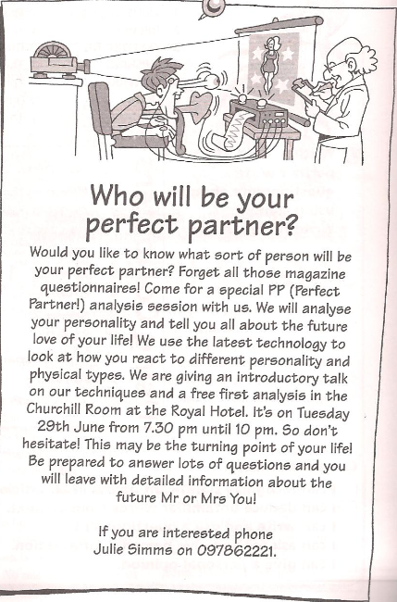

- What does the reading consist of?

- Find the words in the notice which mean the same as
- Stop and think__________
- Very important moment__________
- Most modern_________ : example Latest
- Ways of doing something_________

- Do you know what “Speed Dating” is?
- A very short date
- Meeting a lot of people for a very short time to see if you like them

- You are going to pretend to be a famous person at a speed dating session. On this card write down your information.
Name
Age
Job
Interests
Likes
Dislikes
Other information

- On this card write down some questions you would like to ask the other people at the speed dating evening, examples: What is your favorite place for a holiday? What kind of pet would you like to own?
1.
2.
3.
4.
5.
6.
7.

