

Hello, my friends

We usually share with our friends and family members, but sometimes we experience sharing with other people for first time.

Let’s see how some people experience a first date.

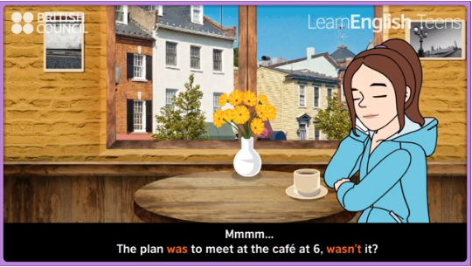
Watch this video and identify a situation related to a first date:

http://learnenglishteens.britishcouncil.org/grammar-vocabulary/grammar-videos/be-present-and-past

ACTIVITY. From the video, answer:

1 | What is the story about?
2 | Where is the date?
3 | What time is the date due to be?
4 | What happened with Jack?
5 | Is he always on time? | Yes- why? | No - why?
6 | Who is Alfie? (guess)
7 | What do Daisy and Alfie talk about?
8 | What is Emilia doing?
9 | Did the date have a happy ending? | Yes- why? | No – why?
10 | Change the ending of the story | Daisy saw Jack with Emilia, so she decided to…..

ACTIVITY. Unjumble the letter in these sentences to find words connected with dating.
- I met my girlfriend on a (NILDB) date.
- I met my boyfriend at a (TYRAP).
- My aunt met her husband through a dating (NYEGAC).
- Some people meet their perfect partner through a (SRALPONE) ad.
- I met my girlfriend (LENION). example (online)
- I met my boyfriend on (DOYLIHA)
- I met my girlfriend in a (AFEC).
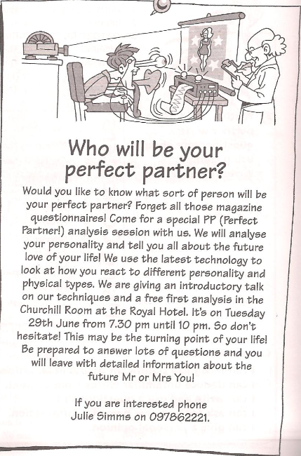

- Read the next article:

ACTIVITY. You are going to pretend to be a famous person at a speed dating session. On this card, write down your information.

Name |  | Photo
Age |  | Photo
Job |  | Photo
Interests |  | Photo
Likes |  | Photo
Dislikes |  | Photo
Other information |  | Photo

