When giving orders or instructions the most important word is the verb; sentences start with it.

When you give orders or commands, when you give directions or instructions, when you ask (request) for a favor (adding a “Please”), when you give an advice and suggestions, when you give warnings and when you invite someone, you are using the “imperative mode”.

ACTIVITY. Read the following instructions on how to make yogurt at home. Use the links and the key words to understand better. Listen to the Reading.
How to make yogurt (instructions).

Yogurt is a healthy food that can be made at home. One way to make it is to first buy some yogurt from the store or purchase dry yogurt culture. Add two small spoonfuls of the yogurt to two cups of milk; this will be the starter for your own yogurt. A cup in the United States is two hundred forty milliliters. When making yogurt it is very important to have clean equipment, clean hands and good temperature control.
Pour eight cups of milk into a large cooking pot. Keep the milk to eighty-five degree Celsius, then cold the milk quickly to forty-three degrees. To do this you can put the cooking pot in cold water. Keep the yogurt at forty-three degrees, and add one half cup of the starter, the remaining starter can be kept for later use. If you want to have thicker yogurt you can also add one third of a cup of dried milk.
Cover the pot and keep it at a temperature of forty to forty-five degree Celsius, after that your home-made yogurt is ready. It can be left at room temperature for up to twelve hours if you like a stronger taste. You can add fruits, nuts, honey or spices.

Key words
Purchase: comprar (buy). Starter: “iniciador”. Own: propio. Remaining: “sobrante”. Thicker: más espeso. Third: tercio (tercero). Ready: listo. Taste: sabor.

ACTIVITY. Paint the verbs that are part of an instruction (imperatives) in green as in the example (keep, cold):

ACTIVITY. Make suggestions using images, similar to next:
You can make suggestions about:
- How to work by internet
- How to play soccer /basketball
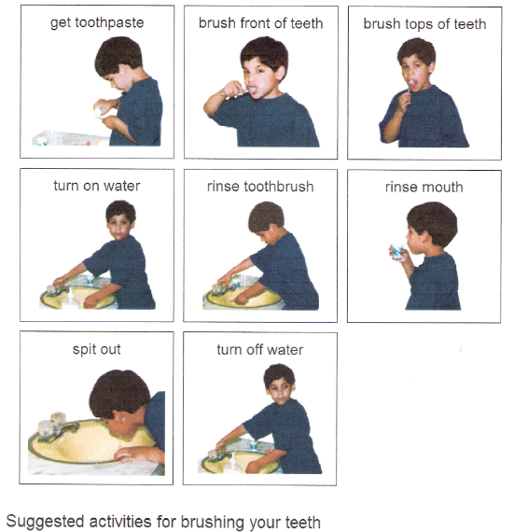
- How to cook a delicious pasta

ACTIVITY. Listen to this mp3 file and fill the blanks

____ is the VOA special _______ development report.
Yogurt can be made with ____ from cows or from other _______ including goats, ______, water buffalo and _______. It can be spelled Y-O-G-U-R-T or Y-O-G-H-U-R-T. ____ information on _______ making ___ be found at ________ such as practicalwanswers.org

Words
Camels | Websites | Sheep | More | Yogurt
Animals | milk | Can | English | This

ACTIVITY. Go to http://www.youtube.com/watch?v=wOZScNBbJgM, choose some poems, read them and then identify the figures of speech you find.

FIGURES OF SPEECH
Sentences | Spanish | Classification
1
2
3
4

