
Hello, my friend

My life has been wonderful so far. I have been living nice experiences at home and school, and my days have always been new opportunities for learning and growing.

What about you?, what has happened?

Look at how to use the present perfect tense.

Go to this page, and find sentences written in present perfect: simple and continuous:
http://www.grammar.cl/Present/Perfect_Tense.htm


ACTIVITY. Watch the next video, and then identify the sentences written in present perfect simple and present perfect continuous.

http://learnenglishteens.britishcouncil.org/grammar-vocabulary/grammar-videos/present-perfect-simple-and-continuous

 | Present perfect simple | Present perfect continuous
1
2
3
4
5
6
7
8

As you could see, the present perfect tense is formed by using HAVE/HAS + VERB (past participle).
I have painted my house

Present | Past | Participle
Paint | Painted | Painted

ACTIVITY. Let’s learn how to write questions.
- Answer the four questions
- Write four questions using the present perfect tense.

 | Questions | Your answers
1 | What has Oliver’s sister forgotten?
2 | What has mom been doing in Dubai?
3 | Where has she gone?
4 | What has Oliver cooked?
 | Your questions | Your teacher’s answers
5
6
7

When you give orders or commands, when you give directions or instructions, when you ask (request) for a favor (adding a “Please”), when you give an advice and suggestions, when you give warnings and when you invite someone, you are using the “imperative mode”.

ACTIVITY. Paint the verbs that are part of an instruction (imperatives) in green as in the example (keep, cold):

How to make yogurt (instructions).
(Download: Yogurt making audio file)

Yogurt is a healthy food that can be made at home. One way to make it is to first buy some yogurt from the store or purchase dry yogurt culture. Add two small spoonfuls of the yogurt to two cups of milk; this will be the starter for your own yogurt. A cup in the United States is two hundred forty milliliters. When making yogurt it is very important to have clean equipment, clean hands and good temperature control.

Pour eight cups of milk into a large cooking pot. Keep the milk to eighty-five degree Celsius, then cold the milk quickly to forty-three degrees. To do this you can put the cooking pot in cold water. Keep the yogurt at forty-three degrees, and add one half cup of the starter, the remaining starter can be kept for later use. If you want to have thicker yogurt you can also add one third of a cup of dried milk.
Cover the pot and keep it at a temperature of forty to forty-five degree Celsius, after that your home-made yogurt is ready. It can be left at room temperature for up to twelve hours if you like a stronger taste. You can add fruits, nuts, honey or spices.

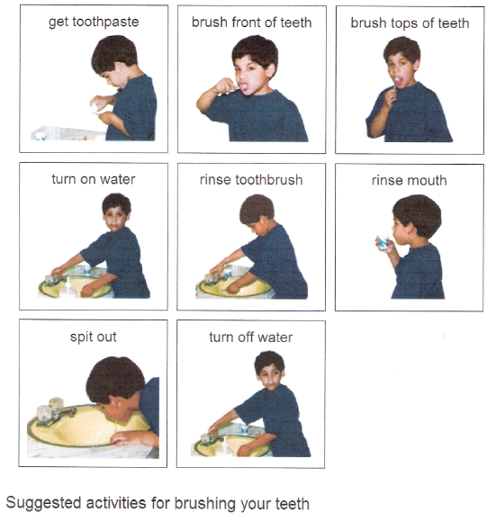
ACTIVITY. Make suggestions using images, similar to next:
You can make suggestions about:
- How to work by internet
- How to play soccer /basketball
- How to cook a delicious pasta

