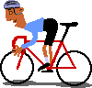
cycling | boxing | tennis | wrestling
fencing | swimming | baseball | bowling
golf | basketball | volleyball | ski
soccer | skating | billiard | canoeing
 |  |  | 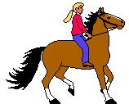
athletics | Ski on ice | football | horse riding
THE SPORTS

