Activity Complete with your personal information, according to the example.
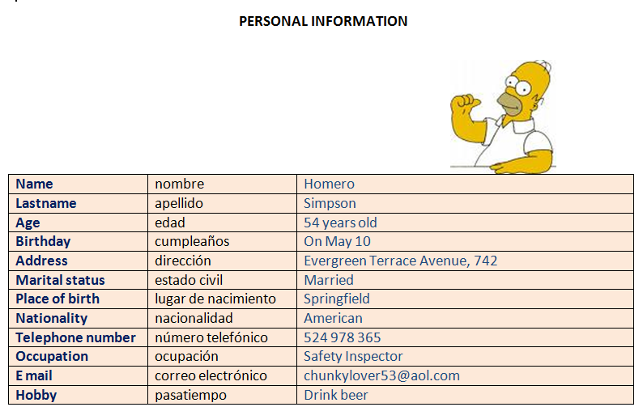


Name
Last name
Age
Birthday
Address
Marital status
Place of birth
Nationality
Telephone number
Occupation
E mail
Hobby

Activity Write your own personal information according to the videos

Personal information part 1
http://www.youtube.com/watch?v=9AtA3Jt9A8Y
Personal information part 2
http://www.youtube.com/watch?v=-sRHE7Ayt10

QUESTIONS | ANSWERS
- What’s your name | My name’s
- Where are you from? | I’m from . . .

