Hello, my dear apprentices.

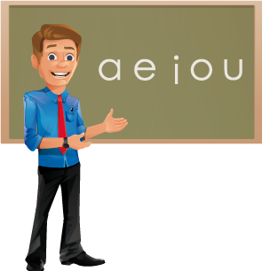

I like to meet new friends, but first I must know what information to give or ask.


Look at how I can give my personal information:

Hello

My name is John
My last name is García
I am from Colombia
I am 35 years old
My birthday is on December 2nd
My telephone number is 6389125
My hobby is listening to music in English
I live in Medellin.

ACTIVITY: It is your turn now.
Go to the next links, watch the videos, then write the questions and answer them according to your personal information.

Personal information 1: https://www.youtube.com/watch?v=9AtA3Jt9A8Y
Personal information 2: https://www.youtube.com/watch?v=-sRHE7Ayt10

 | Question | Answer
First video
1 | What’s your name
2
3
4
Second video
5 | Where are you from?
6
7
8

My family is very important for me. Parents, brothers, sisters, cousins, uncles, aunts…all of them are part of my daily life. However there are some family members whom I do not visit so frequently.

Let’s remember some relationships:

ACTIVITY: From the next options, write on the gaps the corresponding family members, according to their definition.
Uncle | Baby | Cousin | Brother | Granddaughter
Family | Husband | Niece | Son | Dad
Sister | Daughter | Grandma | Grandfather | Mom
Wife | Grandpa | Father | Grandmother | Aunt
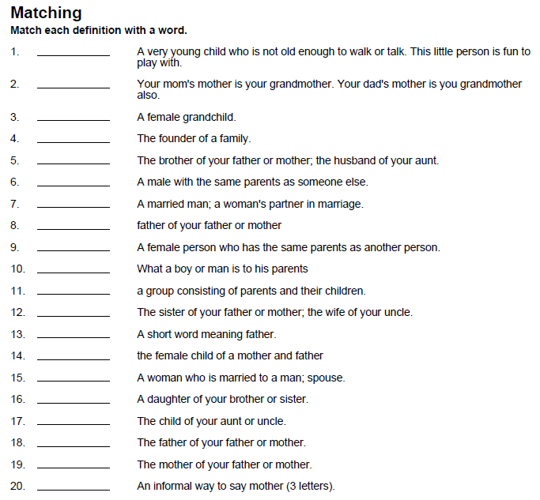

Grandma

Now let’s listen to some family members.

ACTIVITY: Write the members of the family that you listen to.
(For each image)

Visit: https://www.youtube.com/watch?v=GGqOUwh6V-A&feature=related

My family
and
……………………….. and daughter
Father and ………………………………..

