Hello, my dear apprentices.


I am starting a new topic, and learning new things. What are you doing right now?

Look at how I can describe what is happening around me:

Hello, my friends.

I am studying English and learning new words and phrases to write sentences. I am also practicing my pronunciation and listening to some songs. This is a good strategy for improving my English skills.
While I am studying, my sister is reading and my parents are getting ready for work.
This is my daily routine, and I am really happy studying on line.

ACTIVITY: Go to next link and identify what is happening with the animals.
http://learnenglishkids.britishcouncil.org/es/short-stories/the-lazy-bear

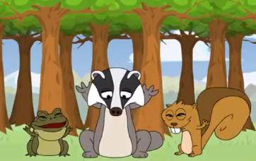 | What is happening?  The animals are waking up
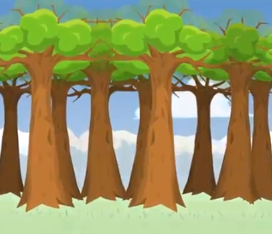  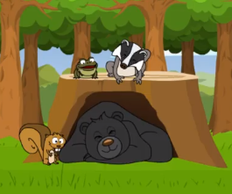 | What is happening?  Leaves are growing
What is happening?

Bruno is snoring
Screenshot | What is happening?
Screenshot | What is happening?
Screenshot | What is happening?
Screenshot | What is happening?
Now I am taking an active break, this is something that I do every day for being healthy.

There are also many activities that I do daily. This is my daily routine:

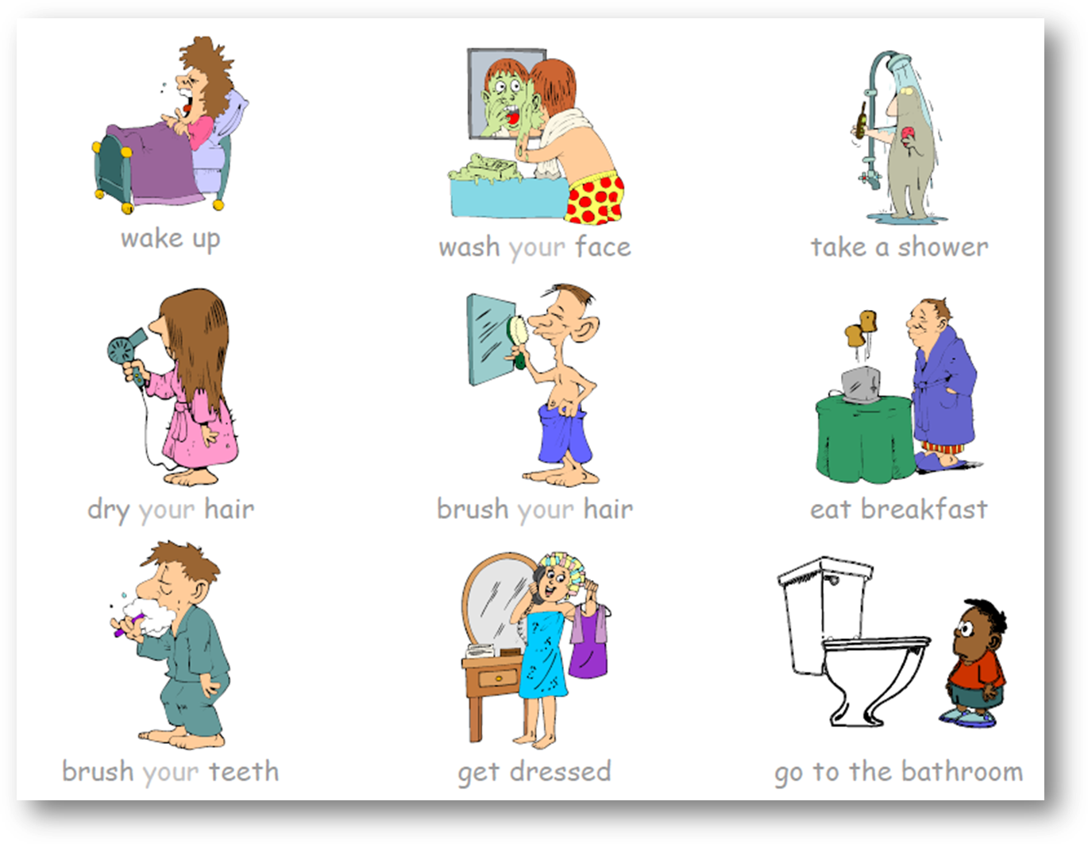

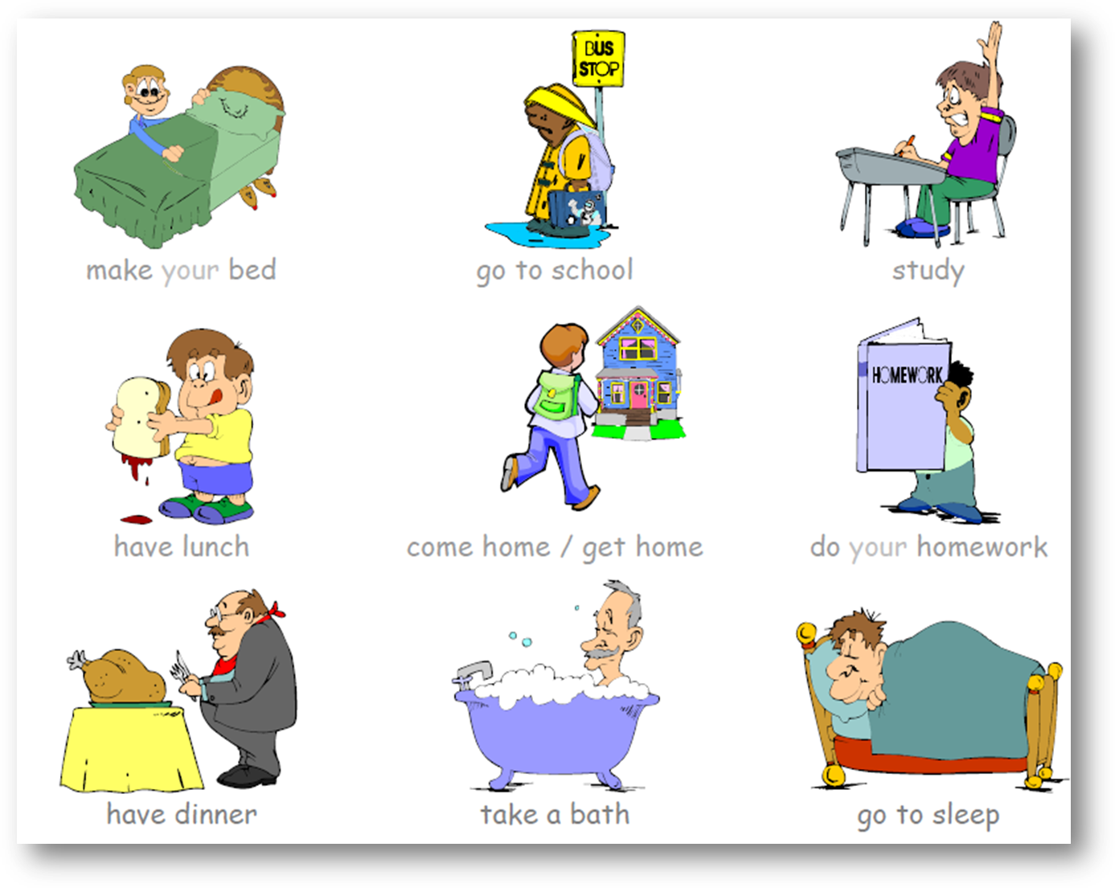
ACTIVITY: Write some other activities that you think are part of your daily routine.

My daily routine:

Get up, ….

There are also people who do different activities every day, according to their occupations.

ACTIVITY: Write the name of the occupations according to the images.

 |  |  | 
Nurse | … | … | …
 |  |  | 
… | … | … | …
 |  |  | 
… | … | … | …
 |  |  | 
… | … | … | …

You can practice the occupations by playing: http://learnenglishkids.britishcouncil.org/es/fun-games/job-mixer

