
Hello, my friends.

This year is a new opportunity for reaching my goals. But first I need to plan what to do for getting what I want.
My dad is planning to buy a new house, my mom is planning to study again, and my brother and sister are planning to pass the school year, and have a scholarship for the next one.

What are your plans?

ACTIVITY. Go to the next link; watch the video, then complete the information below.
http://www.kizclub.com/storytime/summer/summer1.html

Summer vacation | 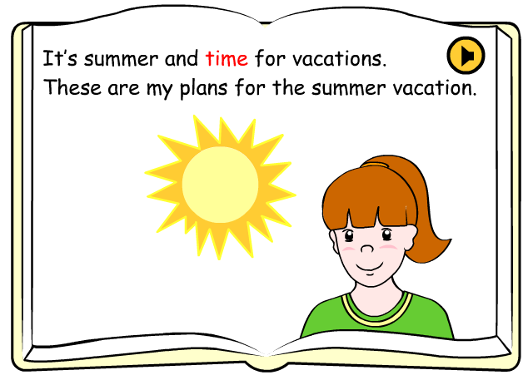
Activity 1. | Take the backpack and go on a camping trip.
Activity 2.
Activity 3.
Activity 4.
Activity 5.
Activity 6.

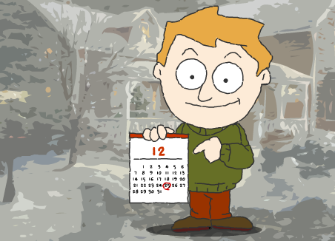

People all over the world celebrate many festivities during the year. Christmas is one of them, and children and parents celebrate it in different ways.

Let’s see how a British family lives Christmas.

ACTIVITY. Watch the next story, and then complete the sentences below.
http://learnenglishkids.britishcouncil.org/es/short-stories/my-favourite-day-christmas

The children decorate the Christmas tree with…
Christmas is on . . .
At school the children sing…
At night Santa Claus bring….
The children put a star on …
For Christmas dinner the children eat …
Under the tree the children …
What is happening on the story?

The children are decorating the treeThe children are sending Christmas cardsSanta is bringing presents

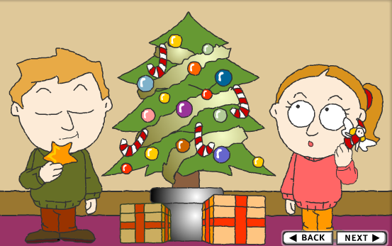
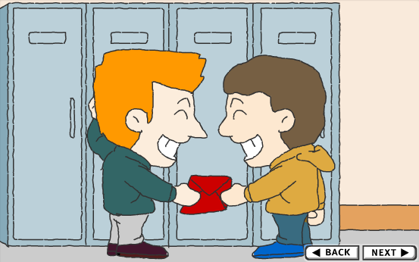


Let’s play.

Go to the next link, then click on each child’s name, listen to what the child likes and choose the two gifts.

http://learnenglishkids.britishcouncil.org/es/fun-games/whose-present

ACTIVITY. After you play the game, identify the presents for each child and complete the information.
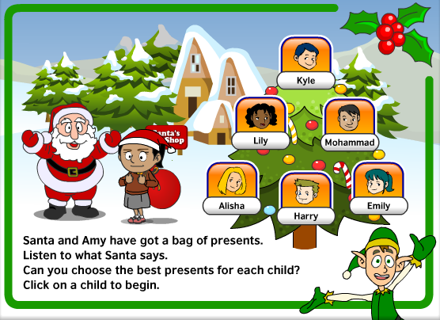
Child | Presents (2)
Alisha
Harry
Lily
Mohammed
Emily | Crayons and paint box
Kyle

