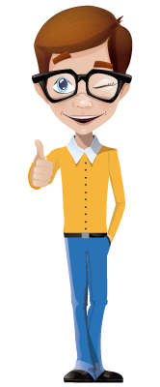
Hello, my friends.

My neighborhood is full of people who daily do different activities. Some of them are teachers, sellers, students, drivers, doctors, secretaries….

Help me identify what people around me do, and also let’s learn what to do in some places of the city.

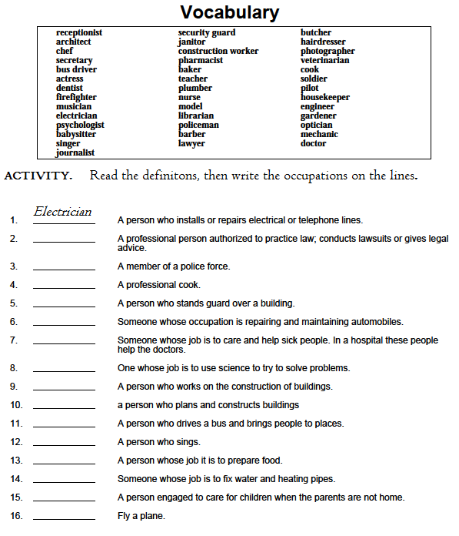

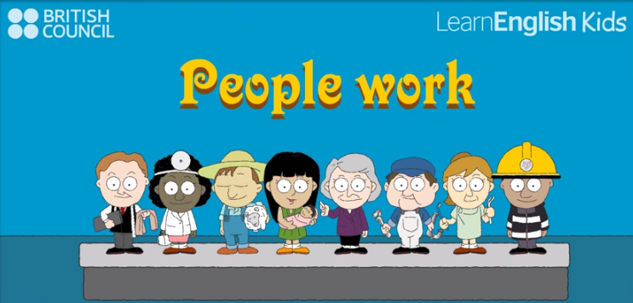

ACTIVITY. Go to the next video.

https://www.youtube.com/watch?v=ORGLQudvMWE

Then complete the next information:

Person | Occupation | Activity
Penny Proctor
Wendy Witter
Ronnie Ryman
Gary Gummer
Nigel Naylor
Peter Palmer
Mabel Meacher
Patty Prentice
The city has many places to visit. I like doing different activities: I like swimming, shopping, skating, riding a bike, watching a movie, reading a book. . .

Let’s see some places in the city. What is your favorite one?

ACTIVITY. From this video, identify 10 places in the city that you like, and write them down:
https://www.youtube.com/watch?v=LULzOE1IVYk

Place 1: | Supermarket | 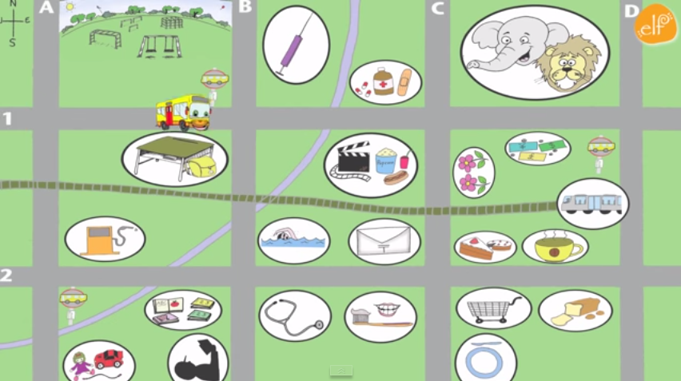
Place 2: | .
Place 3:
Place 4:
Place 5:
Place 6:
Place 7:
Place 8:
Place 9:
Place 10:

