
Hello, my friends.

Feelings are part of my daily life. Sometimes I feel happy, sad, nervous, anxious, tired, hungry…. This depends on what I do.

When I do well at school I feel really happy, but I feel sad when things are going wrong.

Let’s see how to describe our feelings.

ACTIVITY. Go to the next link, watch the story and then complete the next information.
http://www.kizclub.com/storytime/feelings/feeling12.html

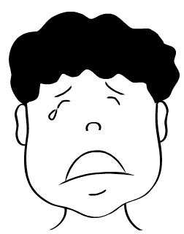

Sentence | Complete (words)
I show how I feel with my
When my birthday comes near, I feel
When I’m sick in bed, I feel
When the lights go out suddenly, I feel
I feel angry when
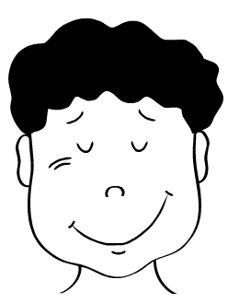  I look like this when I feel | 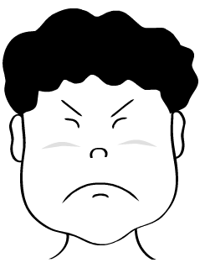  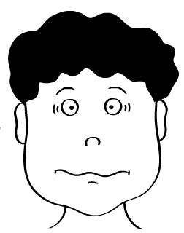
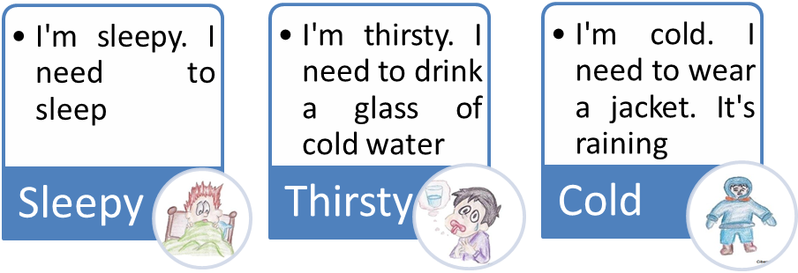

There are some other adjectives that describe my feelings and emotions:

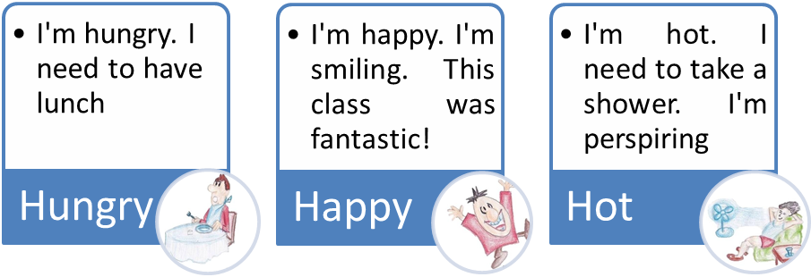

ACTIVITY. Match the adjectives to their corresponding recommendations. ( )
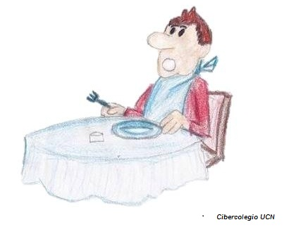

Hungry
Go to bed

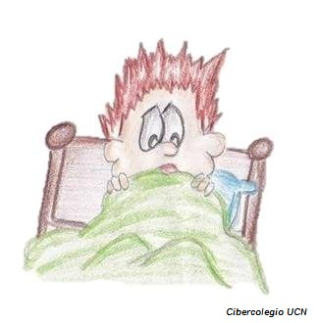
Wear a jacket
Sleepy

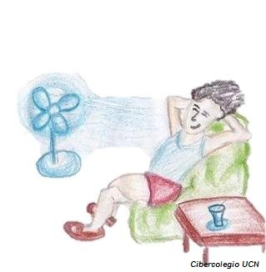
Take a shower
Hot

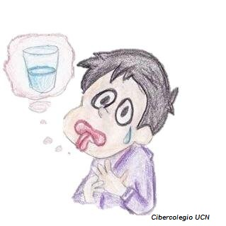
Eat something

Thirsty


Drink something cold

Cold

ACTIVITY. Answer:

- What do you do when you are cold?
  - When I am cold I____________________________________
- What do you do when you are thirsty?
  - When I am ______ I __________________________________
- What do you do when you are happy?
  - When I am ______ I __________________________________
- What do you do when you are hot?
  - When I am ______ I __________________________________
- What do you do when you are sad?
  - When I am ______ I __________________________________
- What do you do when you are sleepy?
  - When I am ______ I __________________________________
- What do you do when you are hungry?
  - When I am ______ I __________________________________
- What do you do when you are scared?
  - When I am ______ I __________________________________

ACTIVITY. Go to the next link, listen to the sentences, and complete them below:
http://www.123listening.com/freeaudio/feelings-1.mp3

- He is __________
- He is __________
- He is mad
- He is __________
- He is __________
- She is _________
- He is __________
- He is __________
- He is __________
- He is tired

