ACTIVITY. Describe what a person in your family was doing yesterday:

Example:
My mother

First | Second | Then | Later | After that | And finally
First She was going to the supermarket | Second she was cooking breakfast | Then she was cleaning the house | Later she was visiting her relatives | After that she was coming home | And finally she was sharing with my brothers and me.
Primero:  Ella estuvo yendo al supermercado | Segundo:  Ella estuvo preparando el desayuno | Luego:  Ella estuvo aseando la casa | Más tarde:  Ella estuvo visitando sus familiares | Después de eso:  Ella estuvo regresando a casa | Y finalmente: Ella estuvo compartiendo con mis hermanos y yo


ACTIVITY. Watch http://www.youtube.com/watch?v=K5B9J2y7nd8 and then write 5 sentences by using first, second, then, later, after that, and finally, according to the images or sentences on the video.

Example:

First, she was having her lunch | Then, she was taking pictures | . . . and finally, she….
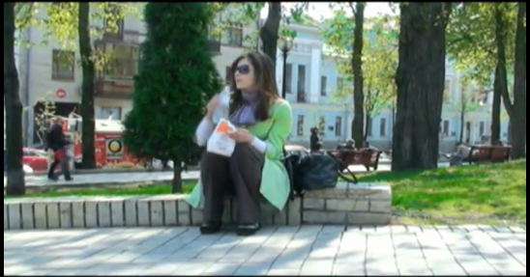 | 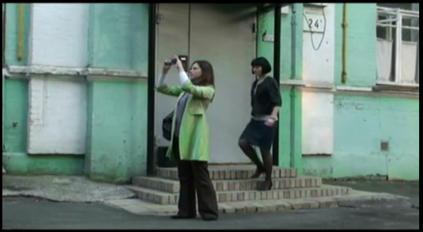 | 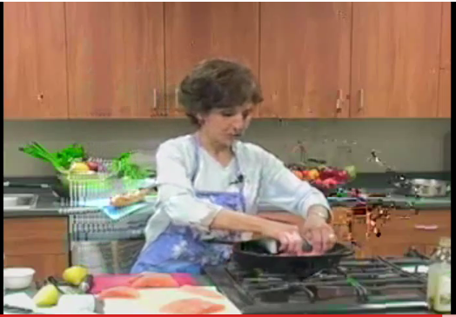
Primero, ella estuvo almorzando | Luego, ella estuvo tomando fotos | . . . y finalmente, ella . . .
ACTIVITY According to the next short reading, answer the questions below.
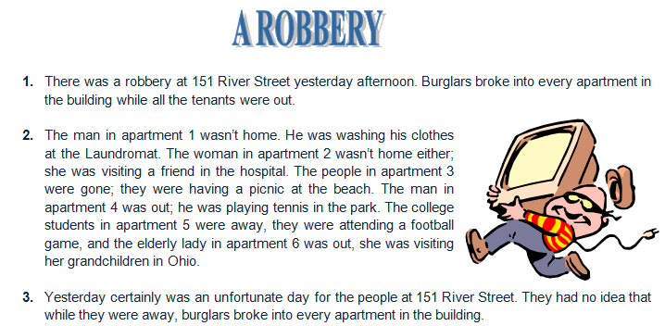

- What was there yesterday?
- Where was man in apartment 2?
- What was the elderly lady doing?
- Why wasn’t woman 2 in her apartment?
- Where were students in apartment 5?

ACTIVITY. Using there was and there were, describe a place you visited:

The shopping center:

There was a parking; there were many stores; there was an elevator; there were three restaurants….

(Había un parqueadero; había muchos almacenes: había un ascensor; había tres restaurantes. . .)

NOTE: never say “hubieron, habrán, hayan, ha habido” , HABER always in singular.

