
Hello, my friends.

My days are full of wonderful experiences.

I follow some daily routines as part of my personal growth.

Let’s see how to make a good use of our free time.

ACTIVITY. Go to the next link and identify some daily activities. After this complete the information.
http://www.kizclub.com/storytime/week/first.html
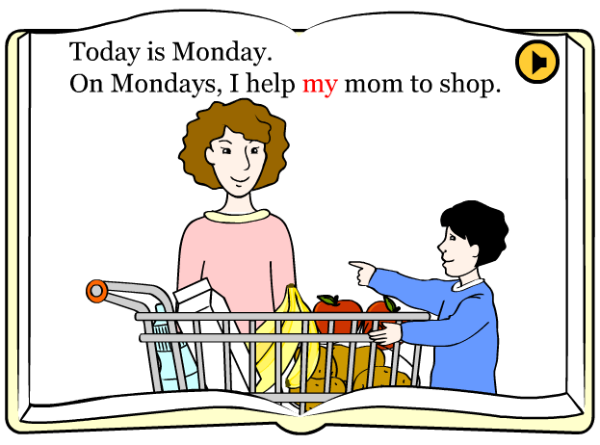
Day | Activity
Monday | I help my mom to shop
Tuesday
Wednesday
Thursday
Friday
Saturday
Sunday
Let’s play.
The next game will help us identify our daily routine. What is yours?

ACTIVITY. Go to the next link, and then use some those actions to describe your daily routine:
http://learnenglishteens.britishcouncil.org/grammar-vocabulary/vocabulary-exercises/daily-routine

 | - Wake up | 2 | 3
 | 4 | 5 | 6
 | 7 | 8 | 9
 | 10 | 11 | 12

But I can also describe what I was doing yesterday:




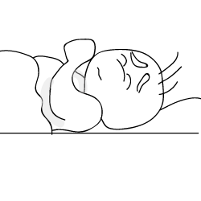





Yesterday was a very busy day.

First I was eating an apple before the class, and then I was drinking a glass of milk. Some minutes later I was reading and studying for the exam, but it was difficult, I was trying to remember the correct answer, and finally I did it.
In the afternoon, at 2:00 pm, I was running and exercising, after this, at 6:00 pm, I was taking my singing class.
At night I was talking to my friends on the phone, and at 9:30 pm I was trying to rest and sleep, but I was really tired.

ACTIVITY. After you read the last routine, identify the correct order of the images and put them into the boxes.

1 | 2 | 3 | 4 | 5 | 6 | 7 | 8

