ACTIVITY. Read next text and then answer:

THE MONTHS OF THE YEAR

January | Enero | July | Julio
February | Febrero | August | Agosto
March | Marzo | September | Septiembre
April | Abril | October | Octubre
May | Mayo | November | Noviembre
June | Junio | December | Diciembre
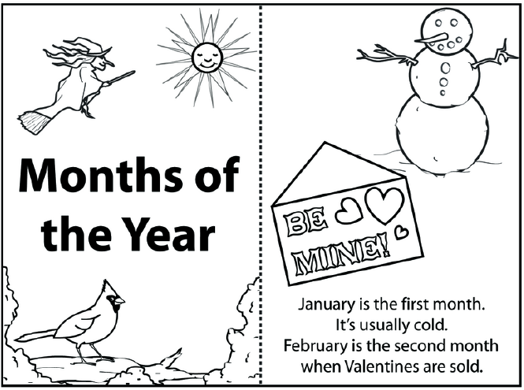

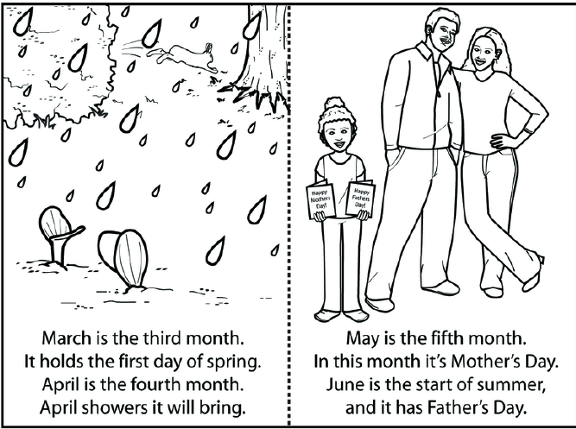
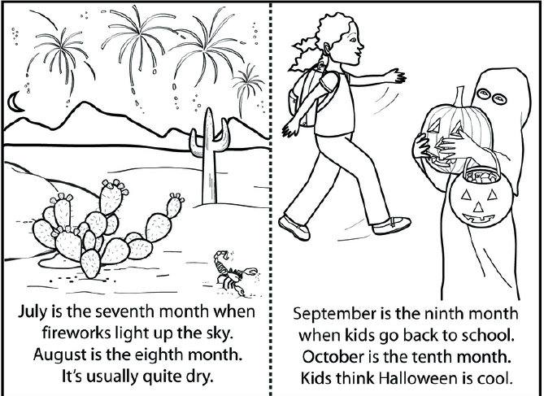

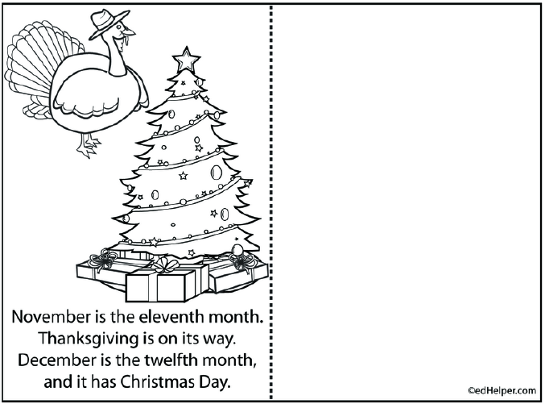
MONTH | CHARACTERISTICS | CELEBRATION IN YOUR CITY  MY PLANS
January |  | The three wise men
February
March | First day of spring | Woman’s day
April
May
June
July
August
September
October
November
December

 | ACTIVITY  Go to http://www.youtube.com/watch?v=c9YqVrJ18Ig watch the video, the animals, names, nouns, listen to the pronunciation and then complete:



Name | Question | Answer
Betty Beaver | What’s Betty Beaver doing? | She is singing
Write 6 nouns you see on the video by using there is and there are:

there is one bed |  |  | there are animals
NOTE: | THERE IS is just for one thing or person (singular) |  | THERE ARE is for two or more things or people (plural)
Write logically 3 sentences in present continuous tense (is, are, am + ing) according to the video using: but, because, and:

 | But
 | Because
 | and
Example: | The elephant was sleeping because he was tired

ACTIVITY
Go to http://www.youtube.com/watch?v=GkuUKX5JzrY watch the video, and write 5 sentences that you identify in comparative degree.
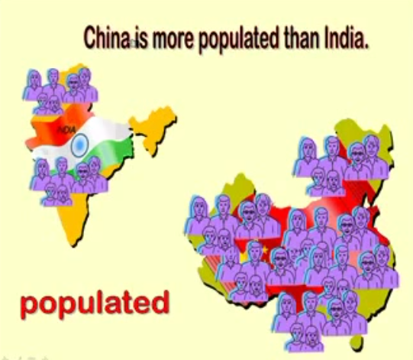

Example: China is more populated than India

Resources:

- There us and there are:
http://www.englishexercises.org/makeagame/viewgame.asp?id=5272

- Comparative degree
http://www.youtube.com/watch?v=GkuUKX5JzrY

- PLAY: quiz (comparative)
http://eslpuzzles.com/Grammar%20Games/Adjective%20Games/Comparatives%20Game%20Multiple%20Choice.html

