
Hello, my friends

I love waking up in the morning and see how my family works hard for making their dreams come true. Those wonderful people are part of my daily life, because we share our same home, problems and goals.
But there are also many people who live around me: my neighbors. They also have any stories to tell us.

ACTIVITY. Go to the next link, watch the video and identify what is happening there. Then answer the questions.
http://www.kizclub.com/storytime/myfamily/first.html

Day | 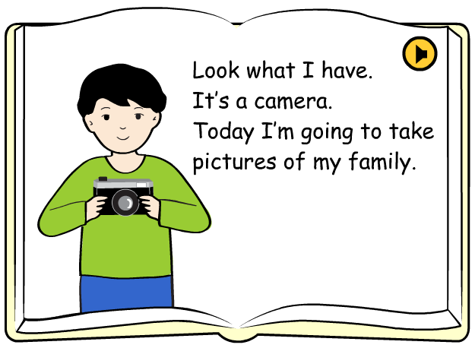Activity
What is the father doing?
Where is he?
What is the mother doing?
Where is she now?
Where is the brother?
What is he doing?
What is the grandfather reading?
Where is he?
Who is playing the piano?

There are other people who make daily activities in my neighborhood. By the way, what places do you have in your neighborhood?

ACTIVITY. Write the places that you have in your neighborhood.
My neighborhood | - School | 2 | 3
My neighborhood | 4 | 5 | 6
My neighborhood | 7 | 8 | 9
My neighborhood | 10 | 11 | 12
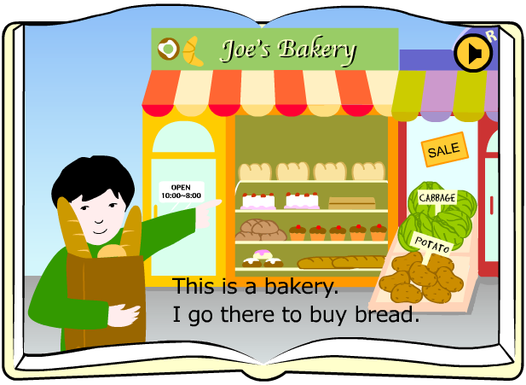

Now let’s identify some activities I can do in different places of the city:
http://www.kizclub.com/storytime/neighborhood/first.html

ACTIVITY. Watch the next story, and complete the sentences below.

Place | Activities
Bakery | Buy bread

After I know some places of my neighborhood, I can describe and compare them. How to do it?
- The library is more important than the stadium
- The stadium is bigger than the school.

Here you can practice the comparative degree:
http://www.learnenglish.de/grammar/adjectivecomp.html

ACTIVITY. Compare some places in your neighborhood, using the next adjectives:

Big: the school is bigger than the drugstore.

Far: _______________________________________________
Expensive: _______________________________________________
Good: _______________________________________________
Interesting: _______________________________________________
Cheap: _______________________________________________
Old: _______________________________________________

