ACTIVITY. Watch next video, then write the questions and answer according to your own personal information:
http://www.youtube.com/watch?v=9AtA3Jt9A8Y&feature=related
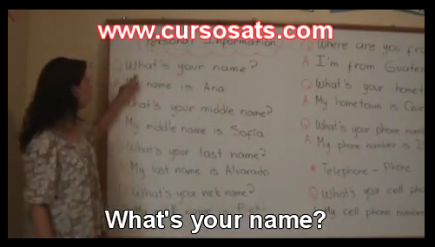

Questions | Answers
- What’s your name? | My name is

Go to next links to practice the superlative form

http://www.youtube.com/watch?v=9vhGsBZN3PI

http://www.youtube.com/watch?v=UMIQEL5z46k&NR=1

http://www.youtube.com/watch?v=w-VW99dmDCU

Activity. Answer next questions by using the superlative and large answers

- Who is the most important person for you?
Answer: the most important person for me is . . .
- What is the most difficult class?
- What is the biggest city in the world?
- Who is the worst person in the world?
- What is your best quality?
- Where is the oldest city in the world?
- Who are the most popular singers in Colombia?
- What is the most beautiful city?

- What is the most beautiful song?

- Who is the tallest person in your family?

- What is the most special celebration?

- Who is your best friend?

