
Hello, my friends

In my neighborhood there are people who have different occupations. I think one should do what we really love.

Are you happy being a student? Will you become a professional? What will you be in a future?

ACTIVITY. Go to the next links, identify how to say our personal information, and then write the questions and their corresponding answers.

- Personal information 1: https://www.youtube.com/watch?v=9AtA3Jt9A8Y&feature=related
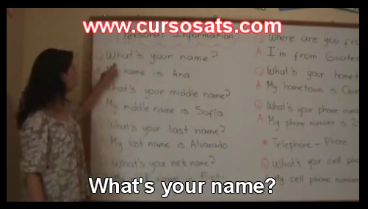
- Personal information 2: https://www.youtube.com/watch?v=-sRHE7Ayt10
Question | Your answer
What’s your name? | My name is (your name)


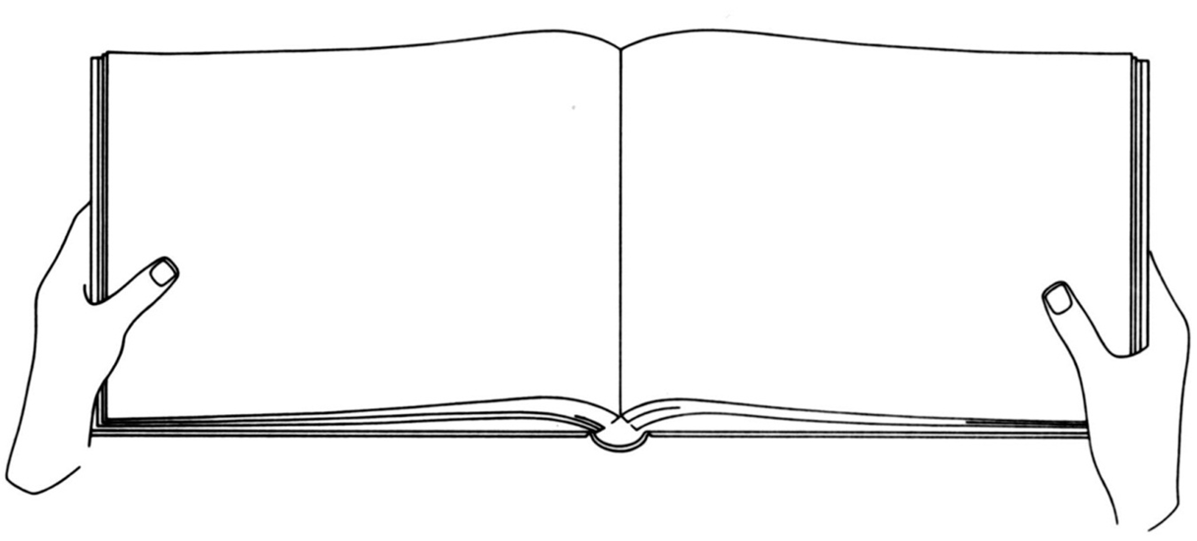
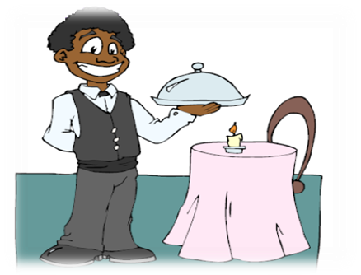
My brother John.

He isn’t married, he is 21 years old.
He is studying languages, and he works in a restaurant as a waiter.
He lives with my parents.

Now let’s see how to use the personal information to talk about our family members.
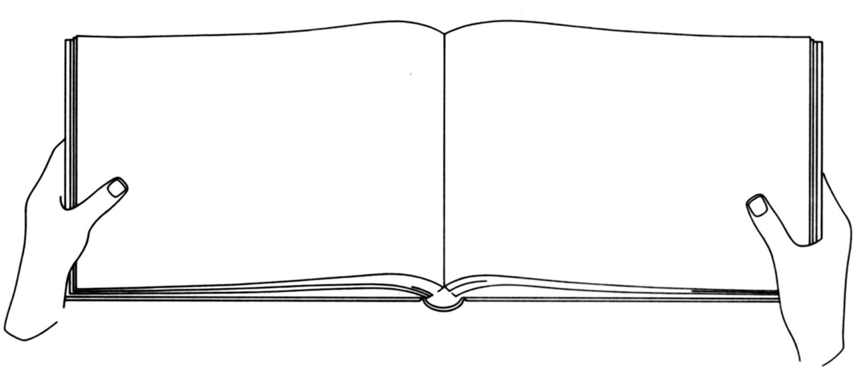

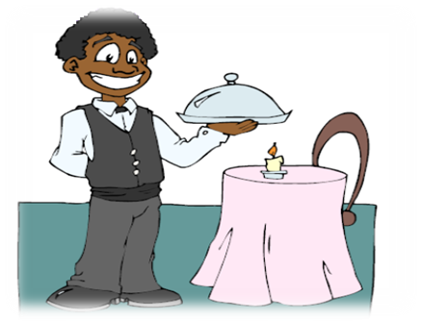
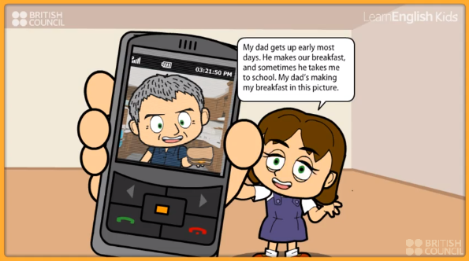

ACTIVITY. Go to the next link and watch the video. After you read and listen to the description, complete the information below.

http://learnenglishkids.britishcouncil.org/es/short-stories/my-dad

 | Dad’s information
- His name is Paul.
- He is 46 years old.
- He lives with his daughters
- .
- .
- .
- .
- .
- .
- .

Now let’s see how to talk about habitual activities
http://learnenglishteens.britishcouncil.org/grammar-vocabulary/grammar-videos/present-simple

On this video we can see how verbs are conjugated according to the subject (pronoun): he, she, and it. For the rest of the pronouns (I, you, we, they), the verb does not add S.

- My dad works every day.
- My parents work every day.

DO and DOES are used in negative and interrogative sentences:

DO: I, you, we, they.
DOES: he, she, it.

- Where does your dad work?
- Where do your parents work?

Now let’s see how to use adjectives in superlative forms:
http://www.learnenglish-online.com/grammar/superlativeadjectives.html

ACTIVITY. Write the next adjectives in superlative form. Follow the example.

Big: the biggest

Far: _______________________________________________
Expensive: _______________________________________________
Good: _______________________________________________
Interesting: _______________________________________________
Cheap: _______________________________________________
Old: _______________________________________________
Happy: _______________________________________________
Important: _______________________________________________

