
Hello, my friends

My life as a virtual student is wonderful, because I learn as much as I want studying at home, and also I have time to share with my family. However, I need some vacation plans in order to have a good time with my loved ones.

Help me plan the best vacation ever!

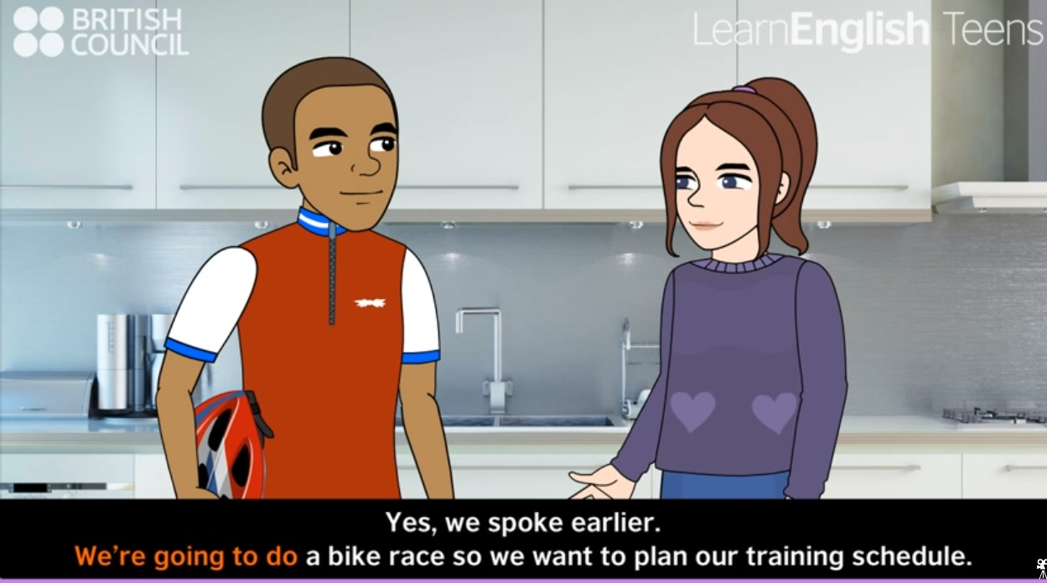
First we need to review how to describe future plans.

ACTIVITY. Watch the next video, then answer:
http://learnenglishteens.britishcouncil.org/grammar-vocabulary/grammar-videos/future-forms

Questions based on the video | Answers
Who are going to a bike race?
What will happen in about one month?
What film are they going to watch?
Will Alfie watch the Matt Damon film?, why?
What is the Matt Damon film about?

As you could see, we can use GOING TO or WILL for describing future plans.

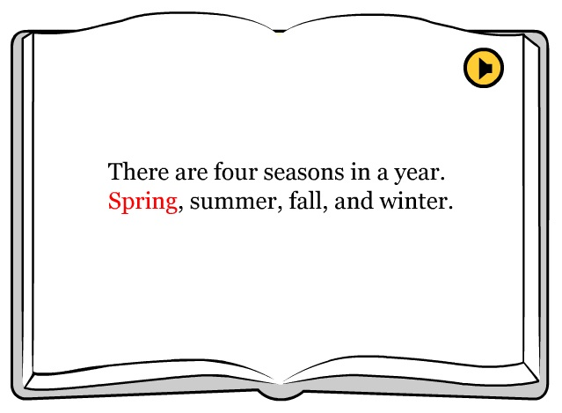
After I decide where to go on vacation, I need to plan which clothes to use. This depends on the weather conditions. Will the weather be hot, cold or rainy?

Look at the next video and find some characteristics of the weather:
http://www.kizclub.com/storytime/seasons/season.html

ACTIVITY. Use your own words to describe some characteristics of the seasons.

Spring | Summer | Fall | Winter

In Colombia there are two main seasons: winter and summer.

ACTIVITY. What are the most common activities people do in your city/town during these seasons?

Season | Activities
Summer
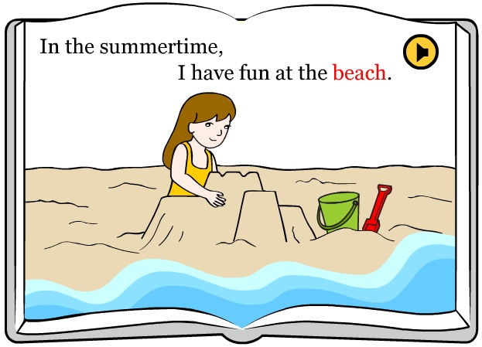

Winter
