ACTIVITY. Read and listen to the story “buy a new car” in next link, then write the sentences in chronological order.

http://www.rong-chang.com/nse/se/nse006.htm

 | Correct order | Sentences
1 |  | $1.000 are her saves
2 |  | The car will cost Linda $33.600
3 |  | She will sign a contract
4 |  | Linda has a car, it is old.
5 |  | She will not have economic problems to pay the car
6 |  | She will pay $400 every month
7 |  | Linda wants to have a new car
8 |  | She wants a red Honda car
9 |  | First, she will give $1.000 for the new car


ACTIVITY. According to the images, identify the correct order (A, B, C ó D), then translate into Spanish your answer.
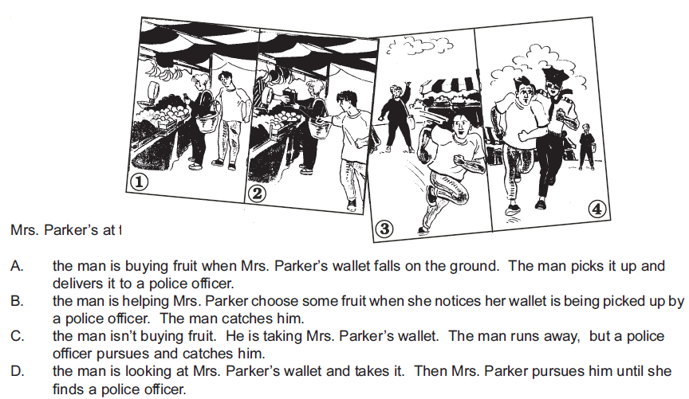
ACTIVITY. In next link, identify and write 5 sentences in simple present tense, using the pronoun HE, by identifying logically those things he likes or dislikes to do.

“ He likes that idea” http://www.rong-chang.com/nse/se/nse121.htm

He lived in a nursing home, “I don’t have anything to do” | El vivía en un asilo de ancianos. “yo no tengo nada por hacer”
CONCLUSION
He lives in a nursing home | Él vive en una casa de ancianos
He doesn’t have anything to do | Él no tiene nada por hacer

ACTIVITY. From next link, after reading and listening to it, write 5 sentences in first singular person “I”, and conjugate the verb according to this pronoun.
http://www.rong-chang.com/nse/se/nse028.htm

Where does Ronald eat breakfast? | ¿Ronald dónde desayuna?
Se observa el orden para preguntar, comenzando con Wh question – do/does – sujeto – verbo – complemento?. Se utiliza does para HE.
He eats breakfast at home |  | él desayuna en casa
En afirmación el verbo lleva S cuando es conjugado por HE, SHE, IT.
CONCLUSION
- Where do I eat breakfast? | ¿Yo dónde desayuno?
- I eat breakfast at home | Yo desayuno en casa
Para la pregunta se utiliza DO para los pronombres I, YOU, WE, THEY.
Si el verbo lo conjuga uno de los anteriores pronombres, éste no lleva S.

