Las siguientes son descripciones del tiempo por medio de verbos, fáciles de interpretar por gracias a las imágenes:

 | The sun is shining | 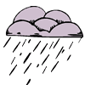 | It's drizzling
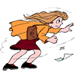 | The wind is blowing | 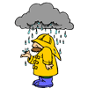 | The rain is falling
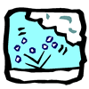 | It's hailing | 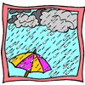 | The rain is pouring
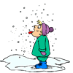 | The snow is falling | 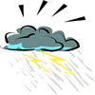 | It's thundering

The effect of weather on our lives
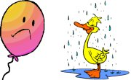

The weather affects us in many different ways. For example, it affects our moods, what we wear, our leisure activities and our mode of travel. To highlight the importance of the effect that weather has on our lives, simple observation and recording work can be done. Weather conditions can be recorded over a period of time and at the same time the effects the weather has on factors such as our mood can also be noted.

CLOTHING
ENGLISH | SPANISH
- Shirt | camisa
- Skirt | falda
- Blouse | blusa
- Jeans | pantalón
- Dress | vestido
- Sweater | buzo
- Uniform | uniforme
- waistcoat | chaleco
- shorts | pantaloneta
- sock | calcetín
- shoe | zapato
- boot | bota
- sneakers | tenis
- suit | traje formal
- tie | corbata
- bowtie | corbatín
- tuxedo | cachaco
- belt | cinturón
- T – shirt | camiseta
- Hat | sombrero

