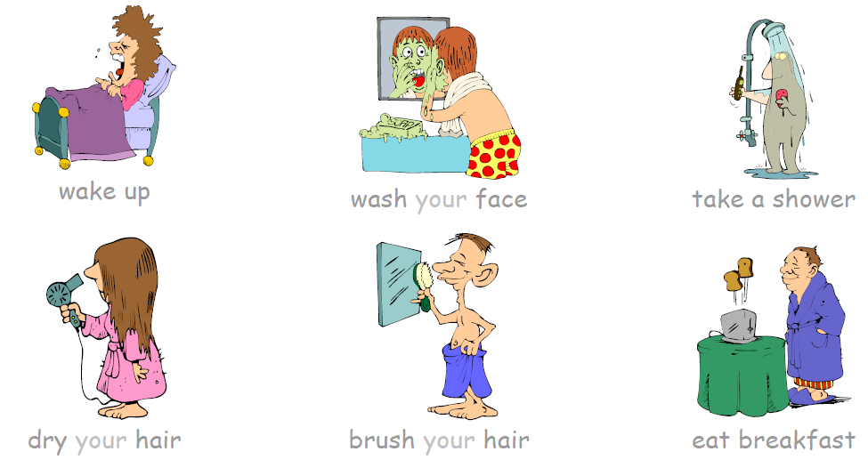
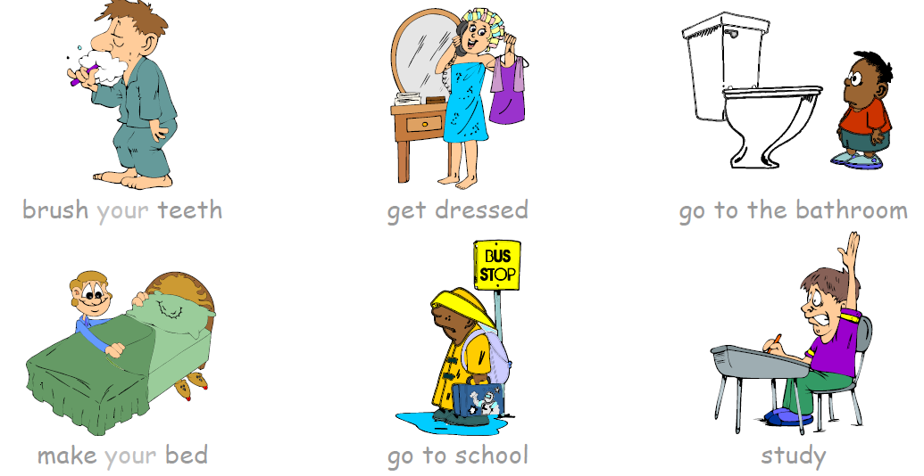
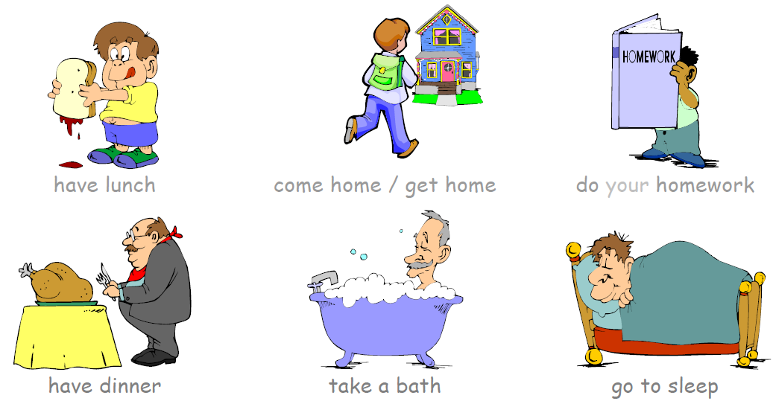
ACTIONS IN MY HOUSE
 | ENGLISH | SPANISH
 | Wake up | Despertarse
 | Wash my face | Lavar mi cara
 | Take a shower | Tomar un baño
 | Dry my hair | Secar mi cabello
 | Brush my hair | Peinar mi cabello
 | Eat breakfast | Desayunar
 | Brush my teeth | Cepillar mis dientes
 | Get dressed | Vestirme
 | Go to the bathroom | Ir al baño
 | Make the bed | Tender la cama
 | Go to school | Ir al colegio
 | Study | Estudiar
 | Have lunch | Almorzar
 | Come/get home | Llegar a casa
 | Do the homework | Hacer los oficios
 | Have dinner | Cenar
 | Take a bath | Tomar un baño
 | Go to sleep | Ir a dormir

