
Hello, my friends

Every day I try to learn as much as possible from my teachers and family. My parents are always my support, although they have their own routine.

Do you want to know our daily routine and what my parents look like? Let me introduce my daily activities and my family members.

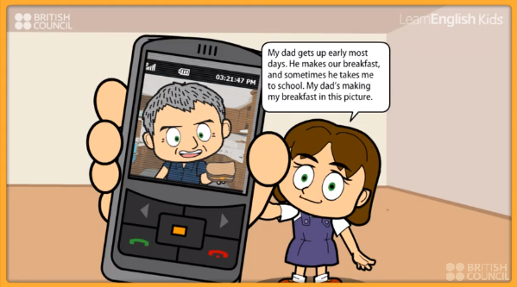

ACTIVITY. Watch the next video, then answer:
http://learnenglishkids.britishcouncil.org/es/short-stories/my-dad

This is how the simple present tense works:

Questions based on the story | Answers
Where does Lottie live?
What color are her eyes?
Where does Lottie’s dad take her?
What does he do?
What time does he get up?
What do they do at the weekends?
When do they watch TV?
What is her dad like | Physically:
 | Personality:
Is he a good father? | Yes – why?
 | No – why?
What do you like from the story?
Are they an exemplary family? | Yes – why?
 | No – why?

Every day we have some common activities to do.
What do you do every day? Let’s watch this video:

ACTIVITY. Watch the next video, and write some activities you listen to and identify.

https://www.youtube.com/watch?v=sIe8lwgDcVY
Daily routine
1 | 2
3 | 4
5 | 6
7 | 8

ACTIVITY. Watch the next video and find some characteristics:
https://www.youtube.com/watch?v=sEDy0wGaXJY


Adjectives from the video
1 | 2
3 | 4
5 | 6
7 | 8

For describing people we need to use physical and personality adjectives. Let’s see how to do it:

https://www.youtube.com/watch?v=ZVE1Vr0Z4rM
Lottie’s dad’s hair is black and grey and he has green eyes. What are you like?

Let’s see how to describe people physically:

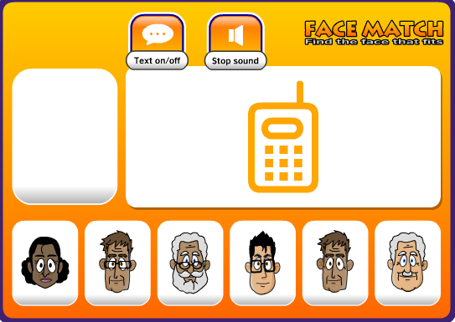

ACTIVITY. Let’s play.
There are some people who are described. Listen to their characteristics and choose the correct option. Then paste three “well done” snapshots.

Example | 1 | 2 | 3
