- These words have something in common. Put them in order, ‘best’ to ‘worst’:

“Truth” | “White lie” | “Whopper” |  | “Lie” | “Fib”
Worst or Better
1. |  |  | 1.
2. |  |  | 2.
3. |  |  | 3.
4. |  |  | 4.
5. |  |  | 5.

- Give large answers for next questions:

- Do you know when people are lying to you? How? Explain.

- Do other people know when you are not telling the truth? Why? Explain

- Read next magazine article and answer?

Does it tell us a) How to lie so that people do not know?
b) How to know if other people are lying?
c) How important it is to tell the truth?
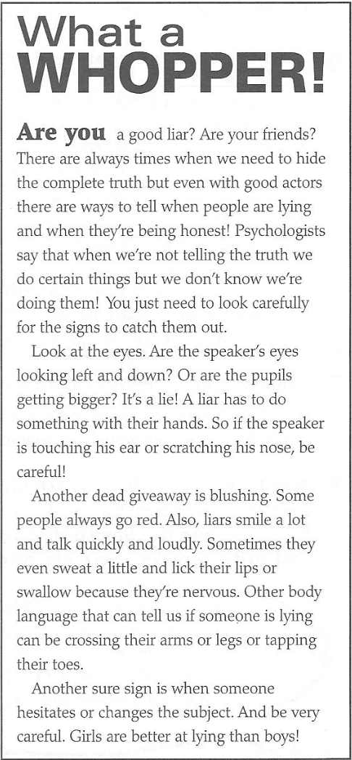

- Read the article again and write the actions in the box next to the picture.
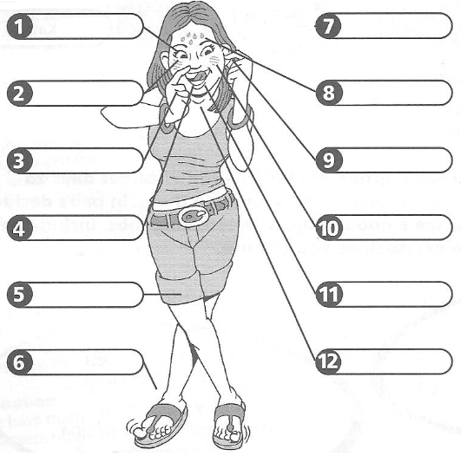

1.
2.
3. scratch nose
4.
5.
6.
7.
8.
9.
10.
11.
12.

