
Hello, my friends

Every day I study on line. I am happy to be at home all day long. However, I need to stay healthy by eating vegetables and fruits, and also following some hygiene habits.

Let’s see how to do it.

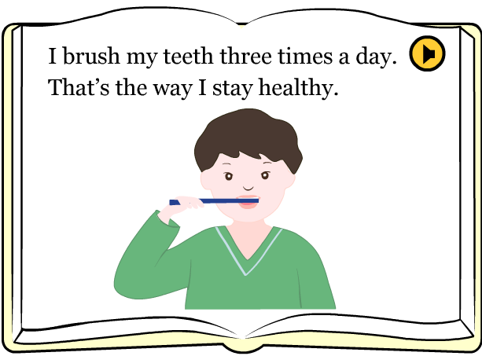

ACTIVITY. Watch the next video, then answer:
http://www.kizclub.com/storytime/healthy/first.html

Questions based on the story | Answers
What does the boy do three times a day?
What time do you believe he gets up?
What does he do at night to stay healthy?
What to do to be strong?
What type of food does he eat?
What activities seen on the story do you do every day?
Are you healthy? | Yes – why?
 | No – why?
Do you practice any sport? | Yes – why?
 | No – why?

Another important way to stay healthy is by eating vegetables and fruits.
Let’s see how important these meals are:

ACTIVITY. Read the story, then answer.


Taken from Colombia Aprende



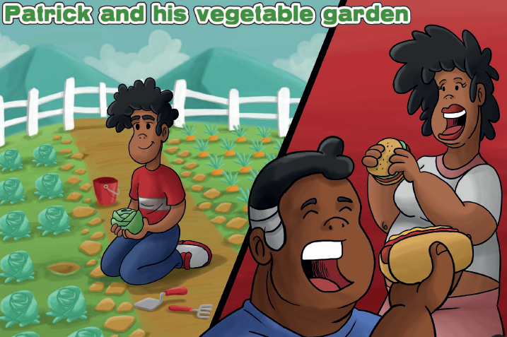
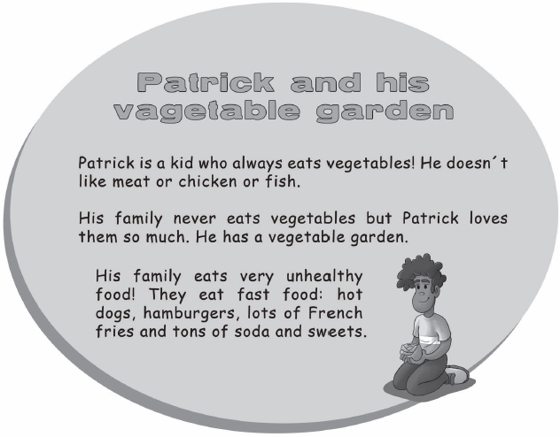

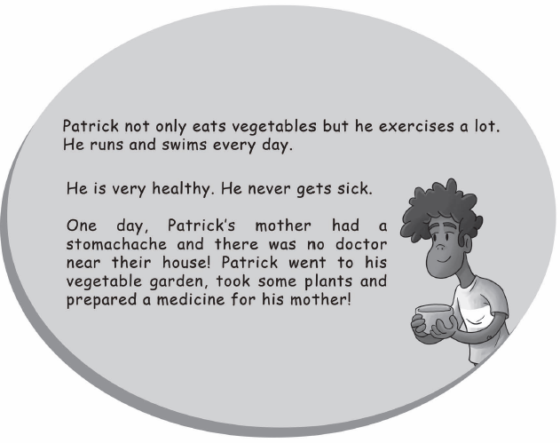
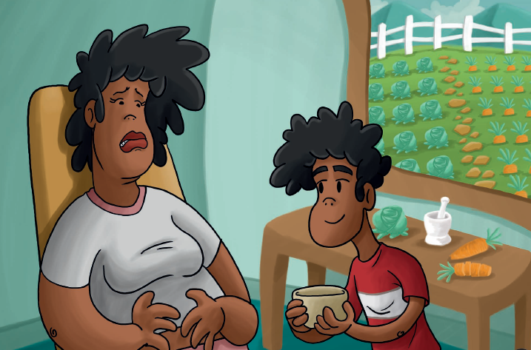

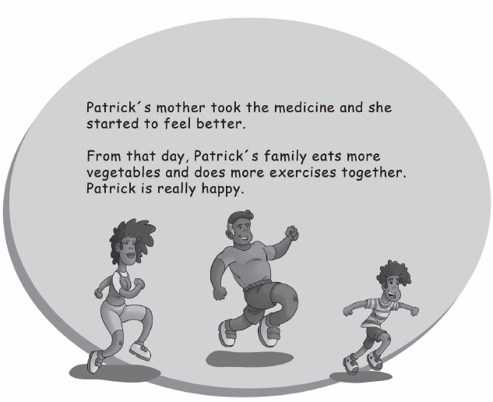
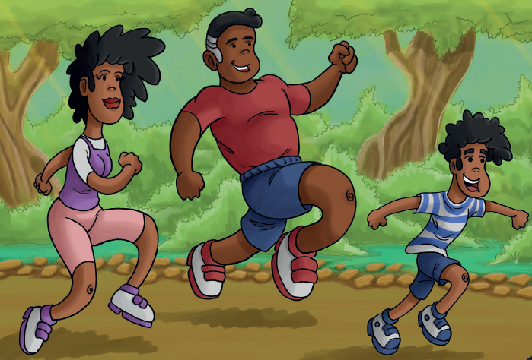

Questions
- Why are vegetables and fruits important?
- Why did Patrick’s parents decide eating fruits and vegetables?
- Do you include vegetables and fruits in your daily meals? | Yes – why?
 | No – why?
- What kind of unhealthy food does the text mention?

Staying healthy also requires some personal hygiene habits.

Let’s see some common situations:

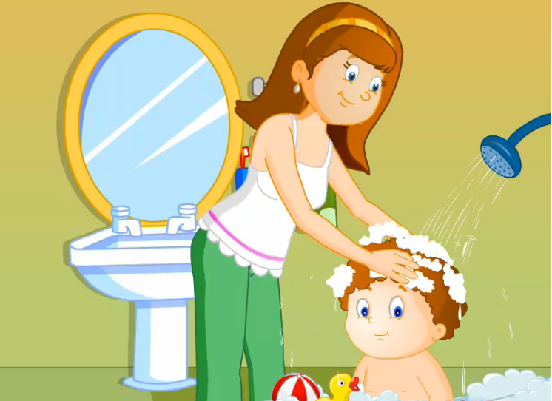

ACTIVITY. Watch the next video and complete the chart:
http://www.turtlediary.com/kids-videos/personal-hygiene.html

Listen to what the boy says when following some hygiene habits.

What does the boy say? | What does the boy say? | What does the boy say? | What does the boy say?
I brush my teeth in the morning; I brush my teeth in the night.
