
Activity: Go to http://www.gcflearnfree.org/reading/play and follow the instructions
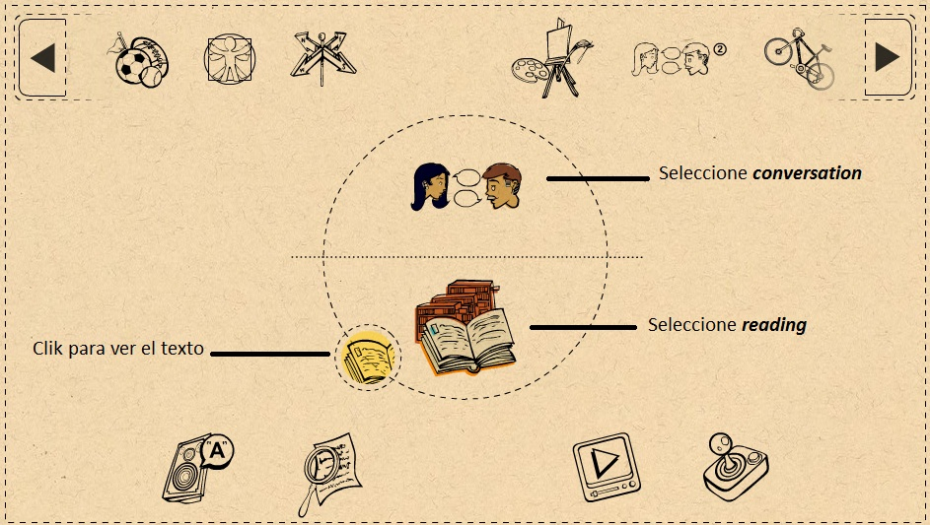

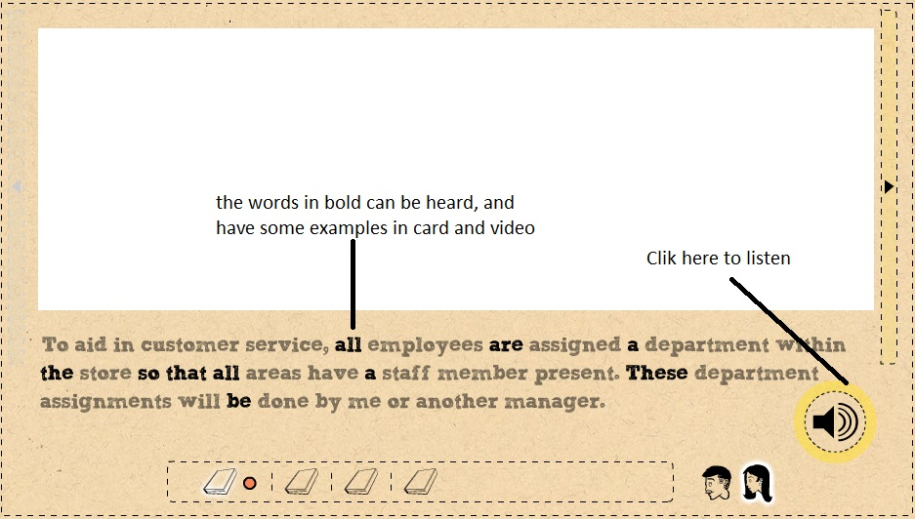

 |  |  | COMPLETE
Store |  | Name
Experience in business |  | Years
Characteristics of the store |  | Tradition
Obligations of the salesperson |  | verbs
 |  |  | - Offer . . .

What is the main idea of the text? What are the key words you can find?

Main idea:

Key words:

Activity. Go to: http://www.englishmedialab.com/GrammarGames/New_Snakes_%20Ladders/Past_simple_tense.html
Play the game, use the past tense, and send an image of the result (a score up to 15)
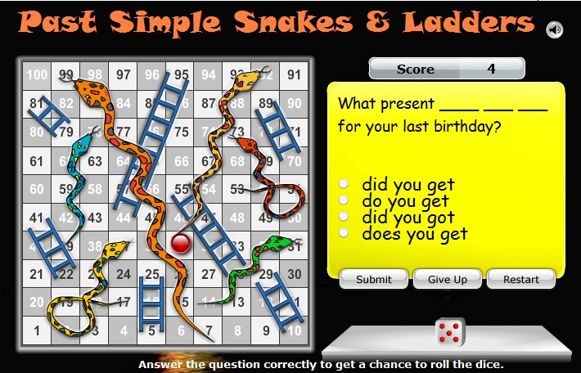

Activity: Go to http://www.rong-chang.com/nse/se/nse012.htm , listen to the story carefully, then rewrite a part of the story by using linking words, example:

Laura looked out the window. A storm was coming. The sky was getting dark.
Laura looked out the window, but a storm was coming, and the sky was getting dark.
Activity: from the last short story “a storm”, write 6 sentences in negative and interrogative forms.
Affirmative | Laura looked out of the window
Negative | Laura didn’t look out of the window
Interrogative | Did Laura look out of the window?

