
Hello, my friends

The stories I learned in elementary school help me identify how to write sentences in different verb tenses, and then how to connect them by using linking words (connectors). In this way I will be able to make up some stories.

In this unit we will practice some short readings and then we will learn to create ours.

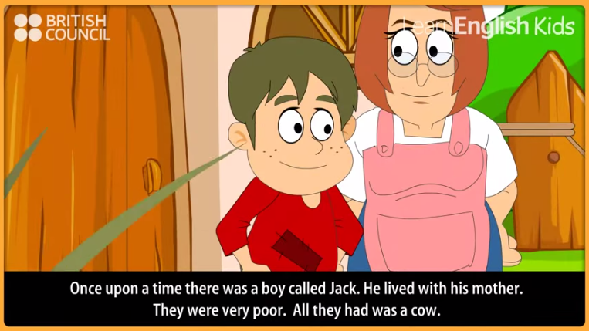
For writing sentences in past we need to use regular and irregular verbs, and also the auxiliary DID.

ACTIVITY. Watch the next video, then answer:

https://www.youtube.com/watch?v=rKB1_wBueFM

Regular verbs |  |  | Irregular verbs
PRESENT |  | PAST | PRESENT |  | PAST
Call |  | Called | Have |  | Had
Start |  | Started | Tell |  | Told
Which other verbs did you identify?
Regular verbs Irregular verbs
When the question has verb to be, the answer must have verb to be, too.
What was the boy’s name? |  |  | The boy’s name was Jack.
When the question has a regular or irregular verb, the auxiliary is DID.
What did jack have in his farm? |  |  |  | He had a cow.
Where did Jack climb up?
What did the giant do when Jack took his hen and harp?
Who said “help, master”?
Why did Jack and his mom decide to sell the cow?
Did you like the short story? |  |  |  | Yes – why?
 |  |  |  | No – why?
Try to change or complete the end of the story.
What happened with the giant?

- Writing a short story is a good strategy for practicing verb tenses, pronouns, possessive adjectives, and the like; however, some of the most important parts of the sentence are “Connectors”. These words help us connect ideas.
However, because, and, but, in addition, moreover, then, later, while, finally ……

Here you can find a complete list of connectors: https://www.dlsweb.rmit.edu.au/lsu/content/4_writingskills/writing_tuts/linking_LL/linking3.html

Let’s practice by using connectors to link sentences taken from the story.

Original story | Connectors included in the story
Jack took the beans and went back home. When Jack’s mother saw the beans she was very angry. She threw the beans out of the window.  The next morning Jack looked out of the window. There was a giant beanstalk. He went outside and started to climb the beanstalk.  He climbed up to the sky through the clouds. Jack saw a beautiful castle. He went inside.  …the giant woke up and shouted… | First Jack took the beans and went back home, then, when Jack’s mother saw the beans she was very angry, for this reason she threw the beans out of the window.  The next morning Jack looked out of the window, and there was a giant beanstalk, so he went outside and started to climb the beanstalk.  He climbed up to the sky through the clouds, and then he saw a beautiful castle. He went inside.  …but the giant woke up and shouted….

ACTIVITY. Now let’s watch the next short story and identify some connectors.
Write the story and underline the connectors.
http://www.kizclub.com/storytime/threebears/first.html

The three bears | 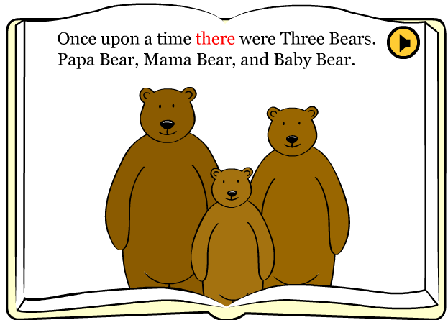
… But the soup was too hot. So they walked out…

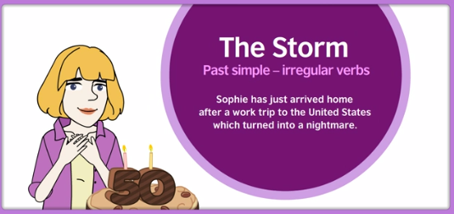

ACTIVITY. Watch the next story and complete.

http://learnenglishteens.britishcouncil.org/grammar-vocabulary/grammar-videos/past-simple-irregular-verbs

Answer based on the video.

Identify the connectors from the video and categorize them.
Connectors |  | Category
- but |  | Contrast
-
-
-
-
-
-
-
-
Write the questions you identify on the story
Classify the verbs into regular and irregular
Regular |  | Irregular
Present | Past | Present | Past

