ACTIVITY. Go to http://www.youtube.com/watch?v=J5E9SWg6_fw, watch the video, then find 10 verbs, 5 regular and another 5 irregular ones.

REGULAR VERBS |  | IRREGULAER VERBS
Present | Past | Present | Past
 |  | 1.
 |  | 2.
 |  | 3.
 |  | 4.
 |  | 5.

ACTIVITY. According to the video, answer:

 | Question | Answer
1 | Where was she?
2 | Did she eat the Apple?
3 | What did she eat?
4 | Was she in the dining room?

ACTIVITY. According to your reality, your experiences, write in past tense 3 sentences in affirmative, negative and interrogative way, by using to be, regular and irregular verbs:

SENTENCE | TO BE (was / were) | EXAMPLE
Affirmative |  | Spain was the last world champion
Negative |  | I wasn’t in a good shape last year
Interrogative |  | Were my students ready for the test?
 | REGULAR VERB
Affirmative |  | I shared good moments with my son
Negative |  | My workmates didn´t travel on vacation
Interrogative |  | Did I dance too well at the party?
 | IRREGULAR VERB
Affirmative |  | My parents got married in 1974
Negative |  | I didn’t take vacation in December
interrogative |  | Did my students understand the topics?

ACTIVITY. Identify the image that follows the best description, and then describe any other one with your own words:
Example:

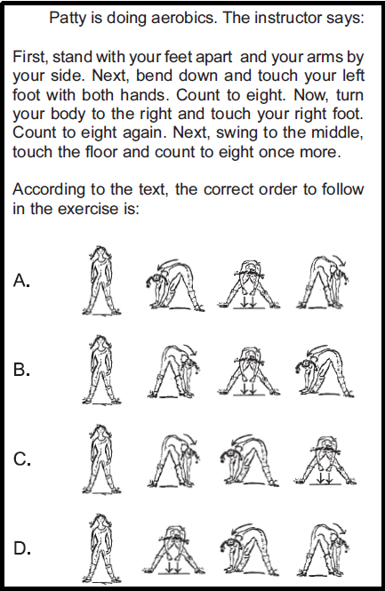
IMAGE E: First, stand up, then touch your right knee, after that jump, and finally move your body.

