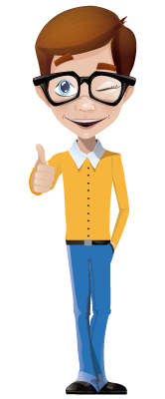
Hello, my friends

Yesterday morning I was studying English when my teacher called me by skype. He explained my brother and me how to use the simple past tense. Later, while I was trying to send the activity, he asked me to include my pronunciation.

What happened while you were doing a common daily activity?

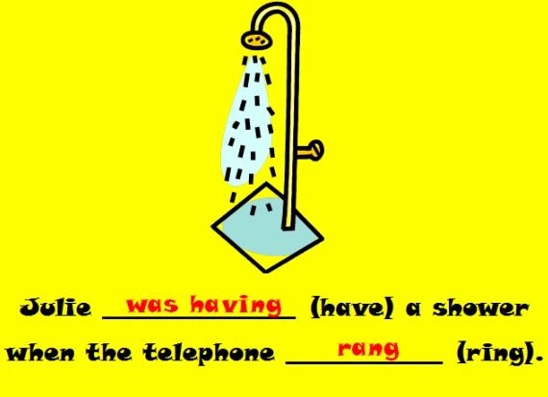

Watch this video, and identify how to use past simple or past continuous:

https://www.youtube.com/watch?v=P_SRx1GBJHw

ACTIVITY. From the last video, write ten complete sentences. Follow the example:

 | Past continuous | Past simple
 | (Describing a situation) | (Interrupting the previous situation)
1 | Julie was having a shower | WHEN the telephone rang.
2
3
4
5
6
7
8
9
10
11
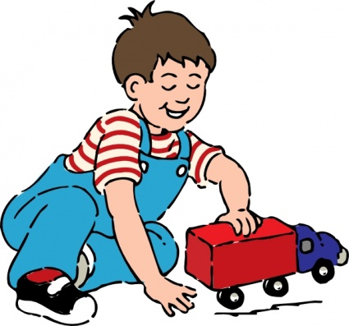
My life has changed a lot.

I am not a baby any more. I don’t play with toys and dolls as I used to do. My childhood was wonderful:
- I used to play with cars and dolls.
- I used to cry for no reasons.
- I used to watch cartoons on TV
- I used to sing children’s songs.

USED TO is a way to describe what I did very frequently, but which does not happen now.

ACTIVITY. Watch the next video, then write some sentences about the situation: how long Sophie used to travel, what clothes the head teacher used to wear, what places she used to visit, what she used to go to London for… (Include USED TO – DIDN’T USE TO in the sentences).
http://learnenglishteens.britishcouncil.org/grammar-vocabulary/grammar-videos/used
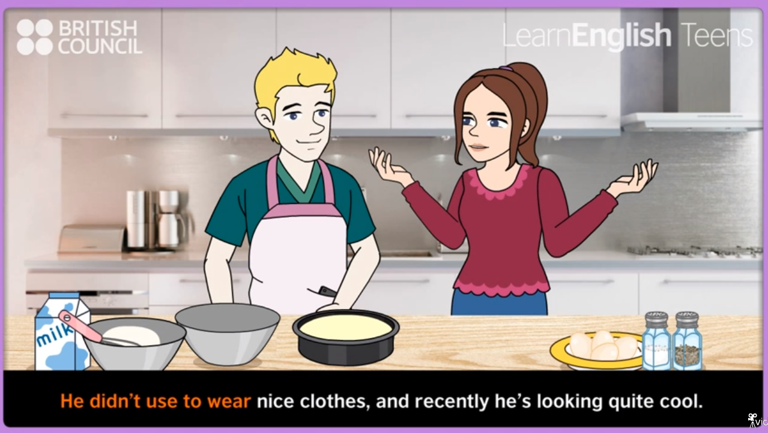

- The head teacher used to wear improper clothes.

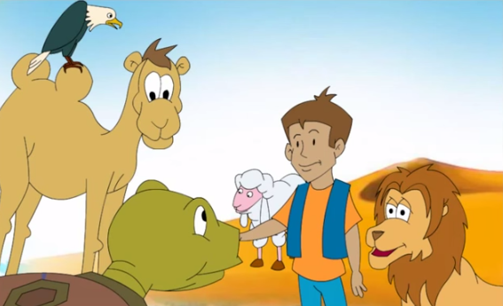
When I used child I used to watch cartoons and read fairy tales. My mom used to tell me children’s stories, which I enjoyed too much.

Let’s go back to our childhood and read a story.

https://www.youtube.com/watch?v=2iOlM9XdOYo

ACTIVITY. From the previous video, answer the next questions:

Question | Answer
What was the lion doing when Peter saw him?

Where were Peter and Lion walking when they met Sheep?

What was Eagle doing when they met Camel?

When did they cheer?

What was Owl saying when they got surprised?

Did you like the short story? | Yes – why?
 | No – why?

