Nivel 01

Comparar y contrastar sustantivos
Introducción, nudo y desenlace, una lectura en YO, para intro, nudo y desenl em tercera persona

Segundo

Go to http://www.starfall.com/n/fiction-nonfiction/mothers-day/load.htm?f, then anser the next questions

Identify the starting, nudo y desenlace,

QUESTIONS
1.
2.
3.
4.
5.
Give another title to the fable

Write 5 questions about the fable, in present, past or future

Write and pronounce the last time that you or somebody else did anything, by using regular and irregular verbs

Experiencias en presente, simple tense, 1, video de explicación, describir ropa
Planes futuros 3. Simple y progresivo
Descripciones de mi entorno,
imperativas
Expresar gustos y opiniones
Textos, preguntas como comprensión 2.
Wh questions: When, exp tiempo,
Organizar párrafor coherentes, cortos, como en Icfes (noveno: divirid un texto en partes. First, then, later…
Escribir experiencias, c on ortografía y gramatica, pasado simple, When was the last time you……….
Irregular and regular verbs
Could, be able to

http://www.youtube.com/watch?v=J5E9SWg6_fw
Sacar 5 regulares, 5 irregulares y escribirlos en el otro tiempo restante (presente o pasado)
Answer:
- Where was she?
- Did she eat the Apple?
- Did she eat a candy?
- Give an example in past tense, according to your reality, in affirmative, negative and interrogative form, using:
  - Verb to be
Af
Neg
int
  - Regular verb
  - Irregular verb
- In a chronological order, make three sentences describing the introduction, the middle and the end
  - In
  - Mi
  - En

Imperayiva 1

Tercero, when was the last time you….

Imperative form
Prohiba anexando imágenes
What did you do last weekend? Use regular and irregular verbs
Used to, con juego s de niños

nivel 03

For the 2020 the fashion will be:

MEN
FORMAL | CASUAL
WOMEN
FORMAL | CASUAL

MEN:

FORMAL CASUAL

WOMEN

FORMAL CAUSAL

People will use ties with jeans….

What will you study in a future?
Where?

comparative de superioridad: more than,
er http://www.youtube.com/user/cursosdeinglesats#p/c/4/7aEtI1crlqc
more http://www.youtube.com/user/cursosdeinglesats#p/c/4/7aEtI1crlqc
lectura, Brownsville changed, identificar o hacer oraciones finales, dos ciudades,

describir personalidad, I am more responsable tha before

I was thinner than now

Describir los trajes de una persona, excelente video

http://www.eslkidslab.com/lessons/course3/videos/clothescolours/index.html
http://www.eslkidslab.com/lessons/course3/videos/clothescolours/index.html
estaciones
http://www.englishmedialab.com/elementaryvideos/seasons/seasons.html
qué ropa utilizar para cada estación
http://www.englishmedialab.com/beginnervideos/clothes%20and%20weather/clothes%20and%20weather.html
deportes para el verano
http://www.englishmedialab.com/higherlevels/summer%20vacation/summer%20vacation.html

de acuerdo a estaciones,
pegar imagen del bosque, 6, con colores incorrectos

pefgue una foto suya y describa la ropa que lleva, pronunciando, en diapositiva y señalándola

In the park

- The Jones family is in the park today. The sun is shining and the birds are singing. It is a beautiful day.

- Mr. Jones is speaking with his wife. Mrs. Jones is having breakfast. Patty and Sally Jones are studying English. Tommy Jones is not studying, he is playing the guitar.

- The parents are looking after their children, the dog is eating a bone and Sally is reading a book.

- The baby is playing with his father; he is not playing with the dog.

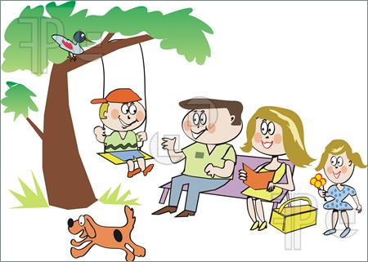
- The Jones family is very happy today, it’s a beautiful day and they’re in the park
ADITION: and (y) | CONTRAST: but (pero)
La conjunción “Y” se utiliza para indicar secuencia, adición.  I am studying and my sister is working.  (yo estoy estudiando y mi hermana está trabajando) | La conjunción “but” se utiliza para iniciar oposición, contraste:  I am studying, but my sister is working.  (yo estoy estudiando, pero mi hermana está trabajando)
Exprese adición y contraste de manera lógica de acuerdo a la lectura anterior.
 | 1.
 | 2.
 | 3.

What are you wearing today?
http://www.englishmedialab.com/elementaryvideos/clothes%20describing/clothes%20describing.html
utilice and y but

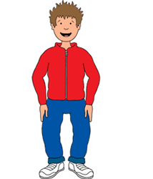  Imagen tomada de  http://www.how-to-draw-cartoons-online.com/cartoon-boy.html |   Imagen tomada de  http://new-animation99.blogspot.com/
He is wearing a red jacket and a blue jean | She is wearing a white blouse, but a red pant

